Let’s take a look at this ½ rectified plate drive question, first the stimulus,

Michael Steffes, 1/20/2020

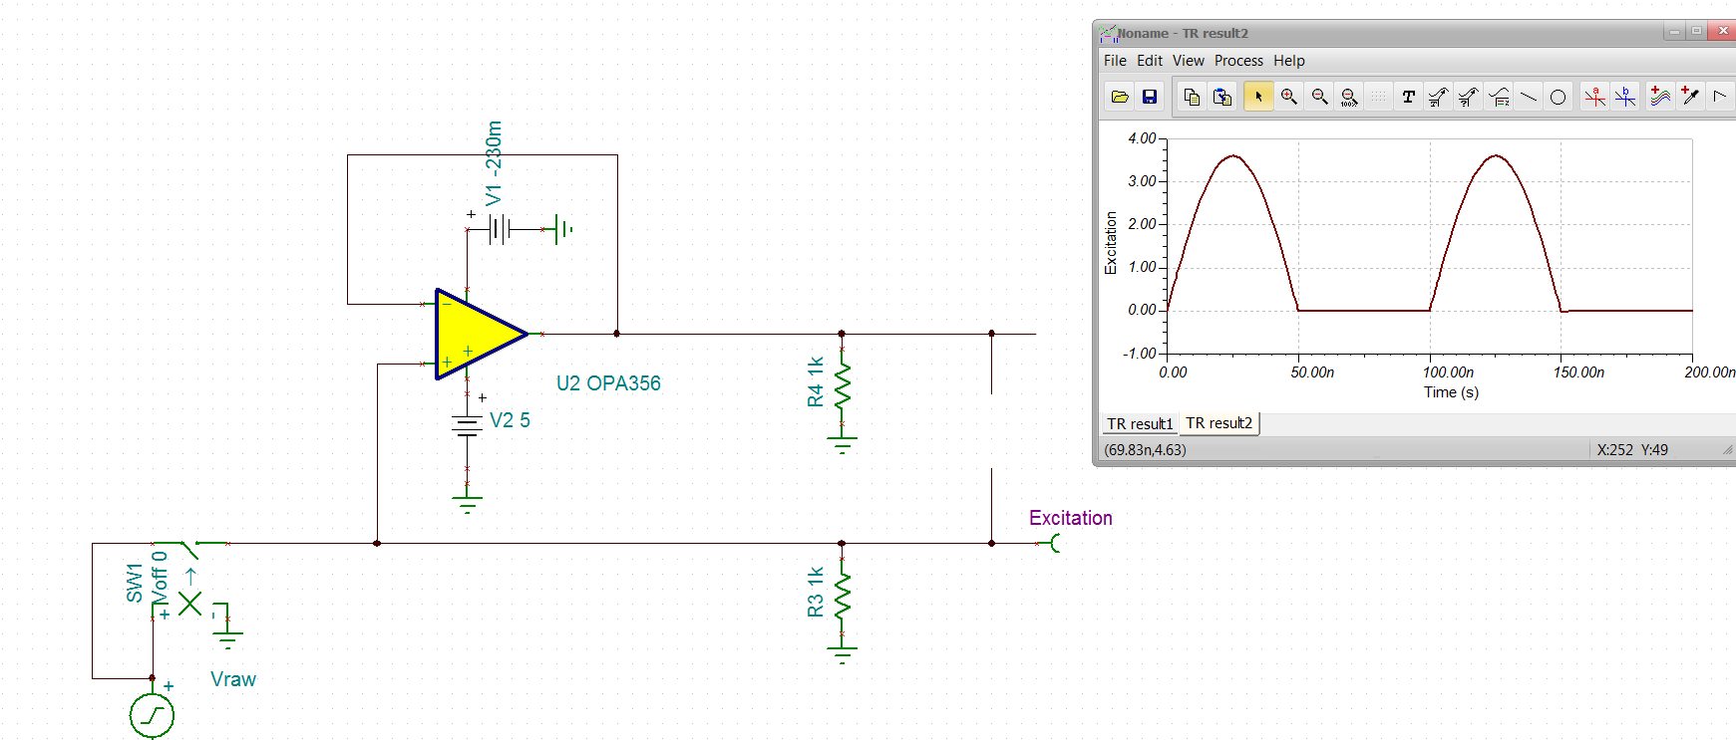

Very nice way to generate this, I do wonder if the FDC2214 can generate that into 100pF load? In any case, let’s check the dV/dT for this and then the implied peak current into the Cload,

Yes, this is what you would expect at 0V, about 220V/usec peaks

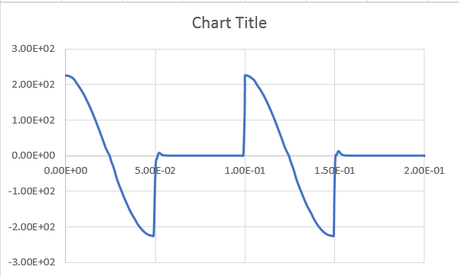

This peaks into 100pF are about +/-22mA peak output, this is just if the op amp output can follow this into a 100pF load,

But, directly driving a 100pF load is a stability issue of course,

This is an unhappy amplifier, 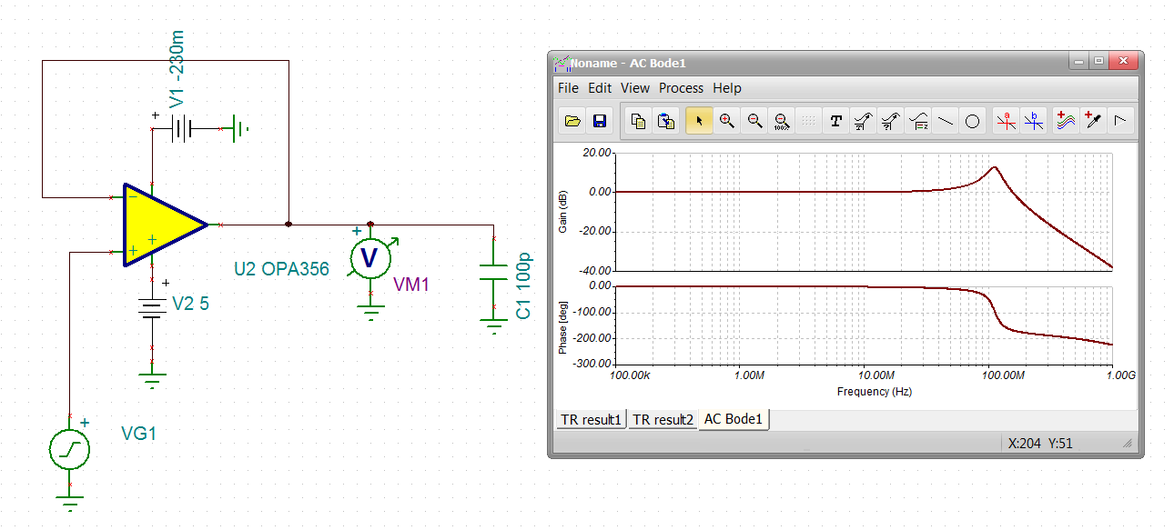

If we center up the DC and run a small square wave, here that is, not as bad as I thought, but still indicative not being able to follow the input at the Cload,

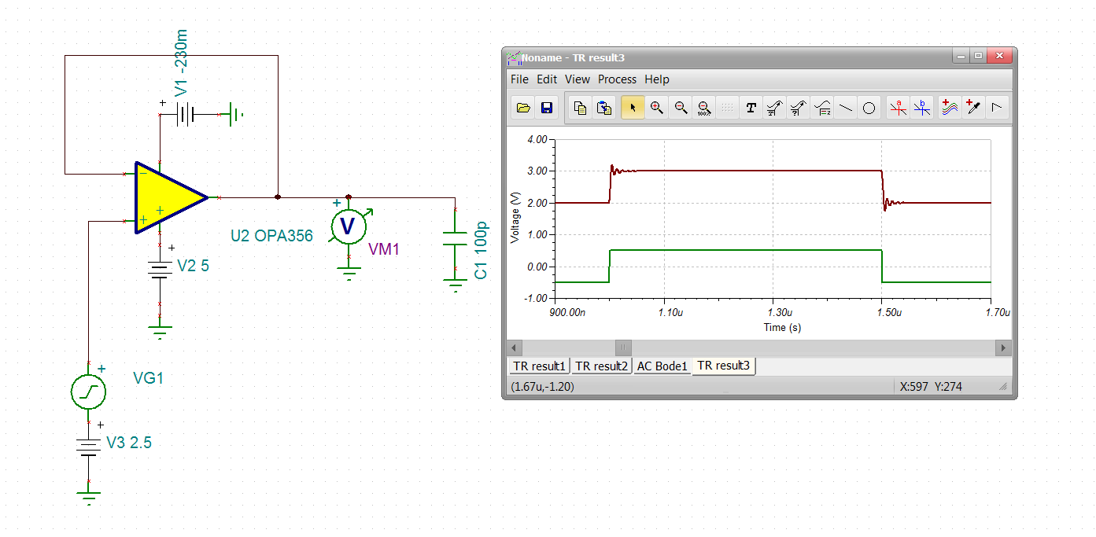

Your measured ringing on the negative edge is this effect.

The simplest thing to try is matching 10ohms to the cap loads, doesn’t look too bad,

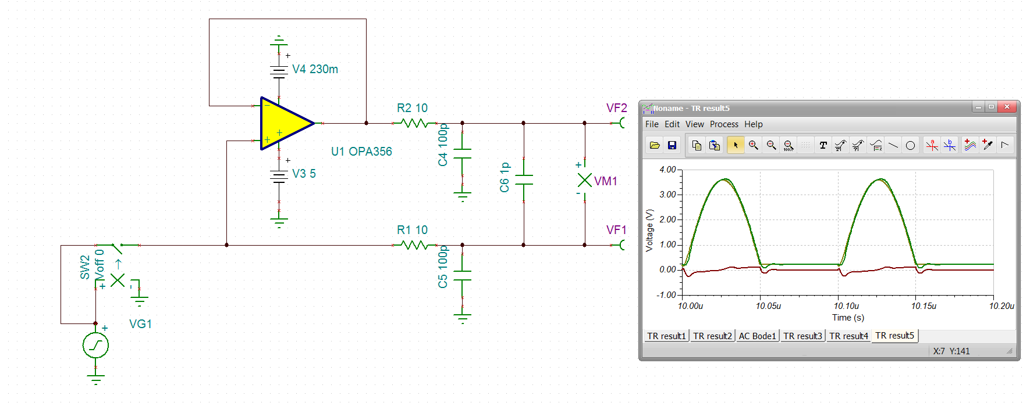

Zooming on the error is here, I think you said -.25V error is ok, well here it is,

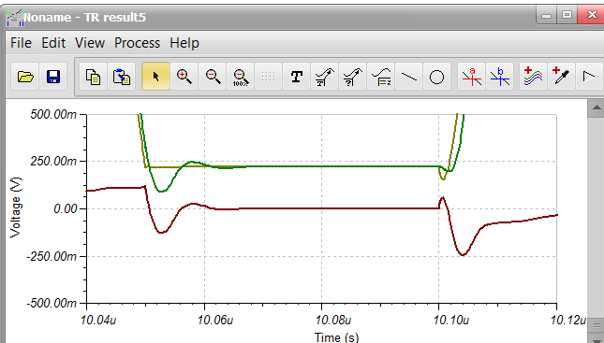

And then the AC response with 10ohm series, yes, a much happier amplifier,

