Investigating required BW and SR for a ½ wave rectified input signal shown here
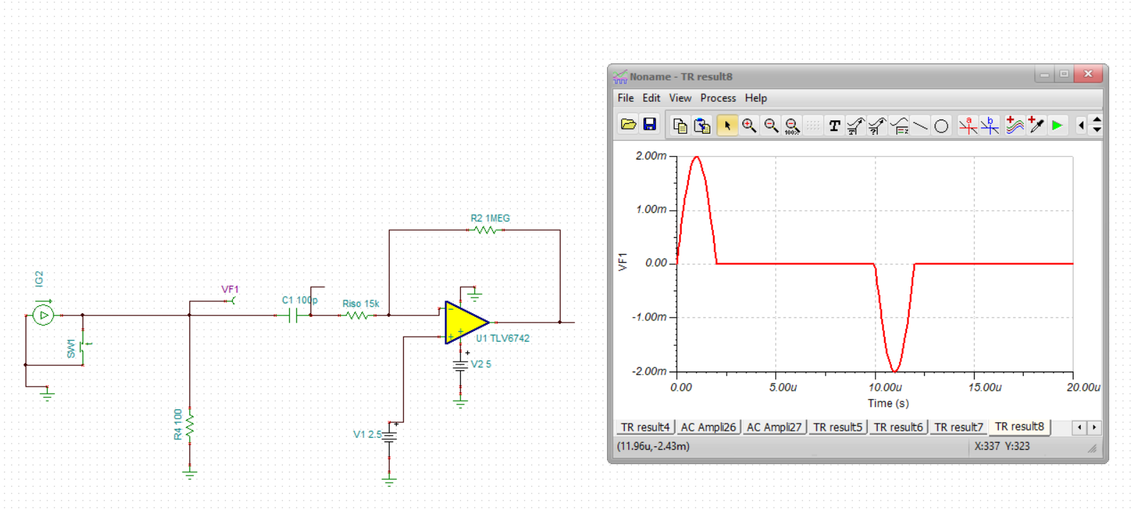
Those edges might be pretty fast dV/dT, not really a sinusoidal analysis going from 0 to ½ wave instantly – the easy way to do this is to dump the data into excel and run a point by point dV/dT. Doing that gives this dV/dT in V/usec at the input. To follow this, the output dV/dT is just the gain times this, times 67 for peaks of 0.2V/usec.

The AC response is bandlimited here by the input AC coupling cap and the high noise noise gain. Yea, this is not much of a response that input high pass pole is at about 100kHz, while the op amp rolloff is at about 10MHz/68 = 147kHz. Trying to make a bandpass filter here?
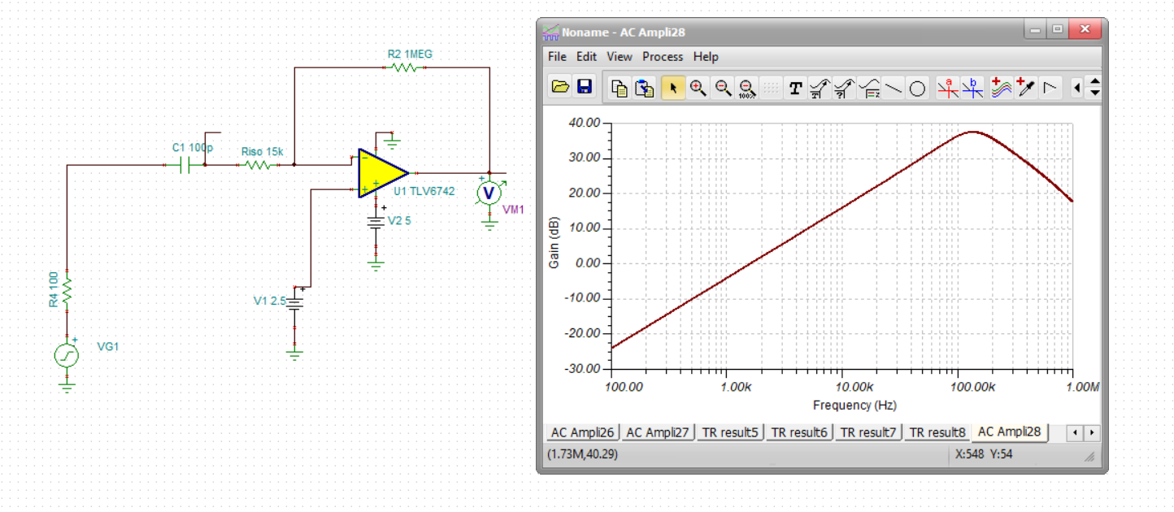
Let’s assume not, the input rep rate is 100kHz, set the high pass at 10kHz, the rolloff is really a little too low (low GBP for this high a gain). But anyway, here is the original ckt output waveform – highly distorted not due to slew rate (4.5V/usec is plenty for the +/134mV output swing) but to SSBW limits.
Highly attenuated due to response shape,
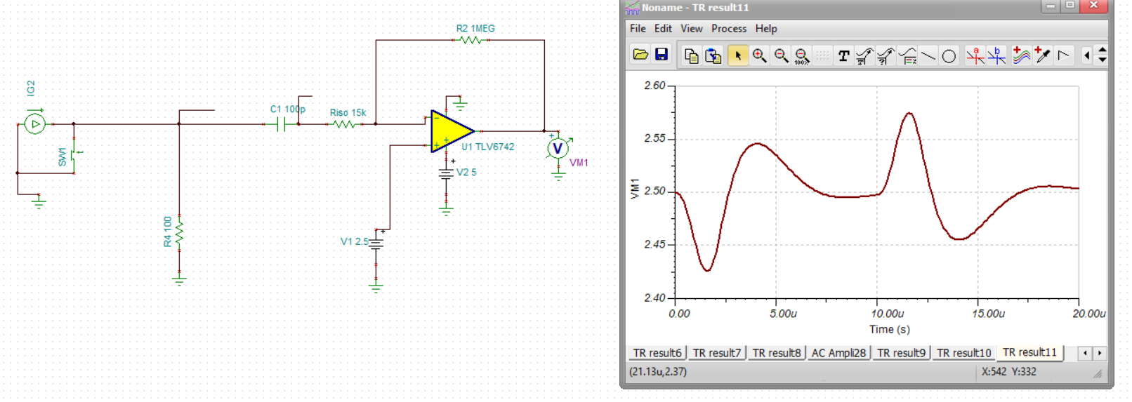
1st try higher input C = 1nF
Little better, still not reaching the intended +/-0.134 swing due to high end rolloff,
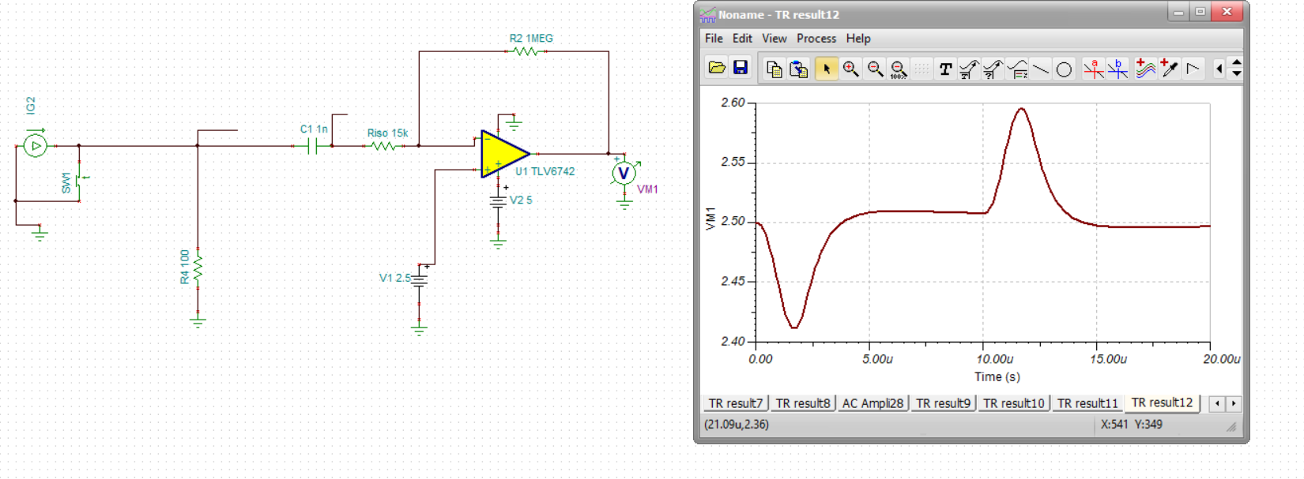
Need a faster part if the gain needs to be this high, The dual is not in the parametric match tool, the single comes up with the lmp7711 – actually, there is a decomp version of that part, maybe not a dual though, try the LMP7712 to get a little more speed – or you can find your own 20MHz option
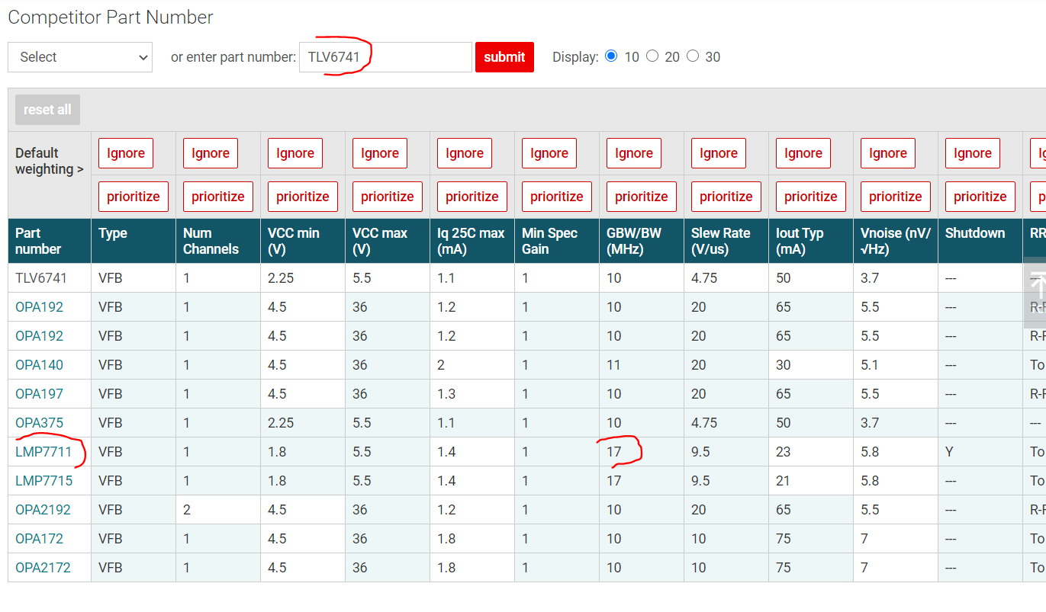
Yes, this is starting to look pretty good, just a bit short of the Vpp out, a faster device will get closer. Not really a slew limit here, but a GBP limit at such high gain.
