LMH6702 output waveform abnormal

LMH6702 output waveform abnormal，Measurements will vary，but not normal。

SCH：

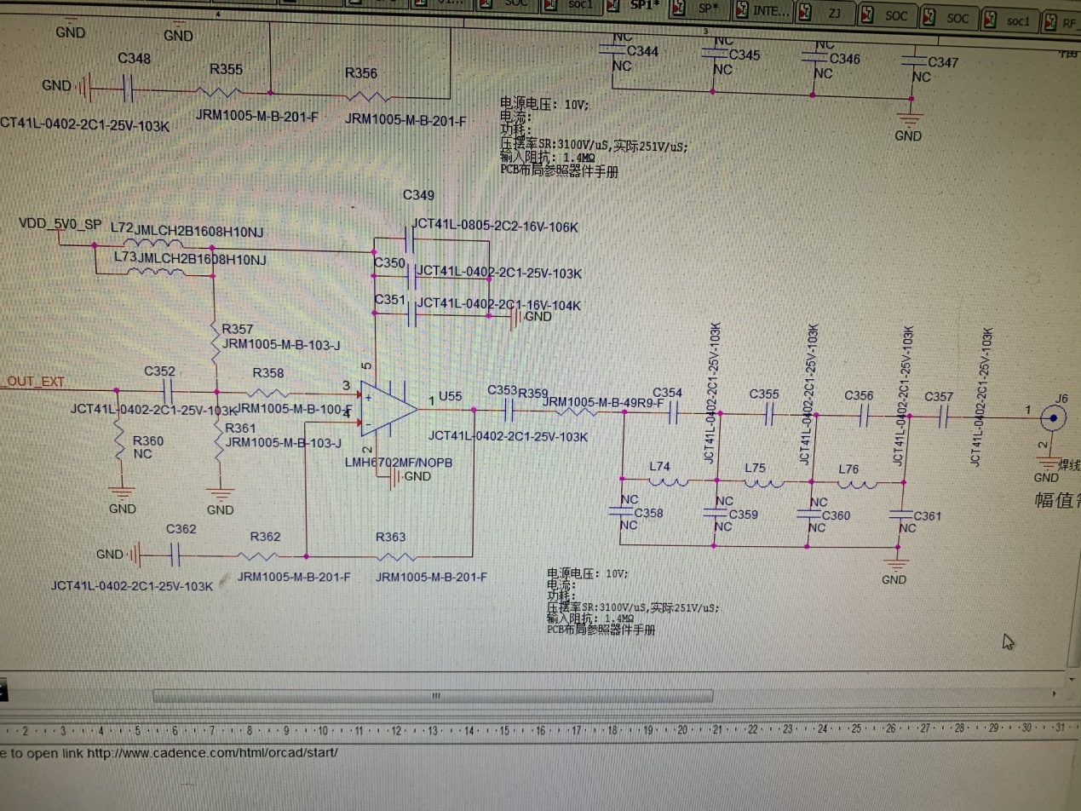

PCB：

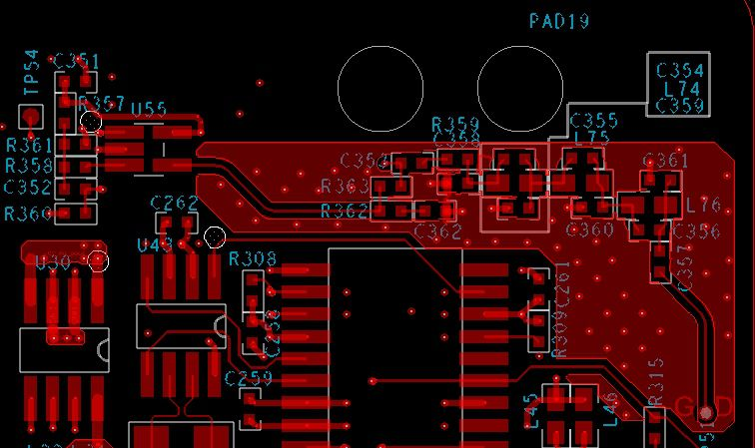

photo：

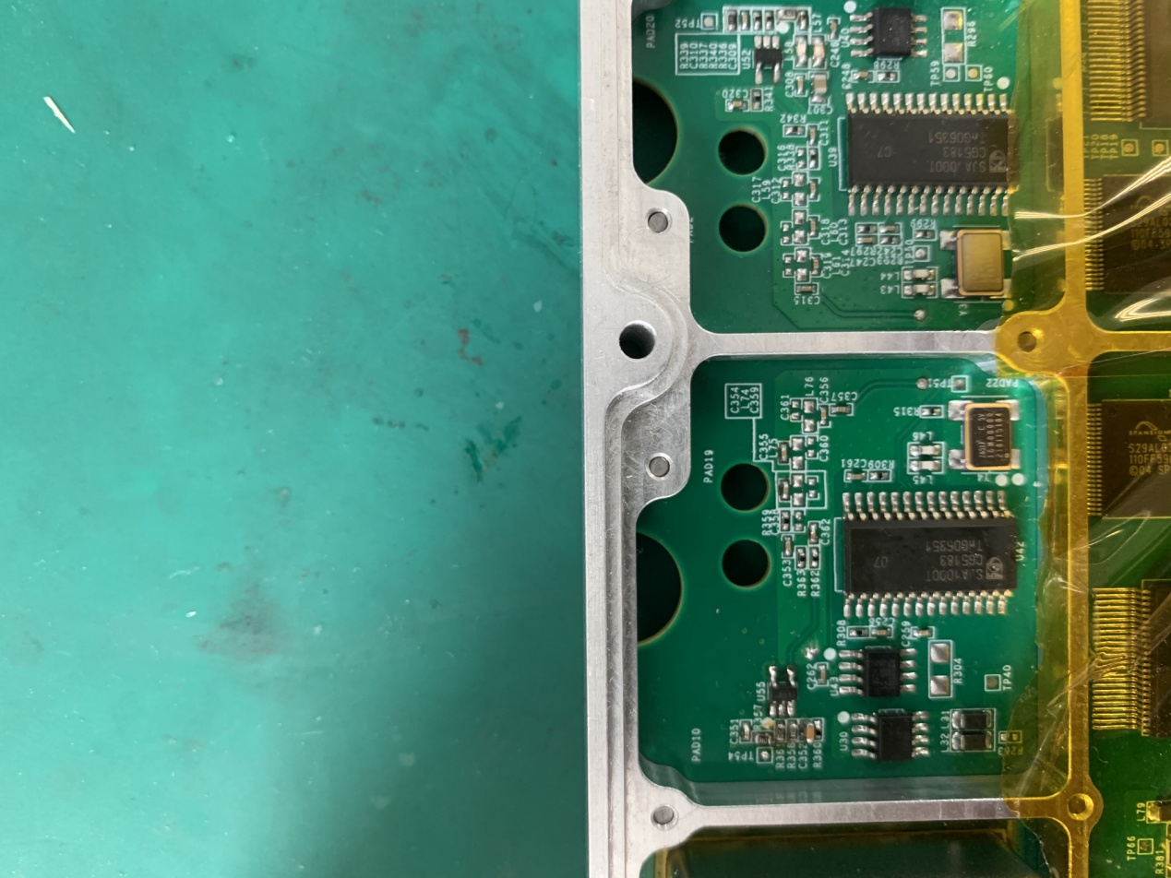

waveform：

LMH6702 3pin and 4pin，blue（+） YELLOW(-)

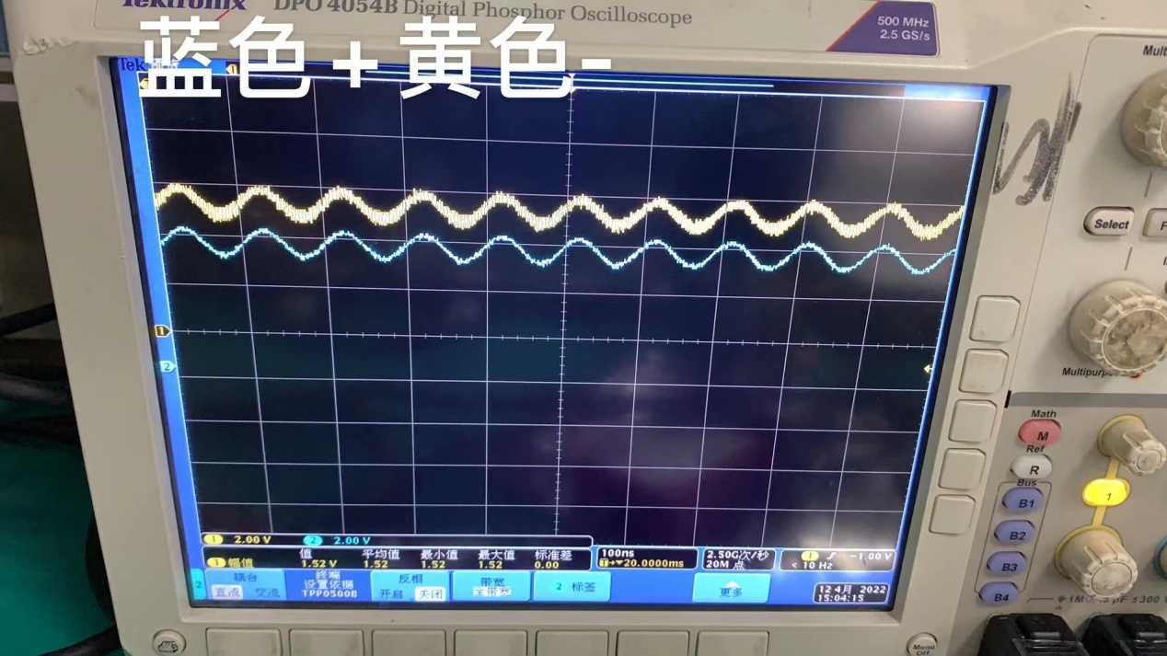

LMH6702 1pin

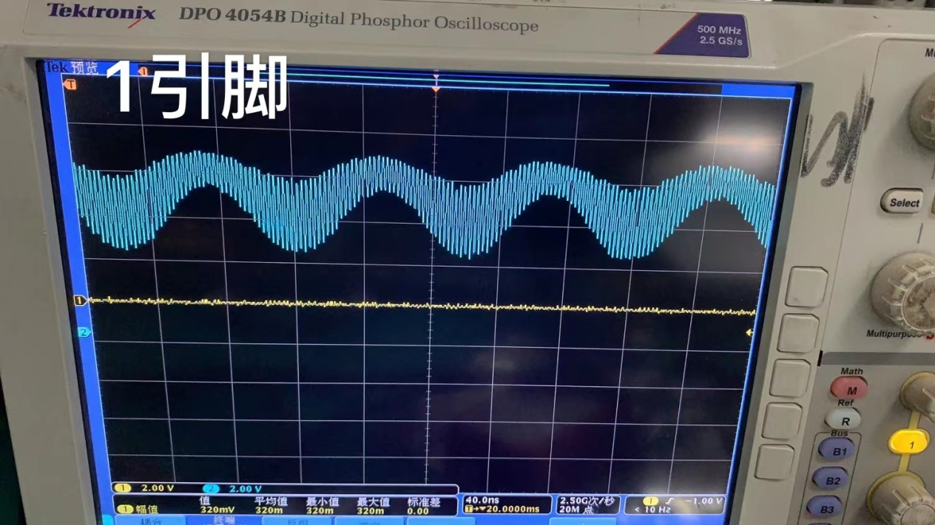

2. The data sheet repeatedly emphasizes the size of the load impedance, 100 ohms, 50 ohms, etc., can the sch I use adapt to the use of different loads?