Paper sensor is always detected without paper also. Earlier we used **SN74LS06** IC and now we are using **SN74AHC05**.

1. Paper sensor is connected to J3 Connector, output of paper sensor is compared with LM393 IC and PESENSE signal connected to SN74AHC05 IC.

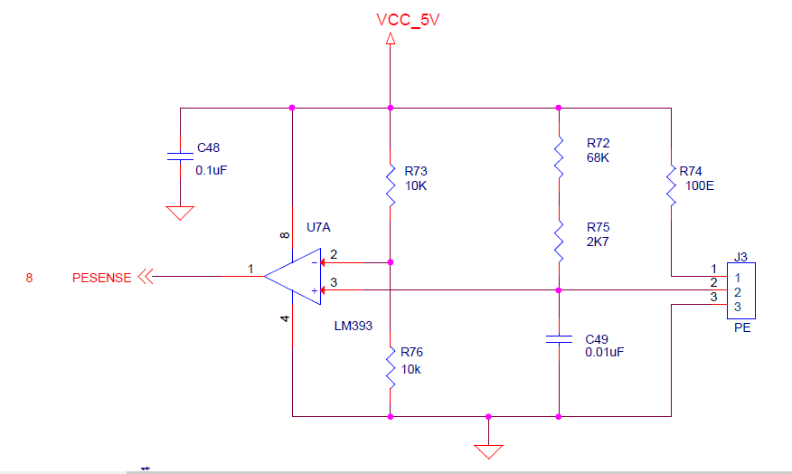

2. PESENSE Signal connected to SN74AHC05. Output of PESENSE1 signal is connecte to MCU pin.

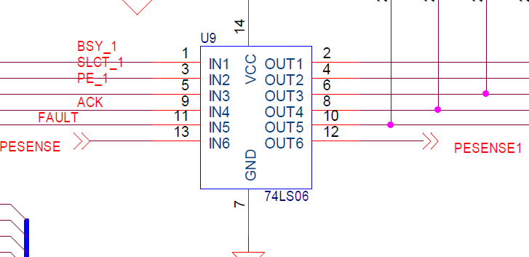

3. PESENSE1 signale is connected to MCU 91st pin

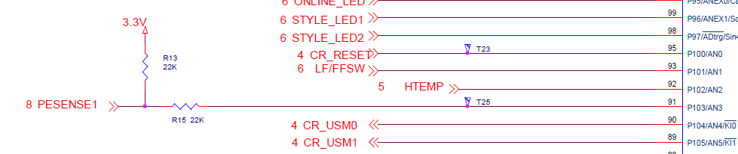

Pls find the voltage refence value with/without paper for both devices.

