Site | Frequency | Margins | Notes
TPV Chamber | 160.28 M | PK 18.4db (over) | Vertical
conduction | 0.40M | QP-3.56 db (number) | 230V (N)
 |  | AV-3.59 db (number)

OTS Ec312tt2 (2560x1400)
Vertical Horizontal
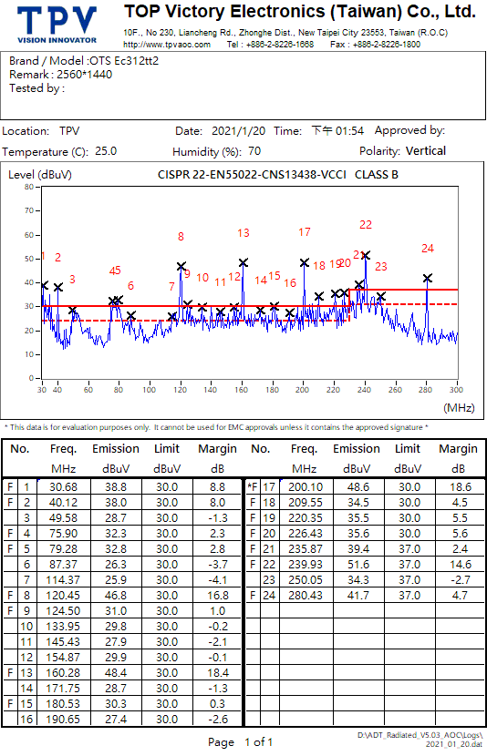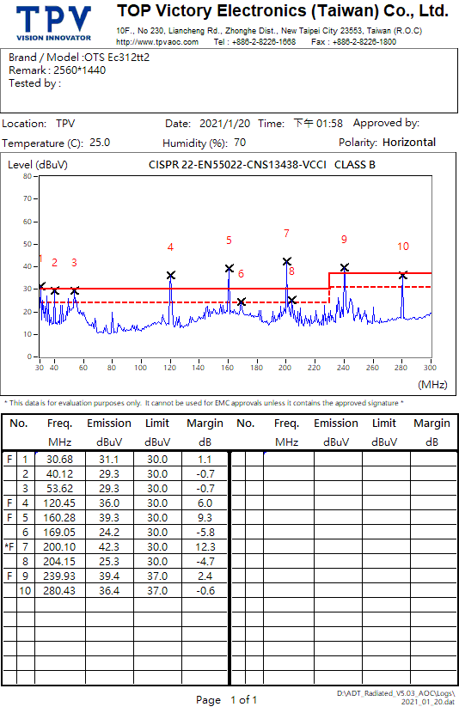
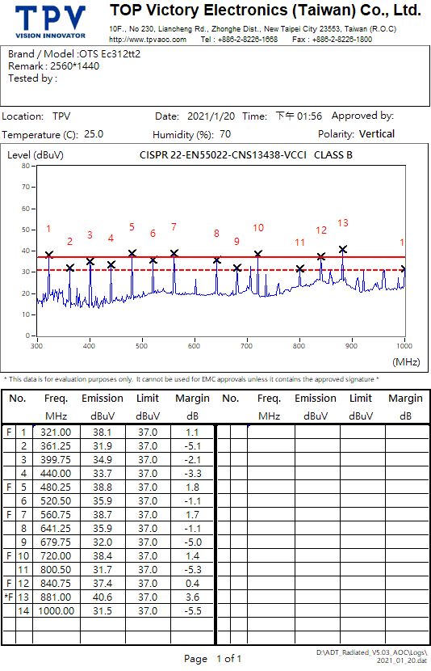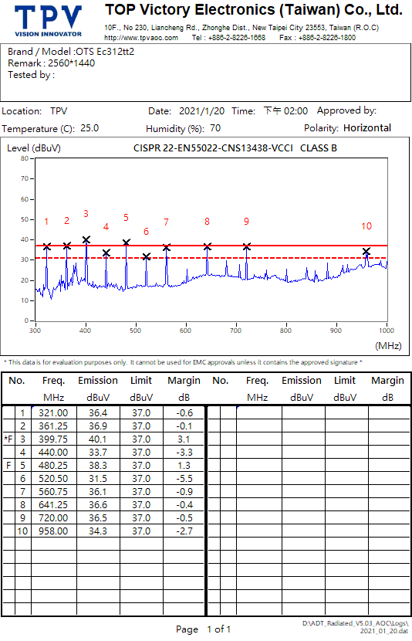
Conduction 230V
L N
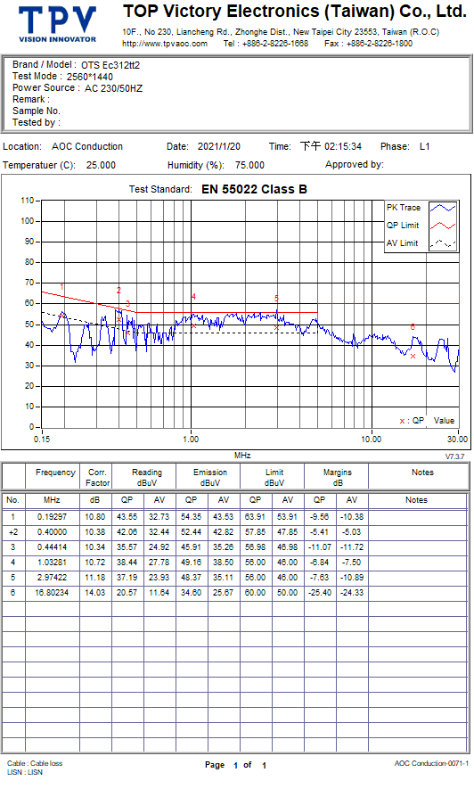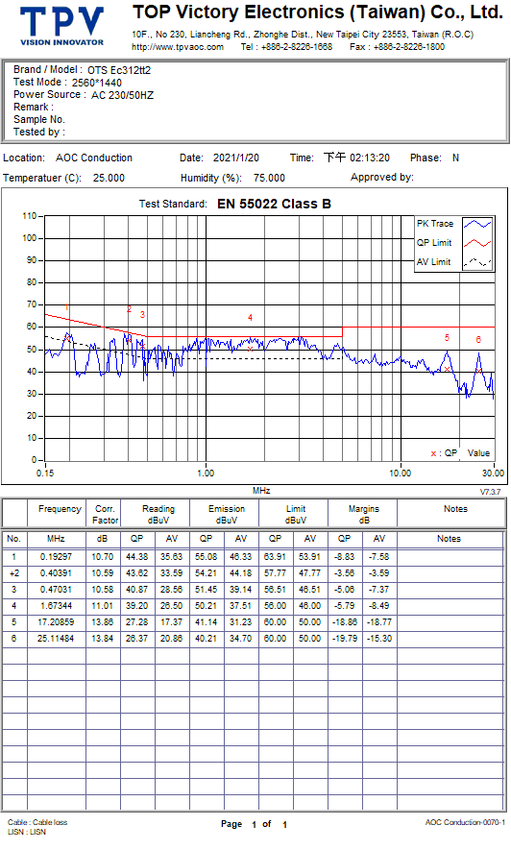
Conduction 110V
