Schematic of SN74LVC1G08DCKR, there is no pull up for both input and output.

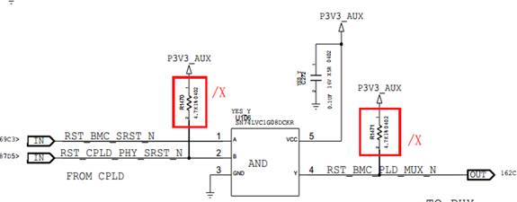

Power on wave of input and output, yellow one is input B, and blue one is input A, and the last is the Y output. Both inputs have one little pulse during power on.

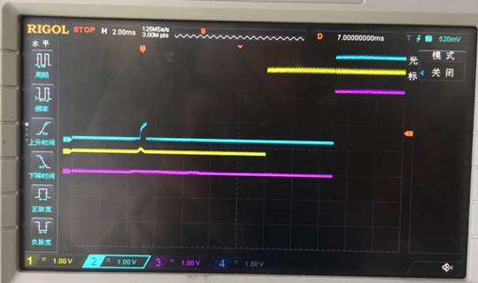

Power on of VCC and output with pull up. Yellow one is the output, and blue one is the VCC, and the output also has one little pulse with pull up during power on too.

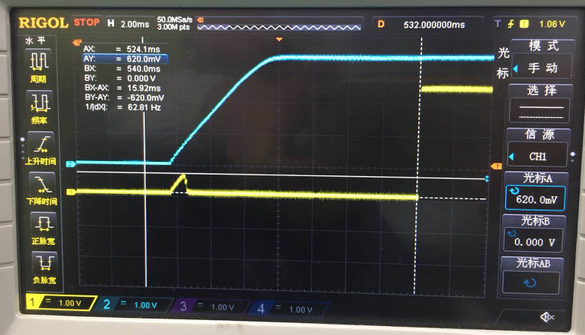

Input and output signal wave for output with pull up.

Yellow one is the input B, blue one is the input A, and the last is output Y.

