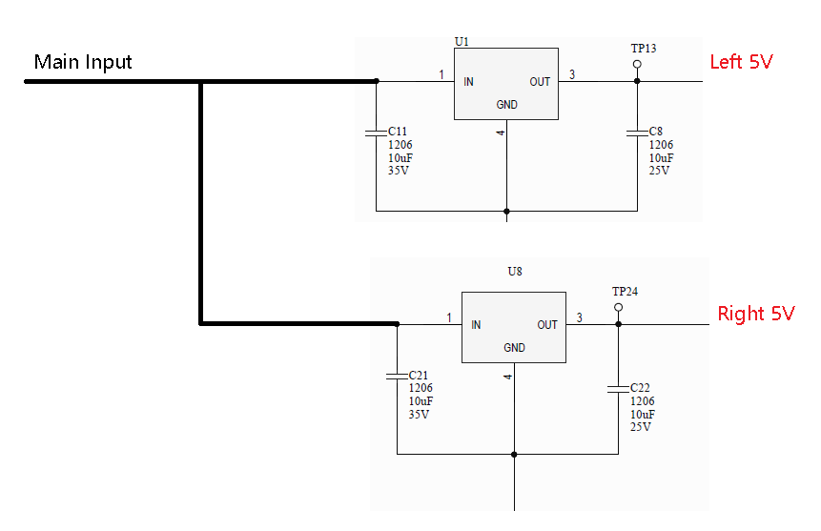
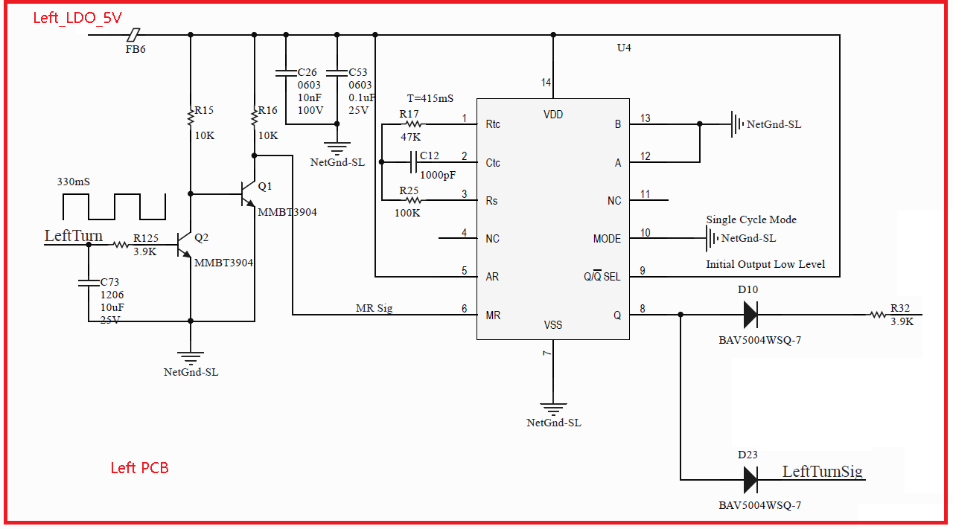
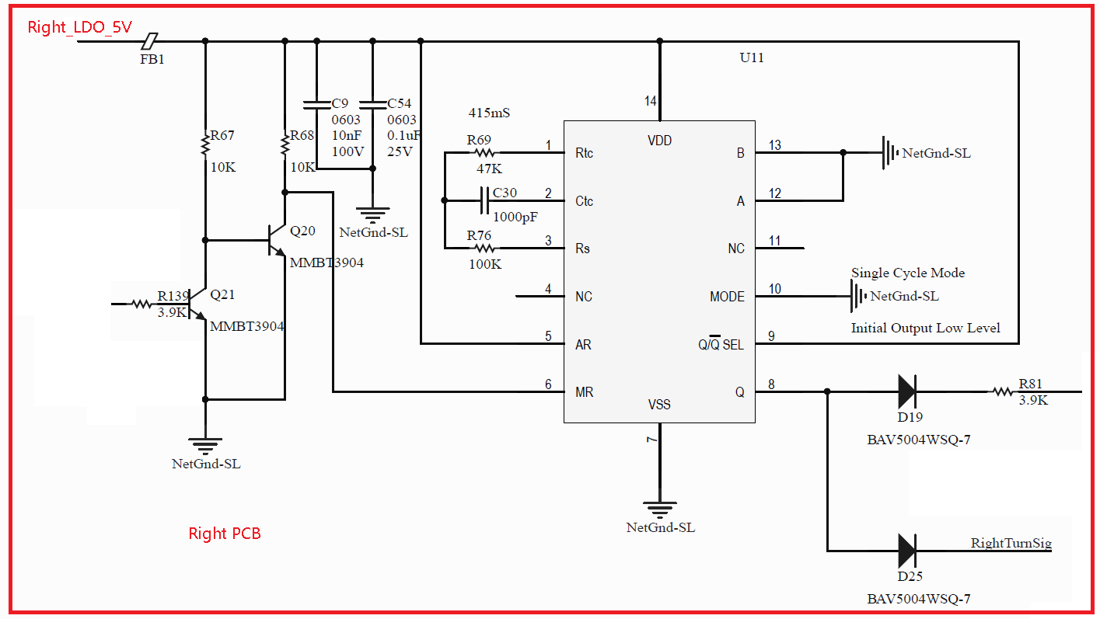

When supplying the power , sometimes the output of U4 and U11 is out of sync .What I design is to achieve time of 415mS after powering ON.
I have no idea how to let these 2 outputs keep pace .
These 2 outputs are to control LED circuit .When they couldn’t keep pace ,it is noticeable to find the LEDs out of sync .

Pls refer to below waveform .
Left_Output_Q is output of the left CD4541BM,
Right_Output_Q is output of the right CD4541BM.

The Rtc Ctc RS as below
Ctc : Capacitor, 0.01uF, 5%, 25V, C0G, 0603
Rtc: Resistor, 14.7K OHM, 1%, 1/10W, 0603
Rs : Resistor, 33K, 1/10W, 1%, 0603

