Hi,
For this design in the system:
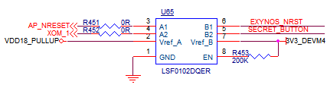
While connection only the 3.3V side (pin 7 and 8), we see 0.8V on pin 2.
Is this normal behavior or malfunction?

