SCH :
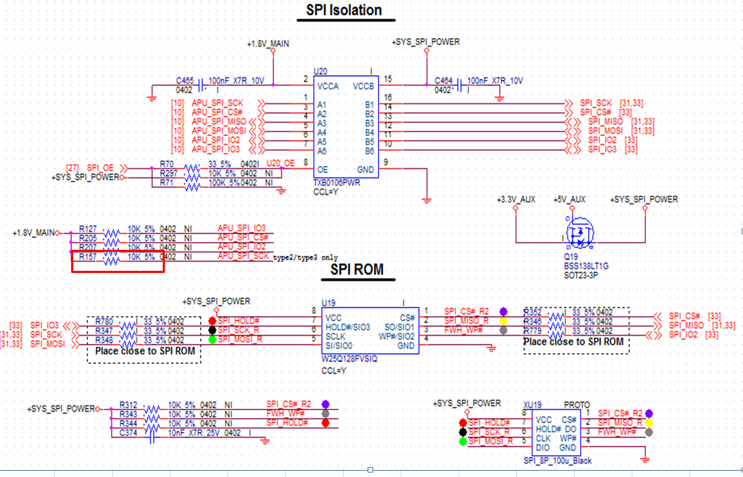
R157 10K / SPICLK 0.5V ( Yellow line)
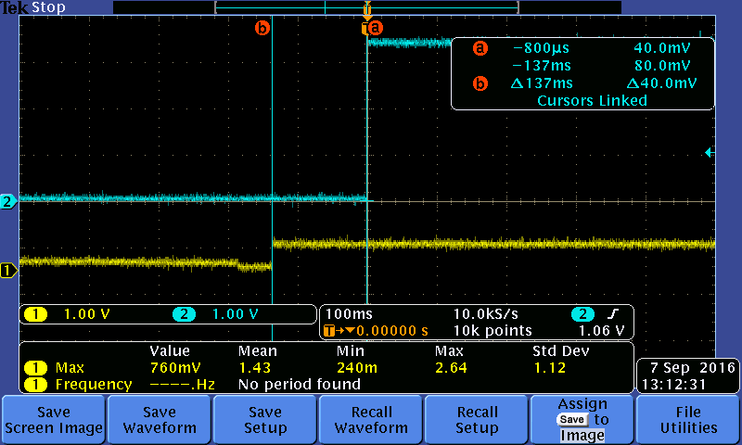
R157 3.3K / SPICLK 1.8V ( Bule line )
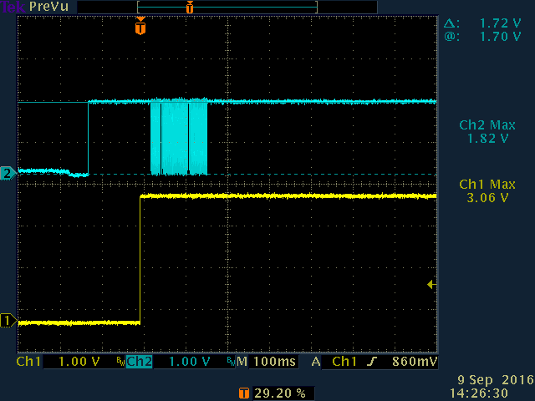

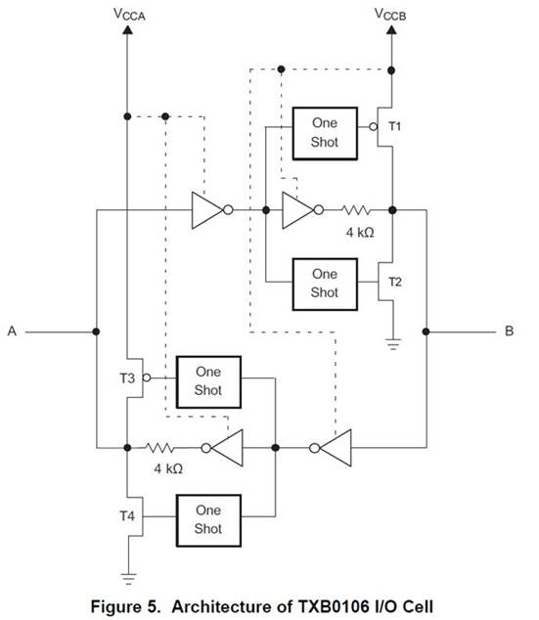
When initial, does the B side(net: SPI_SCK) is low to cause the 4K to GND? (and this is why we measured around 0.5V voltage which is divided 1.8v by 10K PU and 4K PD.)
When does the one shot block active? And when one shot block active, it will cause the A side voltage keep on VCCA(1.8V)?

