Details of board defects

(description)
There is a problem that unintended operation occurs when a specific operation is performed on the device. When the control board was checked, it was confirmed that the output Q changed in the IC (SN74HC74NS) regardless of / PRE: H, / CLR: H, and CLK: L.
Figure 1 shows the circuit, and Figures 2, 3 and 4 show the waveform of each terminal when the phenomenon occurs.
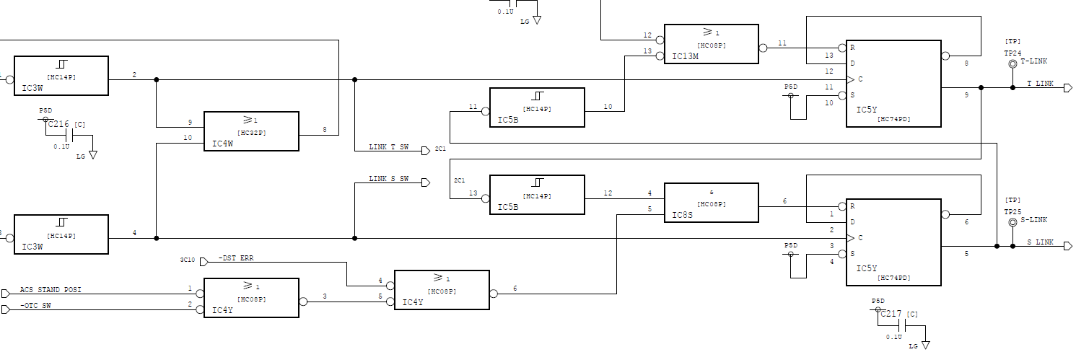
Figure 1. circuit

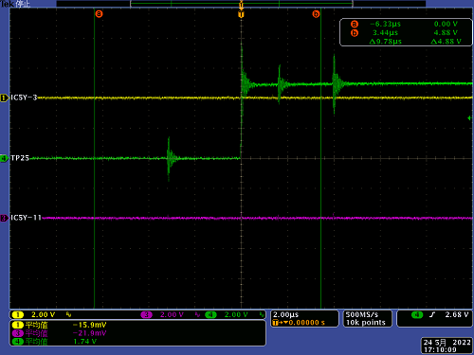
Figure 2. CLK signal when a problem occurs
(Green： 1Q, Yellow：1CLK, Red：2 CLK)

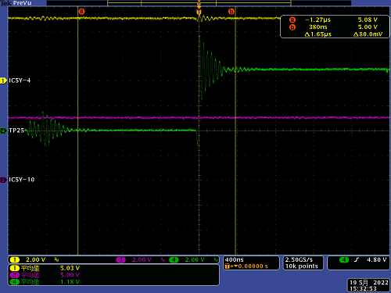
Figure 3. /PRE signal when a problem occurs
(Green： 1Q, Yellow：1/PRE, Red：2 /PRE)

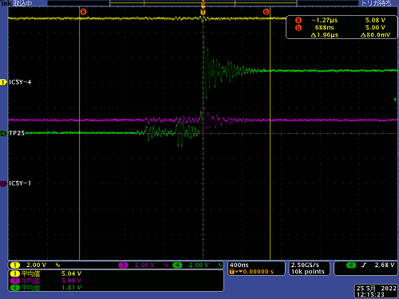
Figure 4. signal when a problem occurs
(Green： 1Q, Yellow：1/PRE, Red：1/CLR)

