Interfacing Circuit (sensor side):
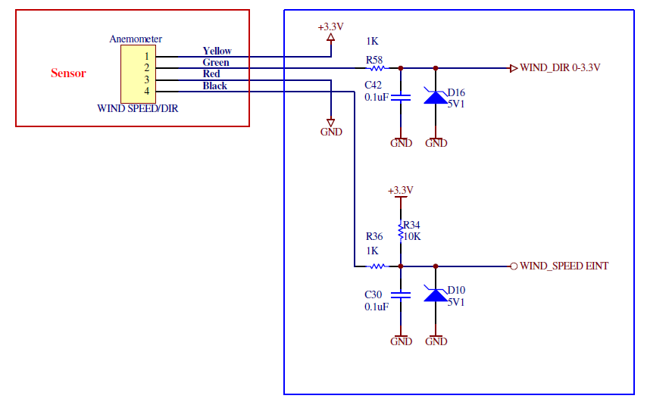

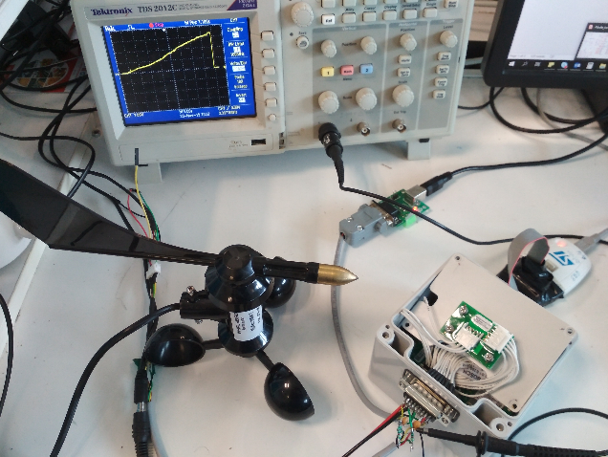
Sensor output waveform:
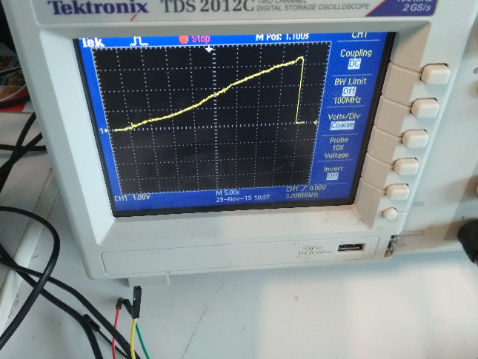
Fig: wind direction sensor output (WIND_DIR 0-3.3)
Sensor output: ADC

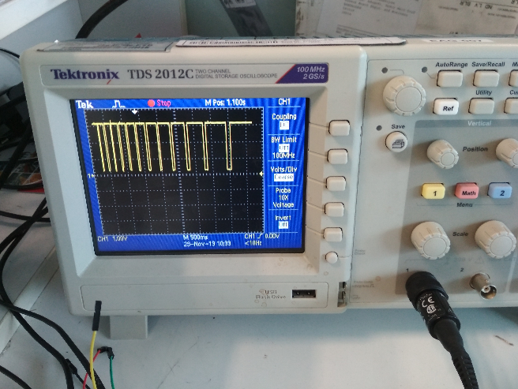
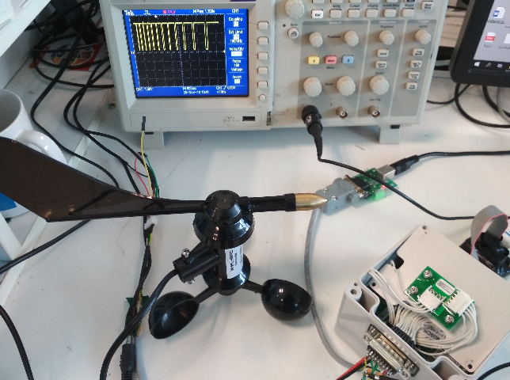
Fig: wind Speed sensor output (WIND_SPEED ENT)
Sensor output: Pulse out

Problem Statement:
In our platform board we are using 8-Bit Bi-directional Level-Shifter (TXS0102DCUR) and 2-Bit Bi-directional Level-Shifter (TXS0102DCUR),
TXS0102DCUR interface circuit:
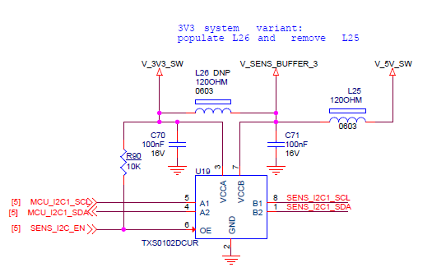

1. SENS_I2C_EN is controlled by using GPIO of controller.
2. Sensor output (WIND_SPEED ENT) is connected to B1 Terminal of
TXS0102DCUR i.e. SENS_I2C1_SDA.
3. A2 output of chip connected to controller Interrupt
PIN (MCU_I2C1_SDA).
4. Output: As expected.

TXS0108DCUR interface circuit:
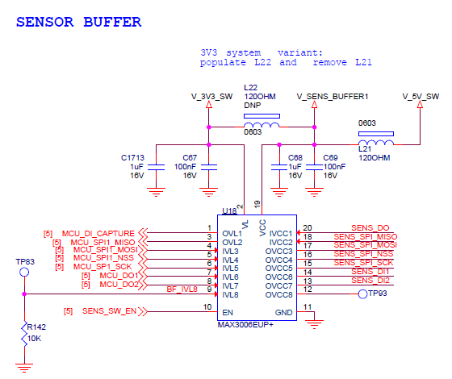

Note: MAX3006EUP replaced with TXS0108DCUR.
- SENS_SW_EN is controlled by using GPIO of controller.
- Sensor output (WIND_SPEED ENT) is connected to B1-B8 (tested on all pins) of TXS0108DCUR.
- Output of Chip A1 to A8(one pin) is connected to external interrupt Pin of controller.

- Output: Not expected.

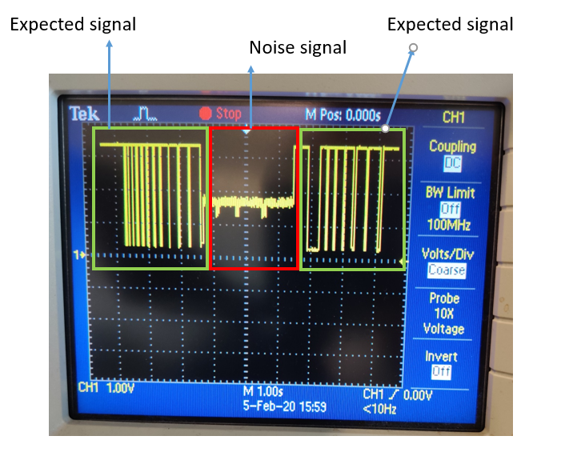

Expected Signal: TXS0108DCUR is OFF
Noise Signal: TXS0108DCUR is ON

When the TXS0108DCUR is enabled getting Noise on the signal Line. But same is not repeating in the TXS0102DCUR, as both are Bi-Directional buffer.

