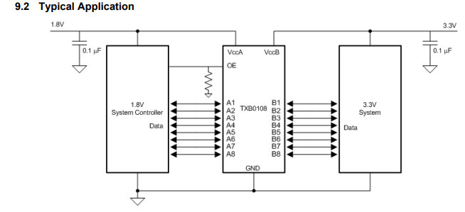
3 inches
Microcontroller
RGB INTERFACE
3.5’’LCD
We are using TXB0108DQSR level translator for level translation of RGB interface from 3V3 to 1V8.
The Operating frequency is 20MHz.
Port A is connected to LCD and Port B is connected to Controller. VCCA=1.8V and VCCB=3.3V
The trace lengths of RGB signals in Port A of TXB0108 will be around 3 inches.
Will this work correctly?

