It is good to remove the conversion chip, and the test result of the conversion chip is as follows:

The oscilloscope measures the I2C signal of HDMI OUT, the test point: U2008, the pin4 of U1301, and 5,8,1.

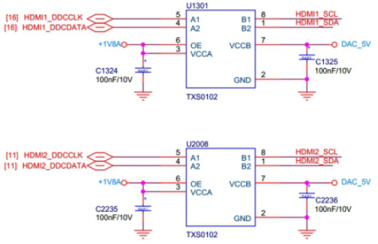

The following figure for V1.1The board is measured.U2008pin4(Page1-1) 和pin1(Page1-2)

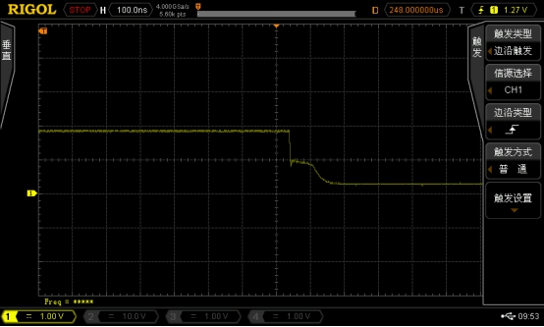

**Page 1-1  1.8V DATA Falling edge**

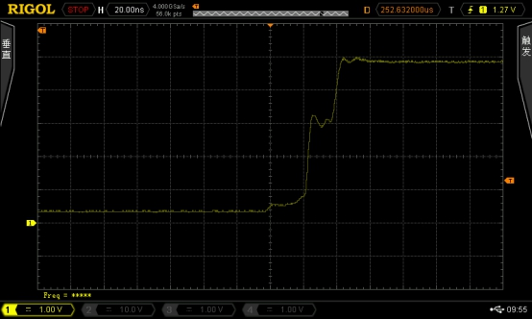

**Page 1-2  5V DATA Rising edge**