So this design customer seeking alternative part for.

So tying two if the B inputs directly to ground as shown below is not OK for the “H” part?

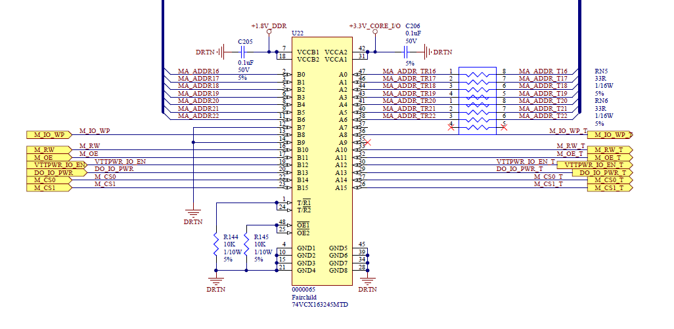

Customer looking for an available alternate for the OnSemi part above. The “H” parts shows as available.