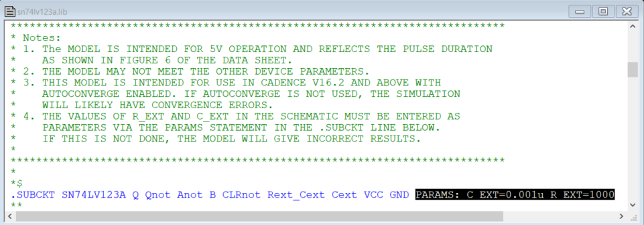

This is how the model gets instantiated into LTspice. The default values of the timing components are: C_ext = 0.001uF & R_ext = 1000 Ohms.

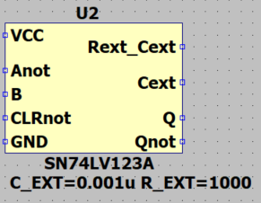

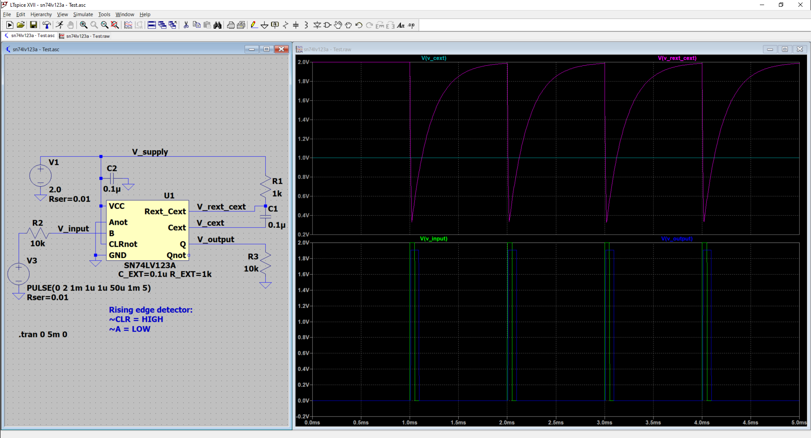

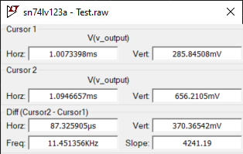
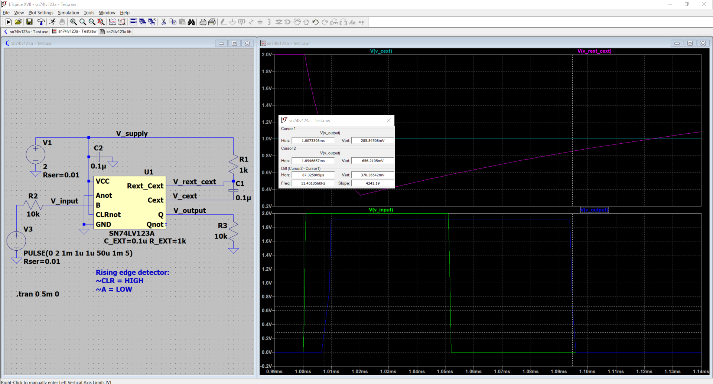

Cursors on the “V_output” signal show a pulse width of about 87.3us (2V supply).

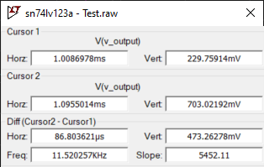
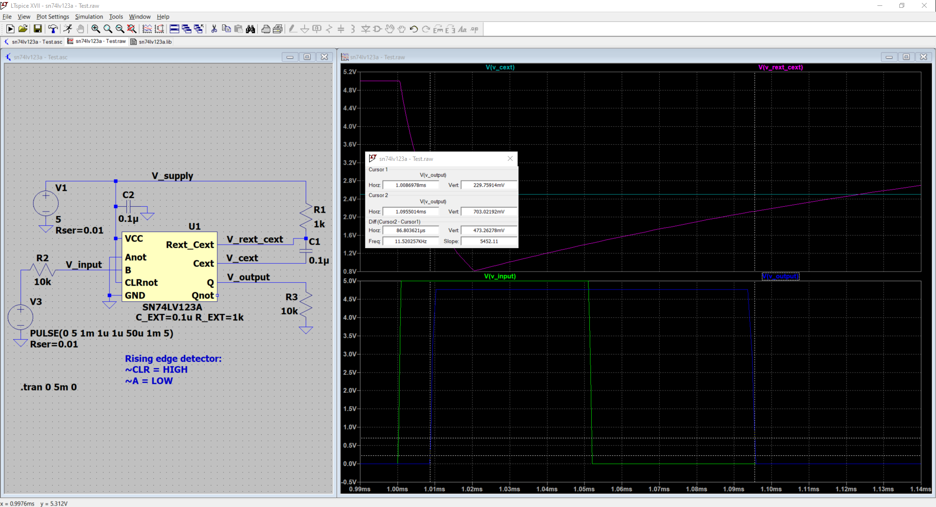

Cursors on the “V_output” signal show a pulse width of about 86.8us (5V supply).

