Working folder of LTspice:

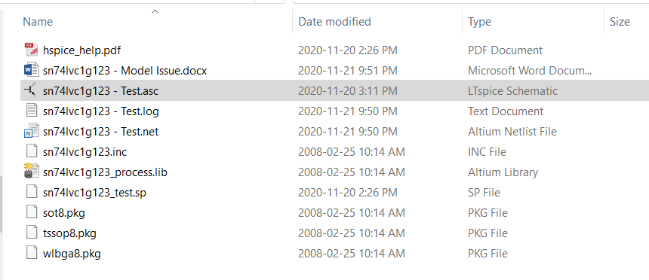

Error observed when running simulation of circuit on following page:

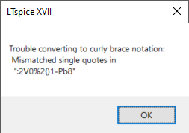

When creating the symbol, I have assumed that “PEx” maps on pin number “x”:

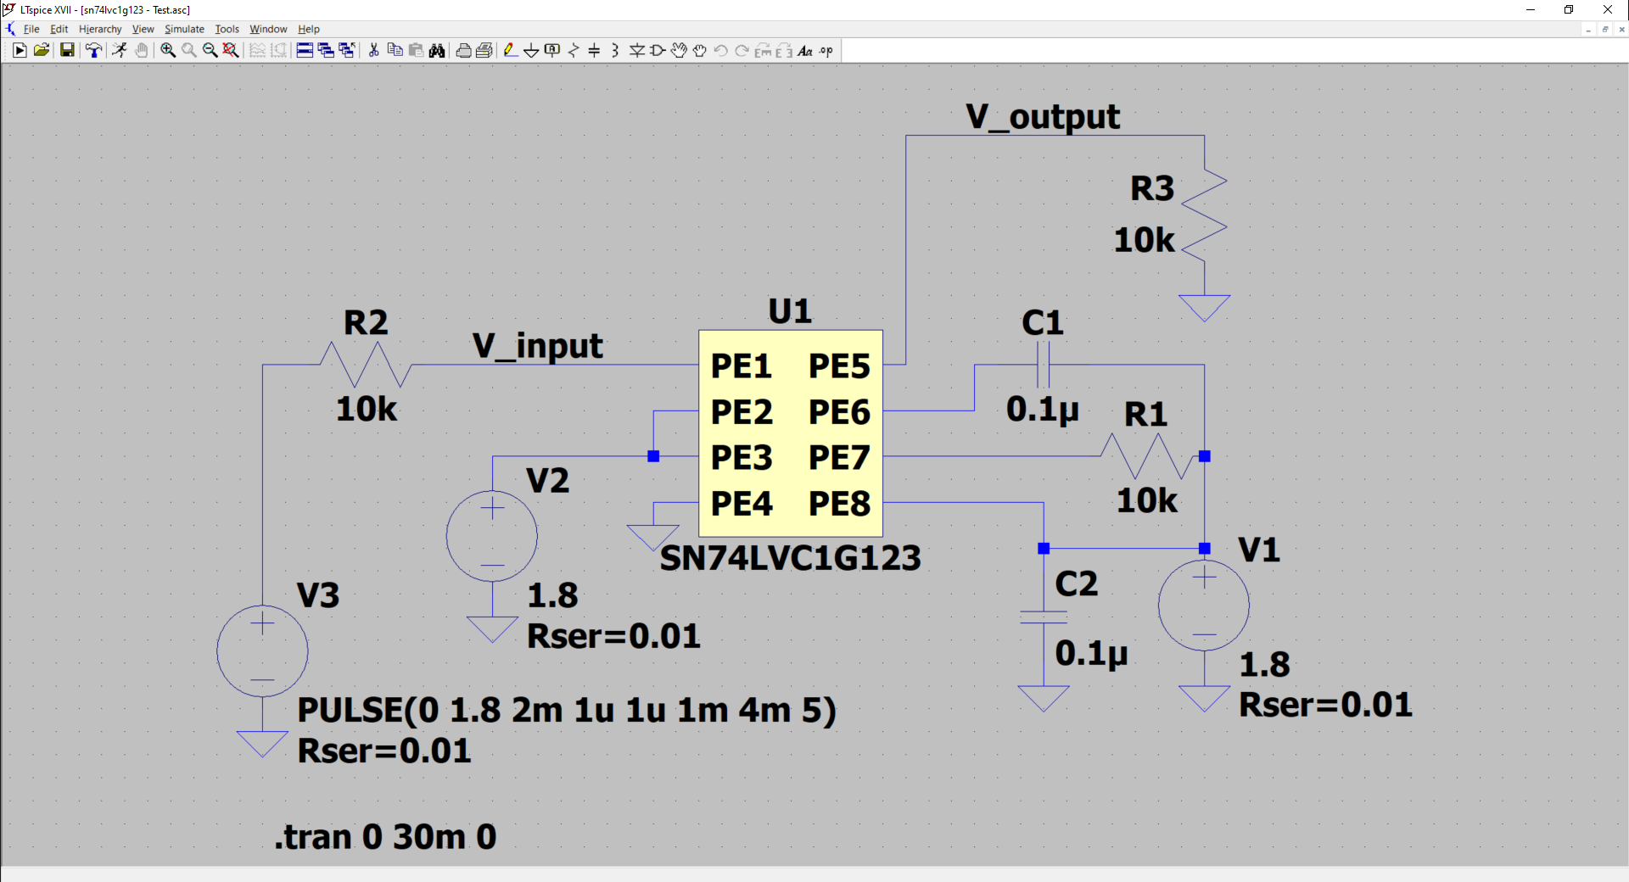

Above simulation does not run…

