Setting:
Span: 2MHZ, RBW: 1KHZ, data rate: 50kbps, 2FSK, 200 KHz bandwidth, IEEE802.15.4g protocol.
Currently result:
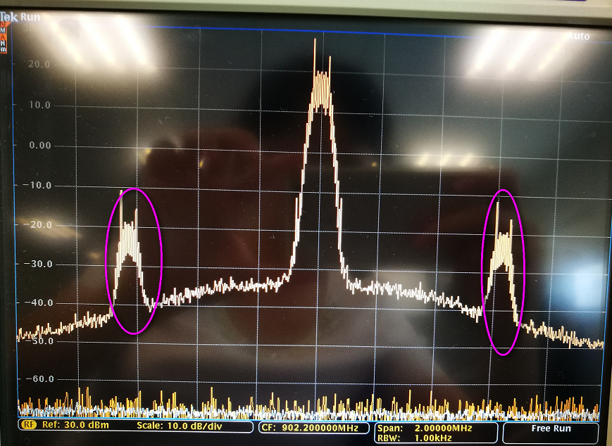

Previous result:
