Below I have shown how it looks like when writing a packet containing 8 bytes to the TXFIFO.
The radio is in SFSTXON state when I start writing to the TXFIFO:
The following 8 bytes are written to the TX FIFO: 0x07, 0x01, 0x02, 0x03, 0x04, 0x05, 0x06, 0x07
The data rate is 4.8 kbps, so it takes 13.33 ms from sending the STX strobe until the sync word is sent.
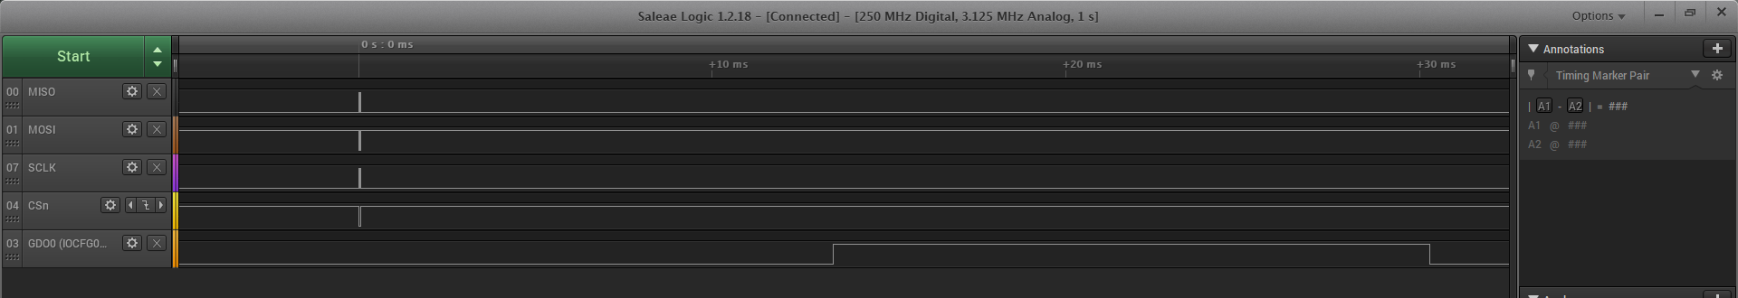
SYNC SENT PACKET SENT
Writing 8 bytes to TX FIFO and strobing STX
The next plot has zoomed in on the FIFO writing and the strobe command. Note that the radio is in SFSTXON when issuing the STX command.
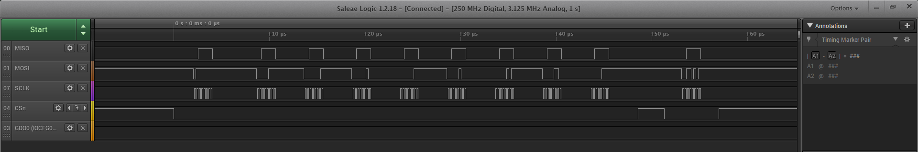
In the next plot I added reading of the TXBYTES register after writing to the FIFO and after strobing STX
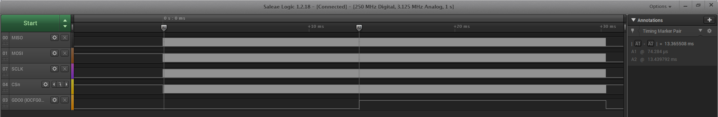
After writing to the TX FIFO, TXBYTES shows that there are 8 bytes in the FIFO. The radio is in SFSTXON state when sending the STX strobe, and when reading the TXBYTES register again, the radio is in TX state and there are 6 bytes in the FIFO (At this pont the radio is transmitting preamble and sync, so the two bytes that has “left” the FIFO has not started to be transmitted yet, the are simply moved to another buffer
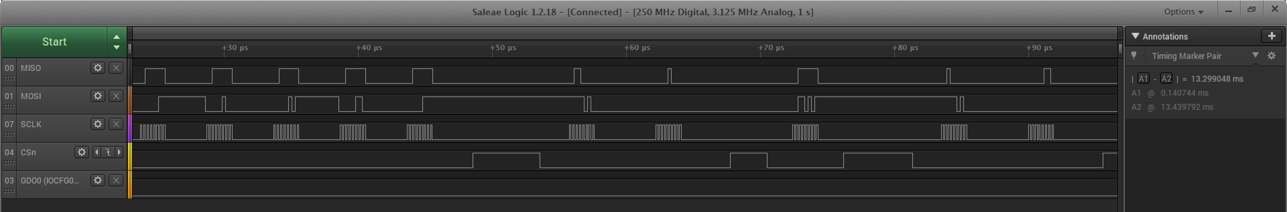
TXBYTES = 6
STX Strobe

TXBYTES = 8

The TXBYTES register will continue to show 6 bytes until the GDO0 signal indicates that sync has been sent. After this it shows that there are 5 bytes left in the FIFO:
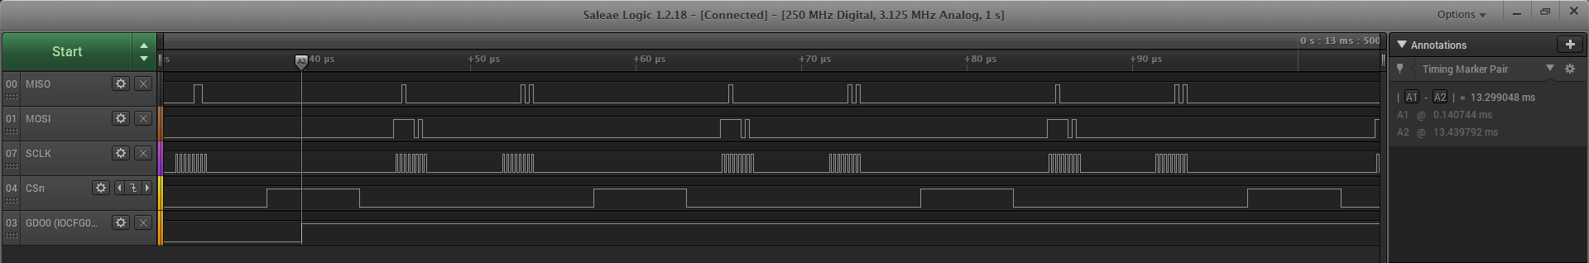
TXBYTES = 5
Right before the GDO0 is de-asserted (packet sent), the radio is still in TX State but there are 0 byte in the TX FIFO. The FIFO has been empty for a while, because the radio is transmitting CRC after the packet. If I had checked status after the GDO0 signal became 0, the radio would be in IDLE state
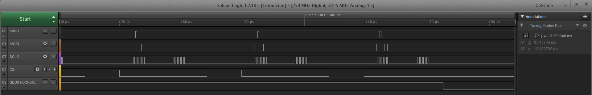
TXBYTES = 0

