1、Demo board test with 40MHz xtal
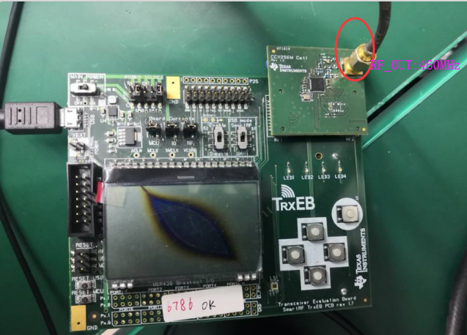
460MHz SET PWR：15dBm

2、The demo board test result of CC1125 output
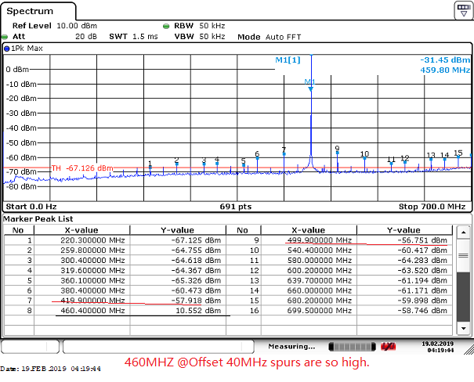
470MHz SET 15dBm

The demo board with a 32 MHz Xtal, as the result showed (the spectrum Maxhold), some unwanted spurs found near the main signal 460Mhz. The Interval frequency is about 40MHz or 20MHz. Is your measurement test the same as mine?

