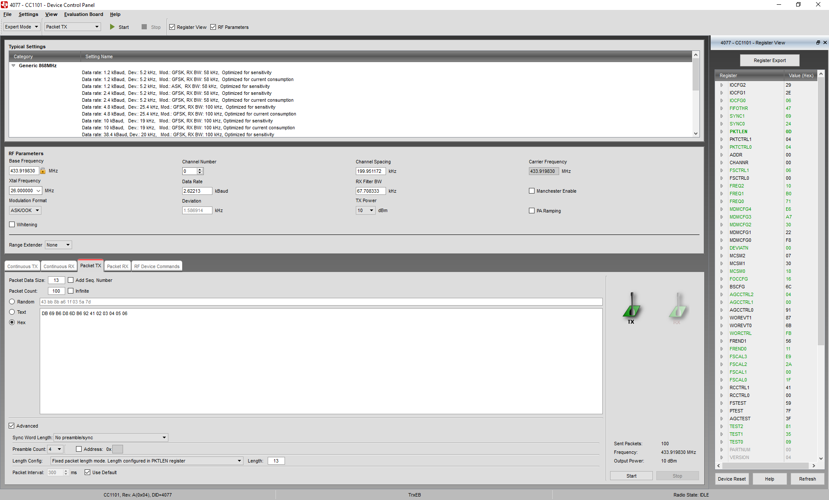

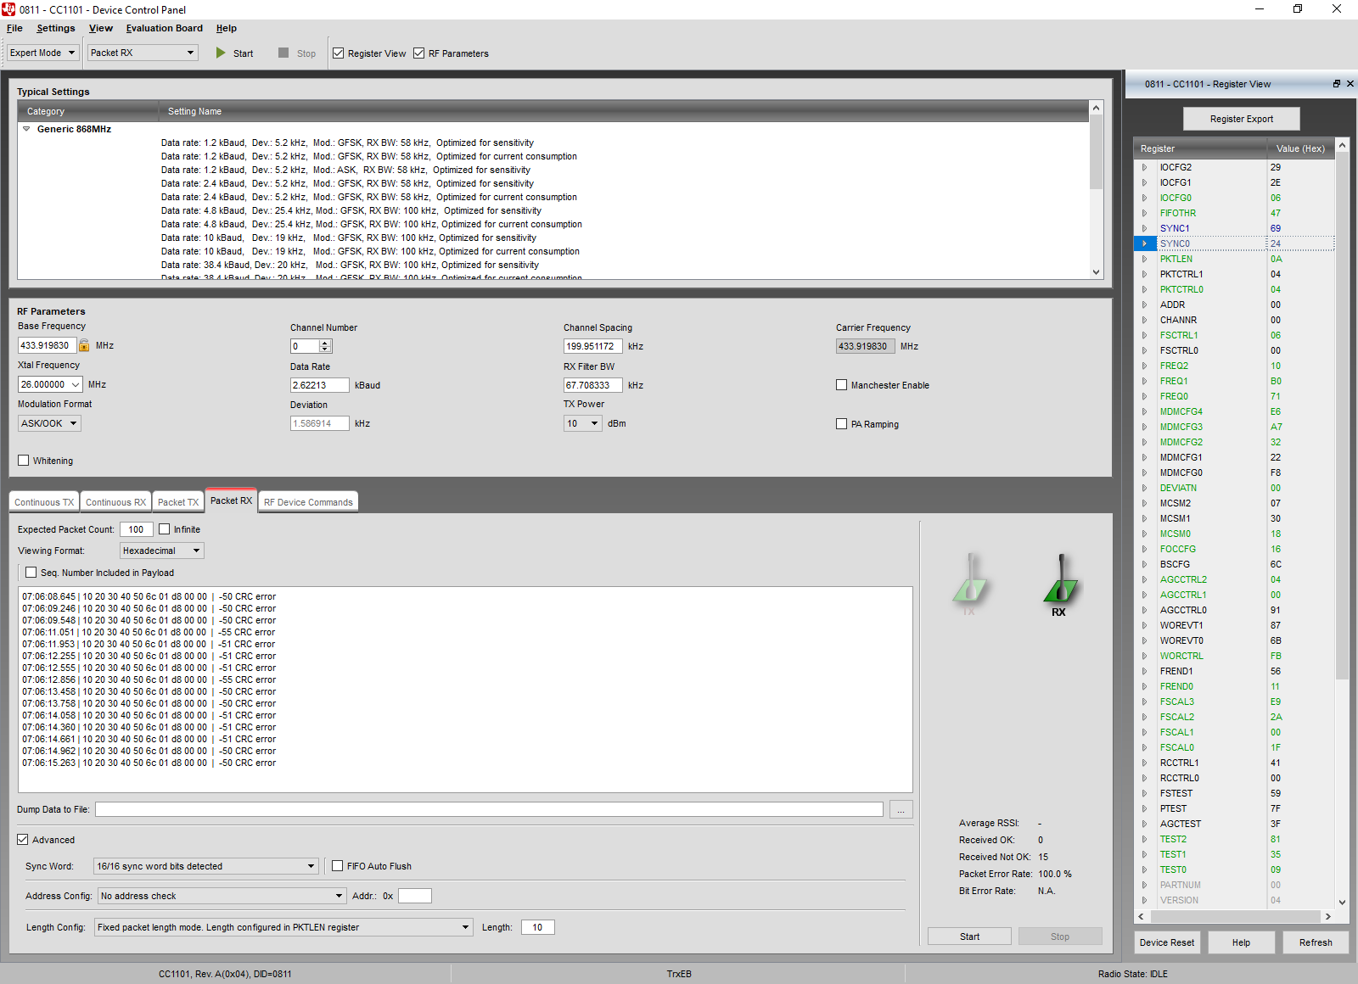

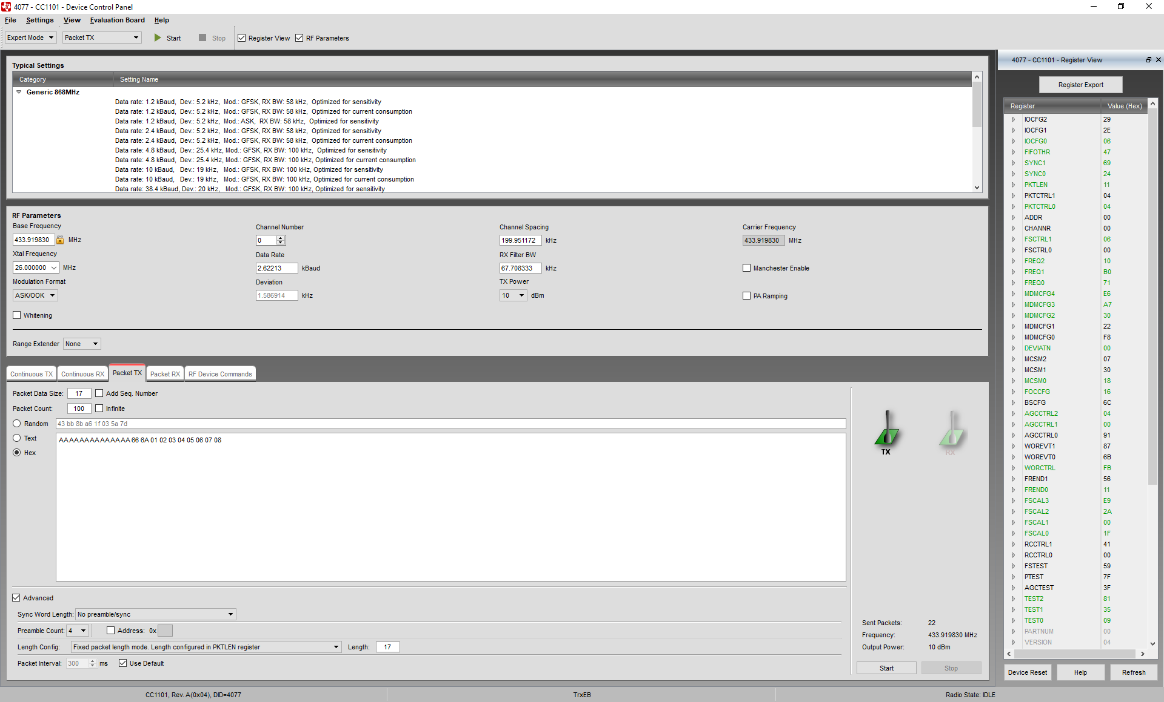

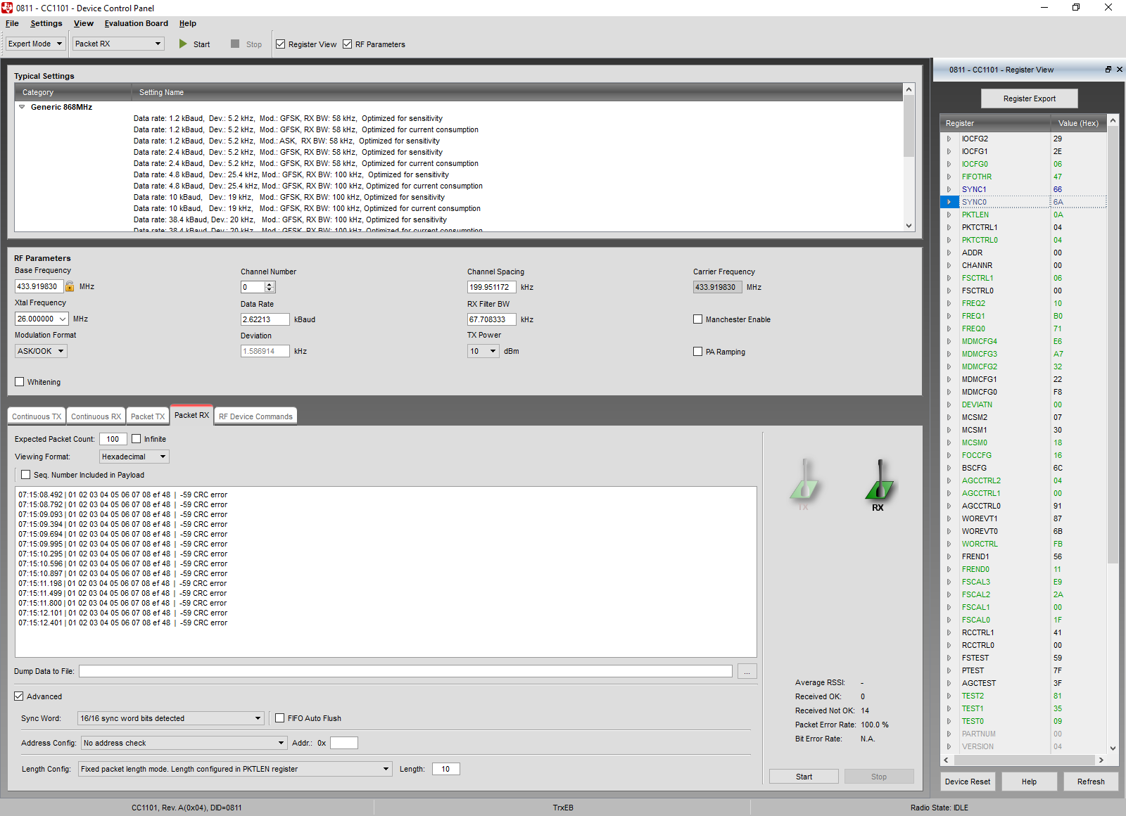

**RX**

// Address Config = No address check

// Base Frequency = 433.919830

// CRC Autoflush = false

// CRC Enable = true

// Carrier Frequency = 433.919830

// Channel Number = 0

// Channel Spacing = 199.951172

// Data Format = Normal mode

// Data Rate = 2.62213

// Deviation = 1.586914

// Device Address = 0

// Manchester Enable = false

// Modulation Format = ASK/OOK

// PA Ramping = false

// Packet Length = 10

// Packet Length Mode = Fixed packet length mode. Length configured in PKTLEN register

// Preamble Count = 4

// RX Filter BW = 67.708333

// Sync Word Qualifier Mode = 16/16 sync word bits detected

// TX Power = 10

// Whitening = false

// Rf settings for CC1101

RF_SETTINGS code rfSettings = {

0x29, // IOCFG2 GDO2 Output Pin Configuration

0x2E, // IOCFG1 GDO1 Output Pin Configuration

0x06, // IOCFG0 GDO0 Output Pin Configuration

0x47, // FIFOTHR RX FIFO and TX FIFO Thresholds

0x66, // SYNC1 Sync Word, High Byte

0x6A, // SYNC0 Sync Word, Low Byte

0x0A, // PKTLEN Packet Length

0x04, // PKTCTRL1 Packet Automation Control

0x04, // PKTCTRL0 Packet Automation Control

0x00, // ADDR Device Address

0x00, // CHANNR Channel Number

0x06, // FSCTRL1 Frequency Synthesizer Control

0x00, // FSCTRL0 Frequency Synthesizer Control

0x10, // FREQ2 Frequency Control Word, High Byte

0xB0, // FREQ1 Frequency Control Word, Middle Byte

0x71, // FREQ0 Frequency Control Word, Low Byte

0xE6, // MDMCFG4 Modem Configuration

0xA7, // MDMCFG3 Modem Configuration

0x32, // MDMCFG2 Modem Configuration

0x22, // MDMCFG1 Modem Configuration

0xF8, // MDMCFG0 Modem Configuration

0x00, // DEVIATN Modem Deviation Setting

0x07, // MCSM2 Main Radio Control State Machine Configuration

0x30, // MCSM1 Main Radio Control State Machine Configuration

0x18, // MCSM0 Main Radio Control State Machine Configuration

0x16, // FOCCFG Frequency Offset Compensation Configuration

0x6C, // BSCFG Bit Synchronization Configuration

0x04, // AGCCTRL2 AGC Control

0x00, // AGCCTRL1 AGC Control

0x91, // AGCCTRL0 AGC Control

0x87, // WOREVT1 High Byte Event0 Timeout

0x6B, // WOREVT0 Low Byte Event0 Timeout

0xFB, // WORCTRL Wake On Radio Control

0x56, // FREND1 Front End RX Configuration

0x11, // FREND0 Front End TX Configuration

0xE9, // FSCAL3 Frequency Synthesizer Calibration

0x2A, // FSCAL2 Frequency Synthesizer Calibration

0x00, // FSCAL1 Frequency Synthesizer Calibration

0x1F, // FSCAL0 Frequency Synthesizer Calibration

0x41, // RCCTRL1 RC Oscillator Configuration

0x00, // RCCTRL0 RC Oscillator Configuration

0x59, // FSTEST Frequency Synthesizer Calibration Control

0x7F, // PTEST Production Test

0x3F, // AGCTEST AGC Test

0x81, // TEST2 Various Test Settings

0x35, // TEST1 Various Test Settings

0x09, // TEST0 Various Test Settings

0x00, // PARTNUM Chip ID

0x04, // VERSION Chip ID

0x00, // FREQEST Frequency Offset Estimate from Demodulator

0x7F, // LQI Demodulator Estimate for Link Quality

0x80, // RSSI Received Signal Strength Indication

0x01, // MARCSTATE Main Radio Control State Machine State

0x00, // WORTIME1 High Byte of WOR Time

0x00, // WORTIME0 Low Byte of WOR Time

0x00, // PKTSTATUS Current GDOx Status and Packet Status

0x94, // VCO_VC_DAC Current Setting from PLL Calibration Module

0x00, // TXBYTES Underflow and Number of Bytes

0x00, // RXBYTES Overflow and Number of Bytes

0x00, // RCCTRL1_STATUS Last RC Oscillator Calibration Result

0x00, // RCCTRL0_STATUS Last RC Oscillator Calibration Result

};

**TX**

// Address Config = No address check

// Base Frequency = 433.919830

// CRC Autoflush = false

// CRC Enable = true

// Carrier Frequency = 433.919830

// Channel Number = 0

// Channel Spacing = 199.951172

// Data Format = Normal mode

// Data Rate = 2.62213

// Deviation = 1.586914

// Device Address = 0

// Manchester Enable = false

// Modulation Format = ASK/OOK

// PA Ramping = false

// Packet Length = 18

// Packet Length Mode = Fixed packet length mode. Length configured in PKTLEN register

// Preamble Count = 4

// RX Filter BW = 67.708333

// Sync Word Qualifier Mode = No preamble/sync

// TX Power = 10

// Whitening = false

// Rf settings for CC1101

RF_SETTINGS code rfSettings = {

0x29, // IOCFG2 GDO2 Output Pin Configuration

0x2E, // IOCFG1 GDO1 Output Pin Configuration

0x06, // IOCFG0 GDO0 Output Pin Configuration

0x47, // FIFOTHR RX FIFO and TX FIFO Thresholds

0x69, // SYNC1 Sync Word, High Byte

0x24, // SYNC0 Sync Word, Low Byte

0x12, // PKTLEN Packet Length

0x04, // PKTCTRL1 Packet Automation Control

0x04, // PKTCTRL0 Packet Automation Control

0x00, // ADDR Device Address

0x00, // CHANNR Channel Number

0x06, // FSCTRL1 Frequency Synthesizer Control

0x00, // FSCTRL0 Frequency Synthesizer Control

0x10, // FREQ2 Frequency Control Word, High Byte

0xB0, // FREQ1 Frequency Control Word, Middle Byte

0x71, // FREQ0 Frequency Control Word, Low Byte

0xE6, // MDMCFG4 Modem Configuration

0xA7, // MDMCFG3 Modem Configuration

0x30, // MDMCFG2 Modem Configuration

0x22, // MDMCFG1 Modem Configuration

0xF8, // MDMCFG0 Modem Configuration

0x00, // DEVIATN Modem Deviation Setting

0x07, // MCSM2 Main Radio Control State Machine Configuration

0x30, // MCSM1 Main Radio Control State Machine Configuration

0x18, // MCSM0 Main Radio Control State Machine Configuration

0x16, // FOCCFG Frequency Offset Compensation Configuration

0x6C, // BSCFG Bit Synchronization Configuration

0x04, // AGCCTRL2 AGC Control

0x00, // AGCCTRL1 AGC Control

0x91, // AGCCTRL0 AGC Control

0x87, // WOREVT1 High Byte Event0 Timeout

0x6B, // WOREVT0 Low Byte Event0 Timeout

0xFB, // WORCTRL Wake On Radio Control

0x56, // FREND1 Front End RX Configuration

0x11, // FREND0 Front End TX Configuration

0xE9, // FSCAL3 Frequency Synthesizer Calibration

0x2A, // FSCAL2 Frequency Synthesizer Calibration

0x00, // FSCAL1 Frequency Synthesizer Calibration

0x1F, // FSCAL0 Frequency Synthesizer Calibration

0x41, // RCCTRL1 RC Oscillator Configuration

0x00, // RCCTRL0 RC Oscillator Configuration

0x59, // FSTEST Frequency Synthesizer Calibration Control

0x7F, // PTEST Production Test

0x3F, // AGCTEST AGC Test

0x81, // TEST2 Various Test Settings

0x35, // TEST1 Various Test Settings

0x09, // TEST0 Various Test Settings

0x00, // PARTNUM Chip ID

0x04, // VERSION Chip ID

0x00, // FREQEST Frequency Offset Estimate from Demodulator

0x7F, // LQI Demodulator Estimate for Link Quality

0x80, // RSSI Received Signal Strength Indication

0x01, // MARCSTATE Main Radio Control State Machine State

0x00, // WORTIME1 High Byte of WOR Time

0x00, // WORTIME0 Low Byte of WOR Time

0x00, // PKTSTATUS Current GDOx Status and Packet Status

0x94, // VCO_VC_DAC Current Setting from PLL Calibration Module

0x00, // TXBYTES Underflow and Number of Bytes

0x00, // RXBYTES Overflow and Number of Bytes

0x00, // RCCTRL1_STATUS Last RC Oscillator Calibration Result

0x00, // RCCTRL0_STATUS Last RC Oscillator Calibration Result

};