TI routine：EasyLink Network Processor example Task5
The emitting board experiment is OK, please see the following screenshot 1. The ATPPP value of the receiving board has been set to 100, but 100 data have not been received? I don't know where the problem is.Then, the receiving board is set to transmit, and the transmitting board is set to receive. The experimental result is the same as screenshot 2.

Screenshot1
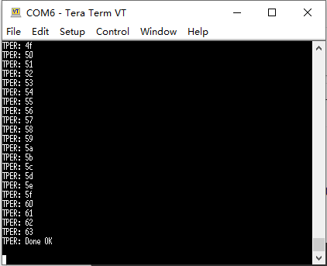

Screenshot2
