1. Import OAD server,client,and BIM demo project to CCS

C:\Users\35323\AppData\Local\Temp\enhtmlclip\Image.png C:\Users\35323\AppData\Local\Temp\enhtmlclip\Image(1).png C:\Users\35323\AppData\Local\Packages\Microsoft.Office.Desktop_8wekyb3d8bbwe\AC\INetCache\Content.MSO\944EC895.tmp

2、Build bim and Client project,and generate the hex file。

The bim project can generate HEX files directly.

The Client project need config CCS to generate HEX.

There must comment out the code of CCFG.C, Otherwise it will report an error“Data overlapped at address 0x1FFA8” When merge HEX file.

Is this correct?

3、Modify the name of the two generated HEX files and place them in the same folder as the Python plugin. 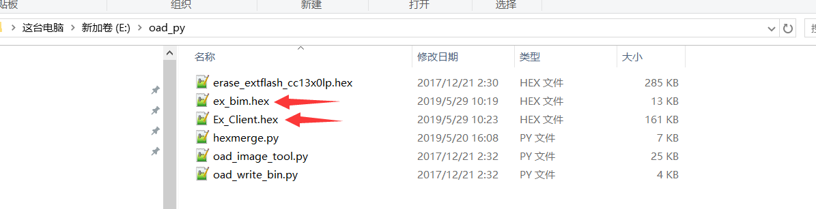

4、Combine two HEXs using the hexmerge plugin

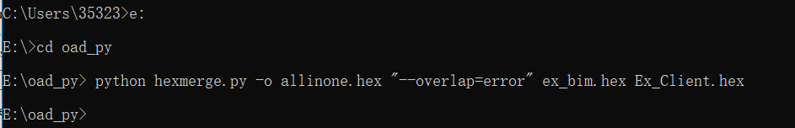

Generate the file as follows

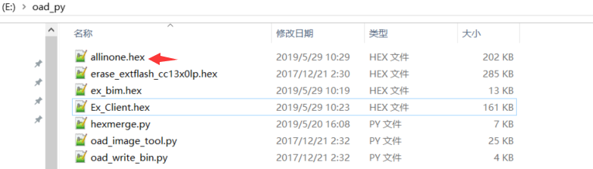

5、Use the oad\_image\_tool plugin to convert HEX to BIN

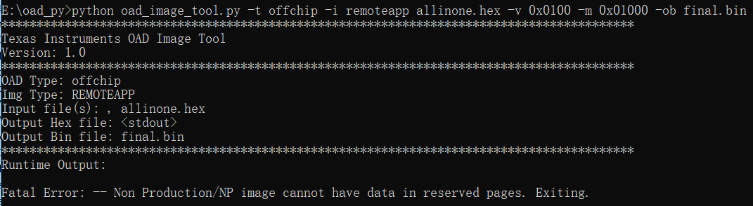

Produced the above picture error.

Modify the parameters of IMG TYPE to production to successfully generate BIN files. Is there any problem with this operation? Is there a problem with choosing to use production?

6、The generated BIN file is downloaded to the hardware through the programmer, the hardware cannot be started, and the hardware cannot be started by resetting or re-powering.

After many attempts, it was found that after opening the CCS and only running the BIM project separately, the hardware can be started normally and can jump to the Client program normally. After the simulation, reset and power-on can jump to the Client program normally.

7、Slightly modify the client source code and recompile. Convert the generated HEX file to a BIN file，and use the following command

python oad\_image\_tool.py -t offchip -i remoteapp New\_Client.hex -v 0x0102 -m 0x01000 -ob v8888.bin

This step can generate BIN files normally.

8、Load the BIN file into the OAD server via the oad\_write\_bin.py plugin.

python oad\_write\_bin.py COM19 v8888.bin

There is no problem with this step.

9、The OAD server performs an over-the-air upgrade of the node(Client), and the data can be transmitted over the air. Finally, both the server and the node display OAD: completed successfully.

However, the node does not switch to the new program, the node program does not start, and it is in a crash state.

After resetting or re-powering, the old program is still running!

Additional information：

CCS ver：7.3.0.00019

SDK ver：1.60.00.21

PYTHON ver：2.7.10

Since all of our company's projects are developed on the 1.60 SDK version, and the routines provided by your company are based on the 1.60 version, it is not necessary to upgrade the SDK version. Please be sure to complete the functions provided by the routines on this version of the technology. thank you very much.