Ti ENP routine smartrf studio ----- Tera term problem

Routine by Ti: easylink network processor example From task 1 to task 3 are OK（ Two cc1350launchpads have been connected: one is connected to the terminal emulator and the other is connected to smartrf studio 7)

After item 6 in task 4, the equipment exits offline, Reconnect smartrf studio 7 and execute the start button in Item 7 to send data, but the terminal emulator cannot receive any information. I don't know why? See screenshot 1 below. Conversely, if the transmit and receive settings are interchanged, smartrf studio will not receive any information? See screenshot 2 below. Screenshot 3 shows that after check the Device Manager, Com port is connected.

Screenshot1
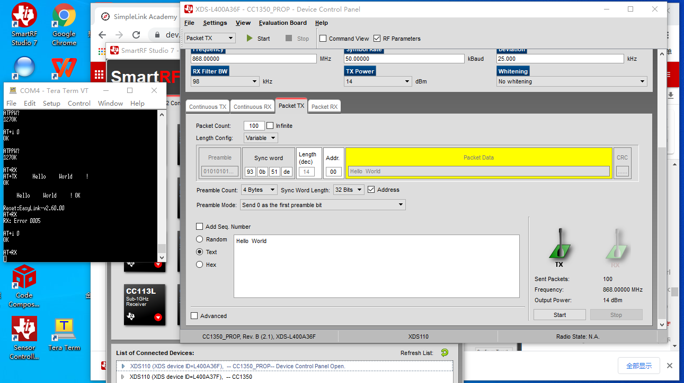
Screenshot2
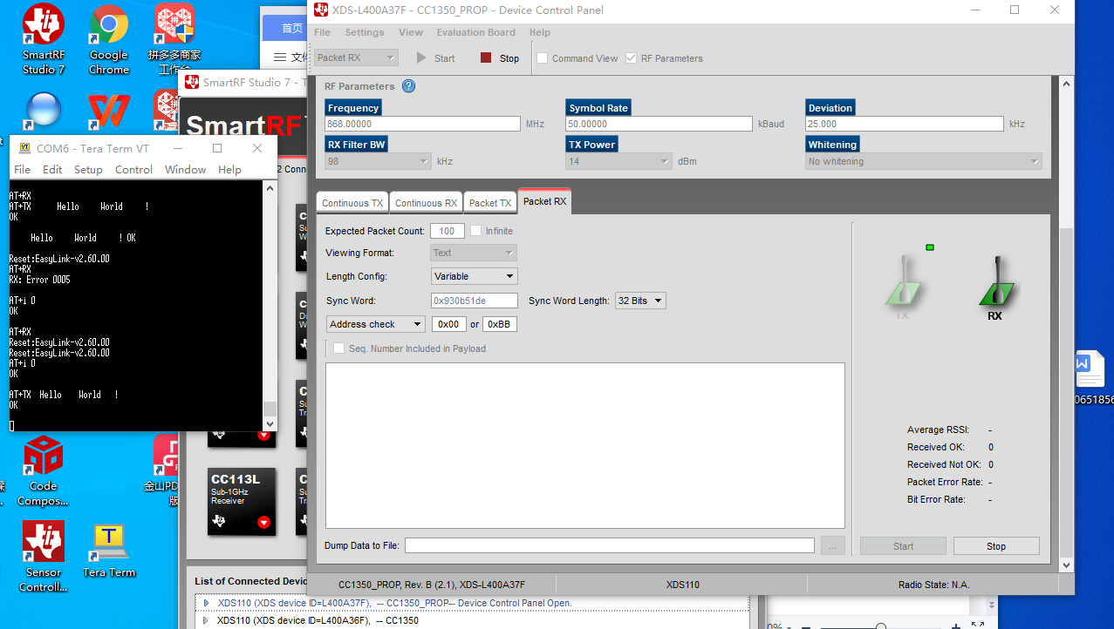
Screenshot 3
