Issue description:

Customer reported an issue that while powered on the CC2538, the current consumption will be increased slowly and then dropped fast to a very low stable current consumption. And this situation also existed while erased full FLASH image at powered on.

Also tried below steps:

1. Connect the RESET_N pin to GND, powered on CC2538, the issue still exist;
2. Using test code, after powered on, using Watchdog to trigger software reset, the issue didn’t exist after software reset;
3. Remove CC2538 from PCB board, test the current consumption of the board, no such issue;
4. Re-work the CC2538 into the board, the issue still exist at power on stage.

Support Need:

This issue seems only exist at the power on stage, could you kindly help to give comments for the power on current consumption issue?

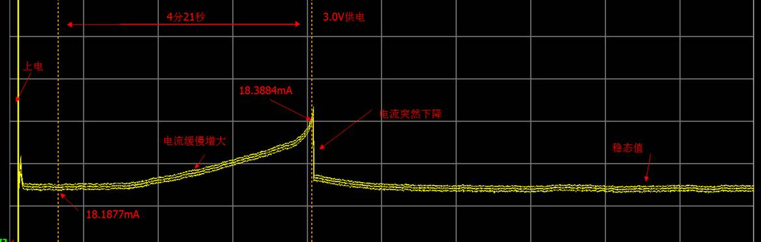

Power on

Current Increased

3.0V Power Supply

Stable

Current consumption Drop

4’21’’