Changes made to receive AF_INCOMING_MSG in hyper terminal in original z-stack code.

**Note:-**My project file name is Beeper. So replace with corresponding project file name.

1. Revised marked lines in zcl_Beeper.c file

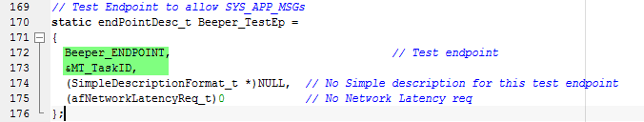

1. Added marked lines in AF.c file

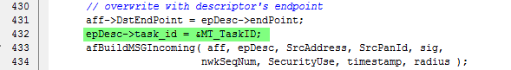

1. Added marked lines in ZCL.c

