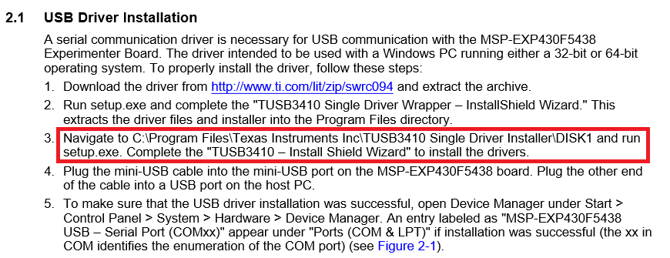

After this step 2, I could find this below and my exact problem occurs in step 3 for setup.exe file
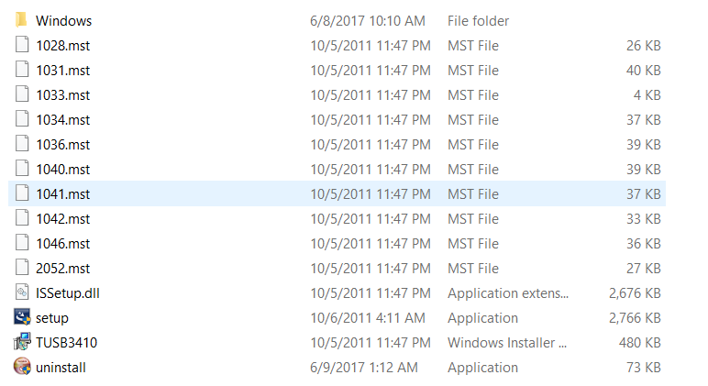
When I tried to install the TUSB3410, it showed error like this
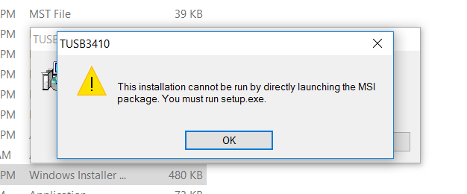

So I went to WINDOWS folder to check if there any setup.exe file,
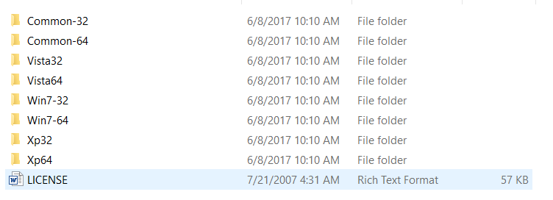
I clicked COMMON 64
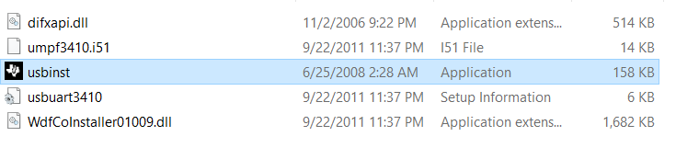
After clicking this , I could find no changes

