In order to communicate/test the BSL I am using the MSP-TS430RGC64C evaluation board and the MSPF5255 microcontroller.
In the picture below the Red Jumper Wire is connected to the BSLEN Pin (55) and the Purple Jumper wire is connected to the RST/NMI (56)
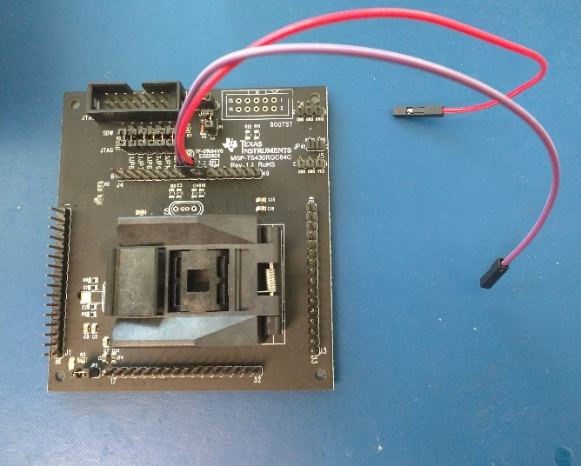
Other equipment:
FTDI Cable: I am using the FDTI USB to 1.8V TTL Cable for data communication and to provide the 1.8V required.
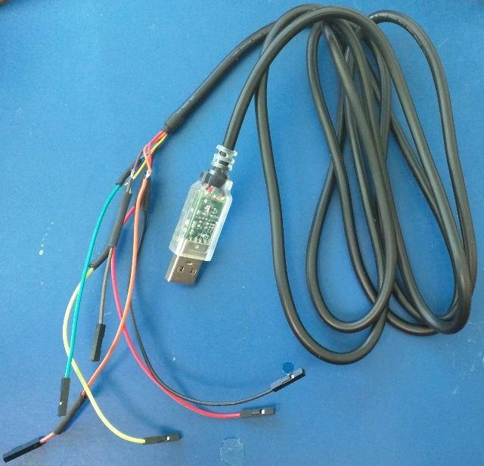

JTAG Is used to provide the 3.3V. Here is the complete assembled setup:
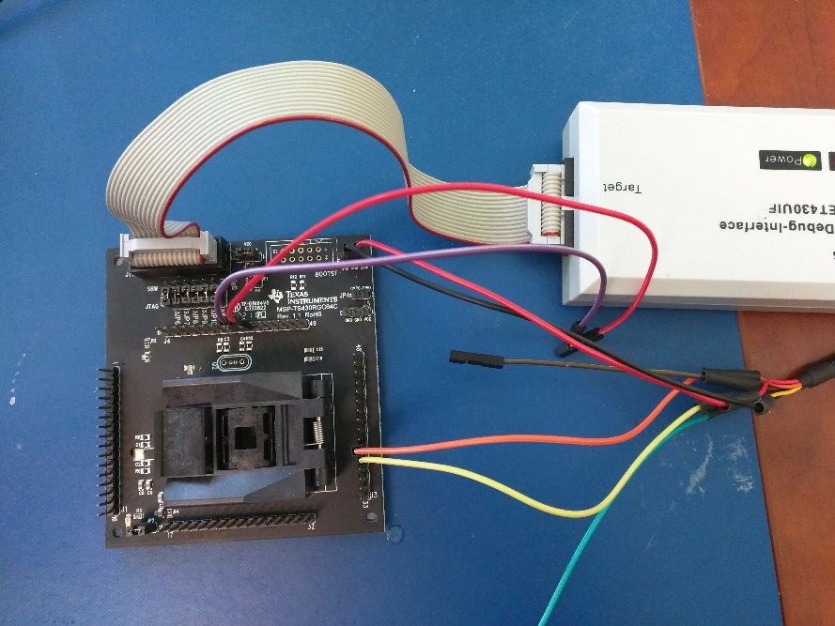

To enter the bootloader mode, I connect the BSLEN line to VIO and the RESET Line to GND.
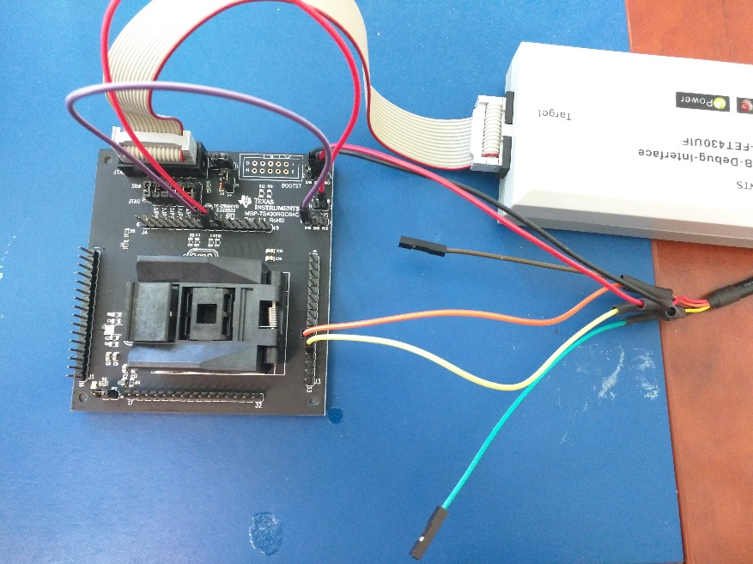
Then I disconnect the reset line from the GND and then disconnect the BSLEN from the VIO.
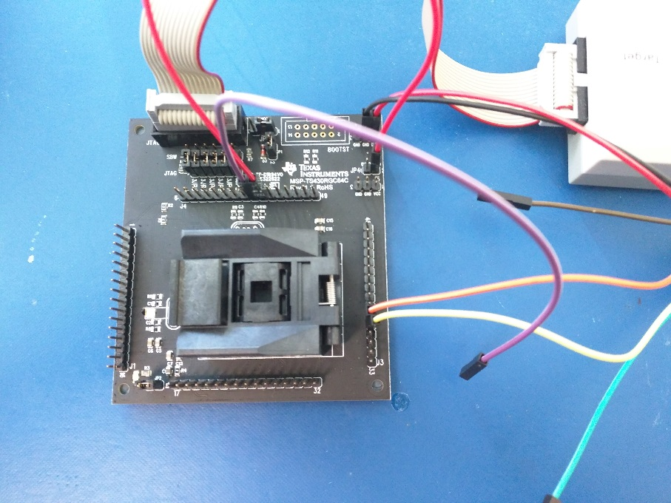

The device is in BSL mode now.
I am using the BSL scripter to talk to the BSL using the 1.8V UCA0 connections. This is when I get the error as shown below:
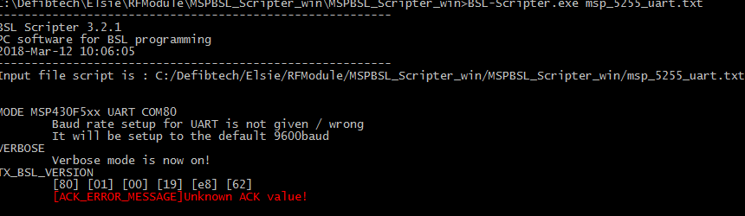

If I now connect a second FTDI cable TTL to 3.3 V to the DVCC Side

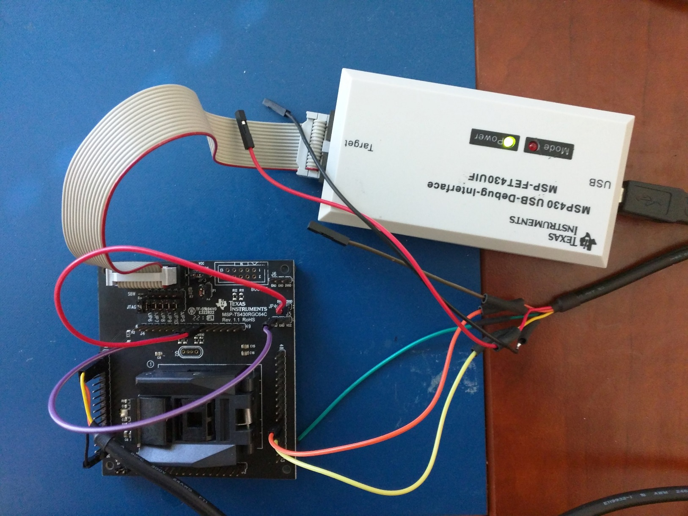

I am still using the BSL scripter with the COM port changed to use the 3.3 V Cable port. It seems that the BSL scripted has received some data.
