Hi Everyone,
We are using MSP430F67751A for our application. In this we are giving clock using an External Clock using TCXO.
I wanted to calculate the exact Main Clock and Sub Main Clock. So I have used the following formulae from User Guide to calculate exact clock output from FLL.
FLL frequency calculation:
XT1CLK
SW CONFIGURATION BITS | Value | Comments
XIN (Hz) | 32768
XT1BYPASS | 1
XT1OFF | 1
XT1DRIVE | 3
XCAP | 3
XTS | 0
OUTPUTS
XT1CLK (Hz) | 32768
VLOCLK (Hz) (fVLO) | 9600 | from datasheet of MSP430
REFOCLK (Hz) (fREFO) | 32768 | from datasheet of MSP430

MCLK ,SMCLK, ACLK Calculation
SW CONFIGURATION BITS | Value | Comments
SELREF | 0 | It sets to XT1CLK
FLLREFDIV | 0 | It divides by one
FLLN | 488
FLLD | 1 | It divides Fdcoclk feedback by 2 and By default, D = 2, and  MCLK and SMCLK are sourced from DCOCLKDIV, providing a clock frequency DCOCLK/2.
DCORSEL | 5
DISMOD | 0
SELA | 0 | ACLK= XT1CLK
MCLKREQEN | 1 | SMCLK conditional requests are enabled.
SELM | 4 | MCLK=DCOCLKDIV
SELS | 4 | SMCLK=DCOCLKDIV
DIVM | 0
DIVS | 0
DIVA | 0
DIVPA | 0
OUTPUTS
FLLREFCLK (Hz) | 32768
DCOCLK (Hz) | 32047104
DCOCLKDIV (Hz) | 16023552
ACLK (Hz) | 32768
MCLK (Hz) | 16023552 | MCLK=DCOCLKDIV
SMCLK (Hz) | 16023552 | SMCLK=DCOCLKDIV
PPM W.R.T 16MHZ | 1472 | PPM

Hence this SMCLK and MCLK are not exactly 16MHz from this calculation.

Is this correct ??

DCO frequency drift calculation due to temperature and core voltage change:

Datasheet Spec over the DCO drift:
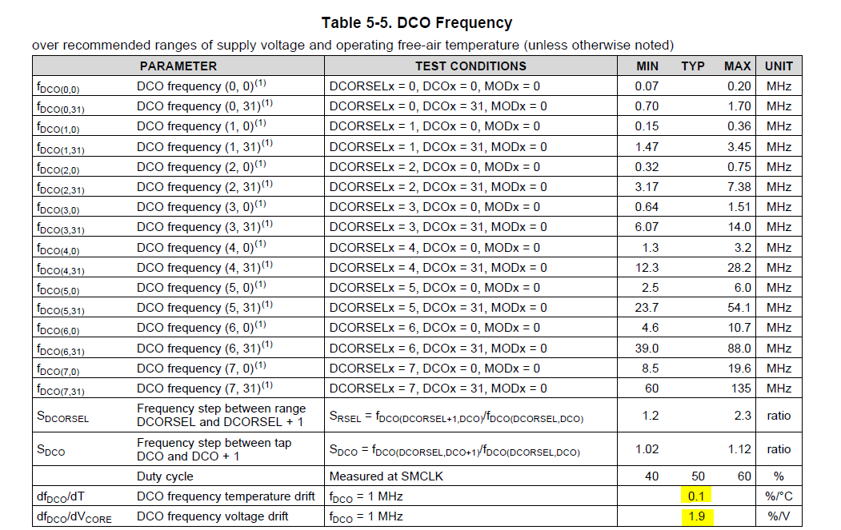

Thermal Drift of Digitally Controlled Oscillator (DCO) frequency
DCO frequency temperature drift (%/°C) | 0.1
Temperature rise (°C) | 30
Total Temperature drift (Hz) | 480706.56
Maximum Frequency (Hz) | 16504258.56
Minimum Frequency (Hz) | 15542845.44
Voltage Drift of Digitally Controlled Oscillator (DCO) frequency
DCO frequency Voltage drift (%/V) | 1.9
Voltage Vcore change (V) | 0.05
Total Voltage drift (Hz) | 15222.3744
Maximum Frequency (Hz) | 16519480.93
Minimum Frequency (Hz) | 15527623.07
ppm Calculation of DCO clock drift
ppm Calculation (±) | 30950
 | -30950

Why DCO frequency is varying this much as per the above calculation ??

eUART Transmit Error Calculation:

UART Tx error is being calculated using the following formula from the datasheet/user Guide:

Max and Min Tx error calculation for 16Mhz clock and 115200 Baud:

My Excel Calculation :

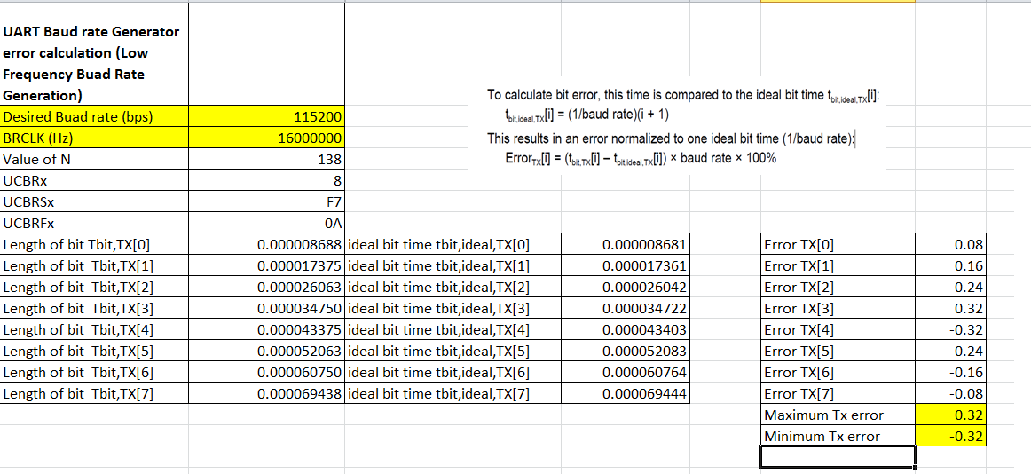

Error calculation table in User Guide:

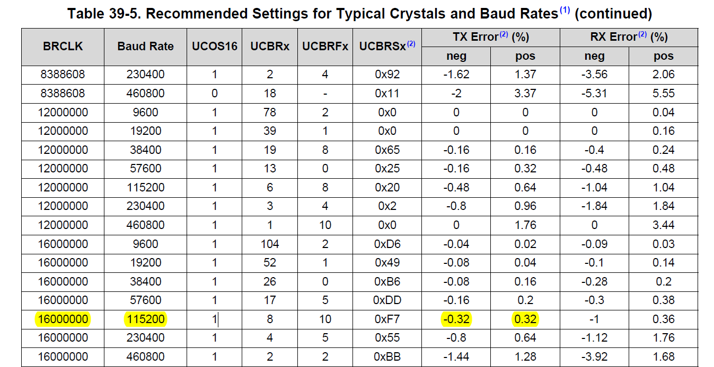

From the above calculation, you can see that the error on your user guide is as same as in our calculation excel.

Tx error calculation for Max drifted clock (16.519481 MHz) and 115200 Baud:

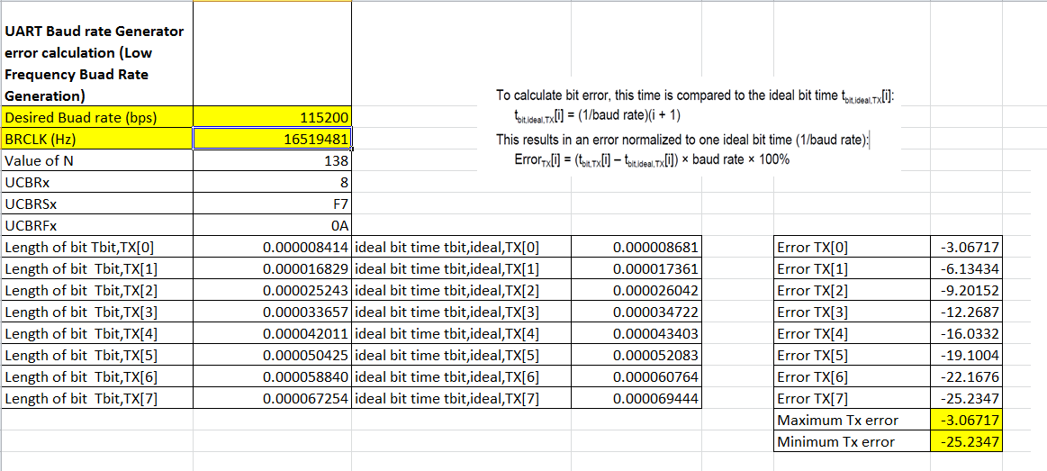

Tx error calculation for Min drifted clock (15.527623 MHz) and 115200 Baud:

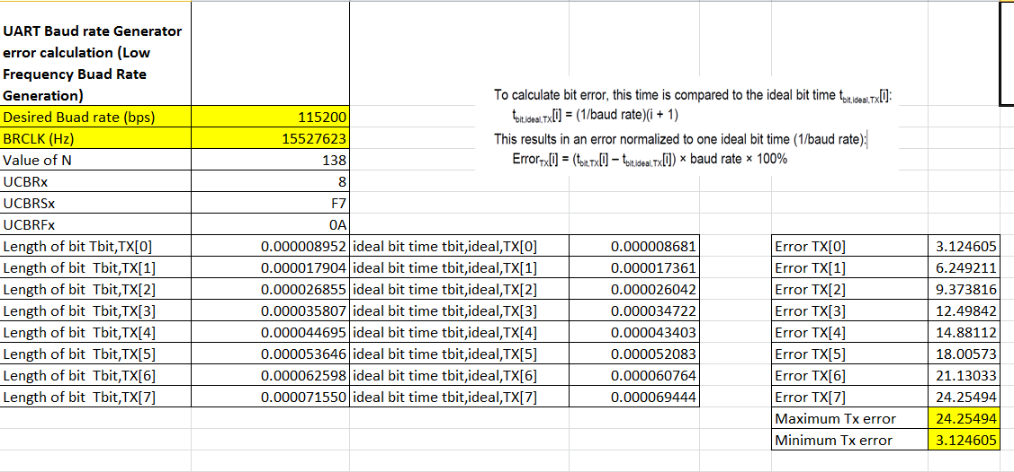

Because of the DCO clock drift, we are seeing a maximum Tx bit Error of around 25 % . Is this acceptable ??

Could you provide the Calculator excel for Rx error calculation similar to this as I am not getting the error correctly for Rx ???

