The difference is in between step 3 of ‘Debug with load symbols only’ and step 3 of ‘Debug with load program’. In ‘Debug with load symbols only’ (debug without download) the jump to Application is not happening. As in ‘Debug with load program’ (debug with download) the jump to Application seems proper.

- Debug with load symbols only

- Step1 is TI_MSPBoot_APPMGR_JUMPTOAPP() is hit (Figure 1)
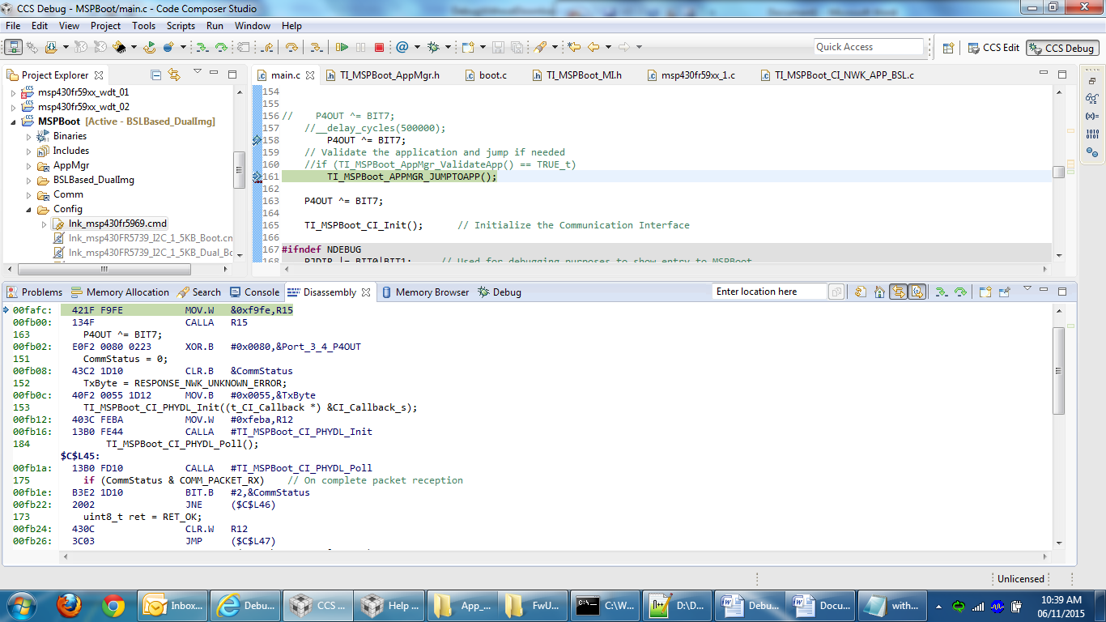
Figure 1

- Step 2 is ‘Assembly Step Into’ after step 1 (Figure 2)
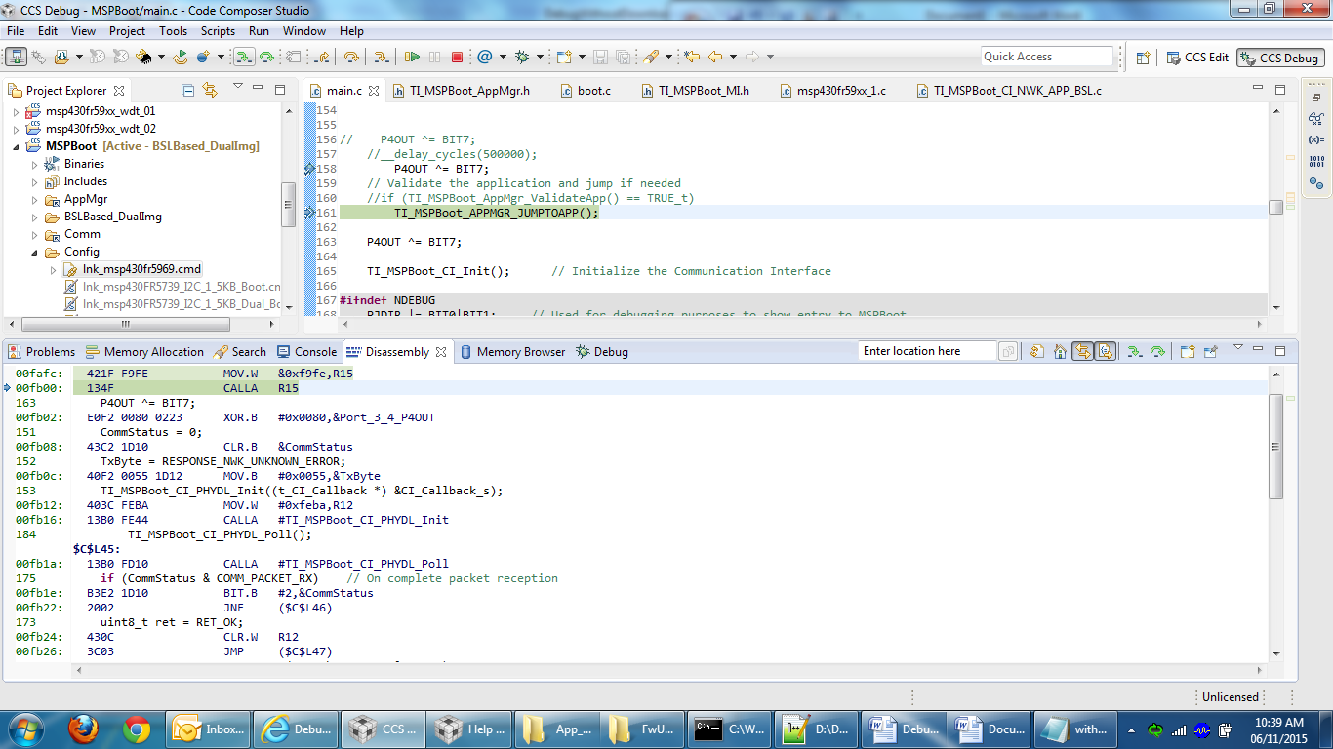
Figure 2

- Step 3 is ‘Assembly Step Into’ after step 2 (Figure 3). Here is the difference it says No source available for “0xfffa”
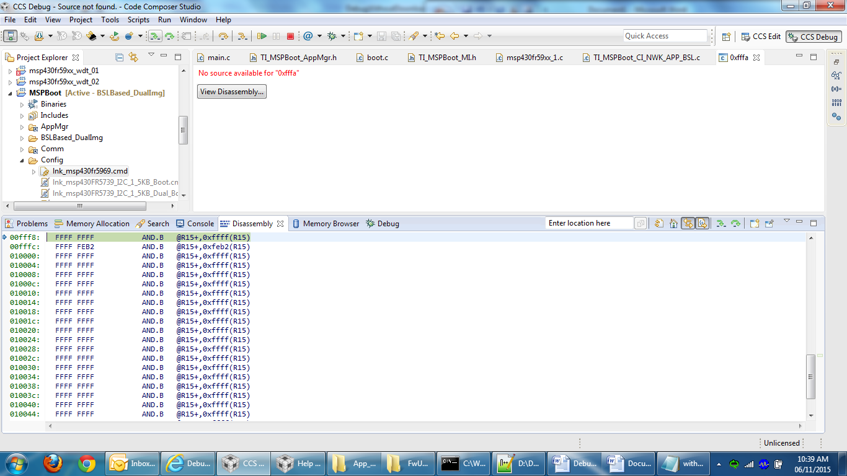
Figure 3

- Step 4 is ‘Assembly Step Into’ after step 3 (Figure 4). Boot Reset.
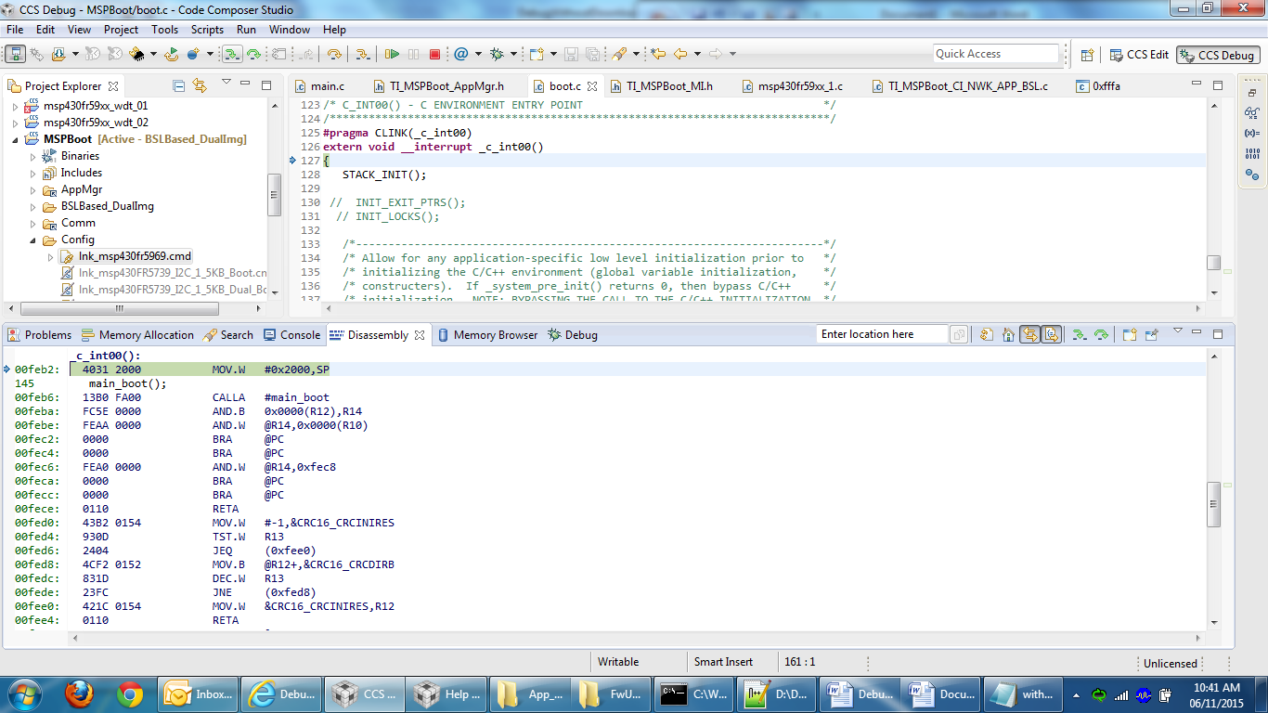
Figure 4

- Debug with load program

- Step1 is TI_MSPBoot_APPMGR_JUMPTOAPP() is hit (Figure 5)
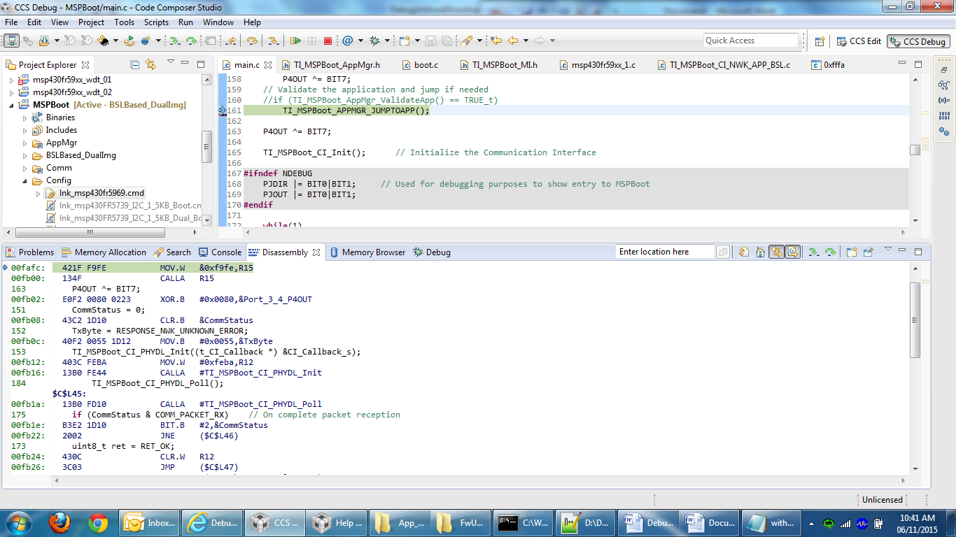
Figure 5

- Step 2 is ‘Assembly Step Into’ after step 1 (Figure 2)
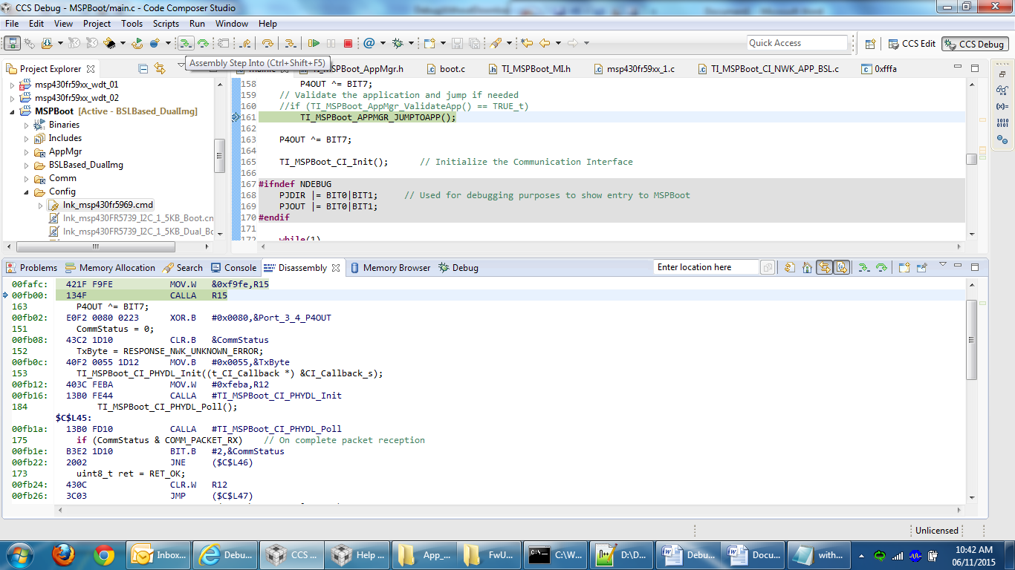
Figure 6

- Step 3 is ‘Assembly Step Into’ after step 2 (Figure 3). Here is the difference it says No source available for “0xde94”. With this address it seems it has entered application and if I Resume the debugger the application Runs (Confirmed by LED observatin).
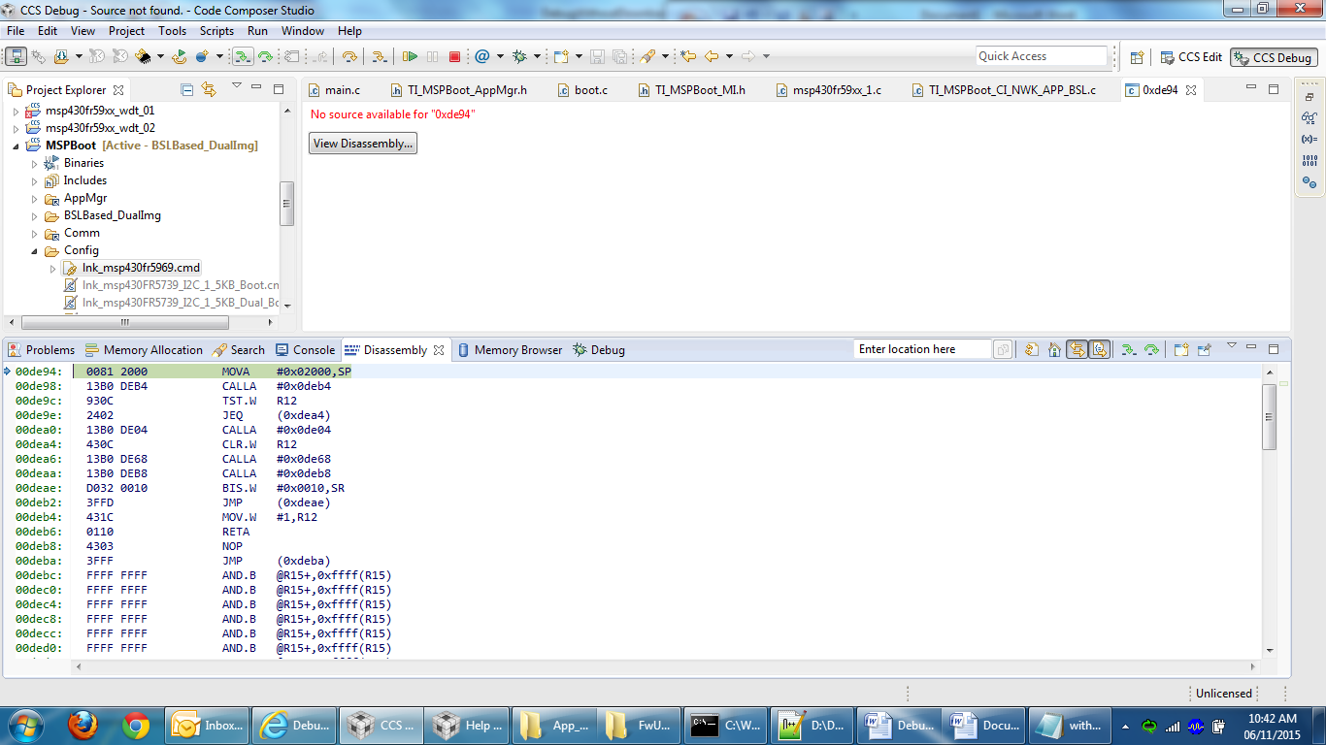
Figure 7

