- Build default application without CRC in linker file (i.e. App1_BSLBased_UART)
- Use CRCGen to calculate CRC (0xA6A7)
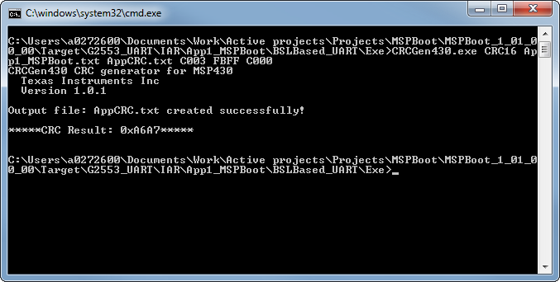
- Uncomment CRC generation in IAR’s linker file
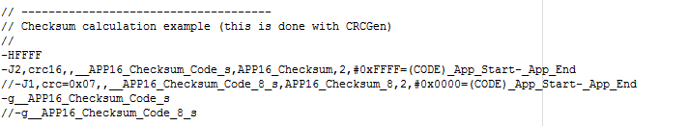
Note that –H3FFF was changed to –HFFFF (just to generate same output as CRCGen)
- Build application and check CRC in .map file (0xA6A7, same as CRCGen)
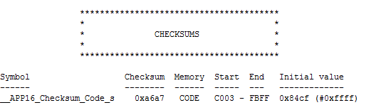
- Test by downloading MSPBoot
  - When downloading MSPBoot, add the Application image so that we can debug both the application and bootloader at the same time
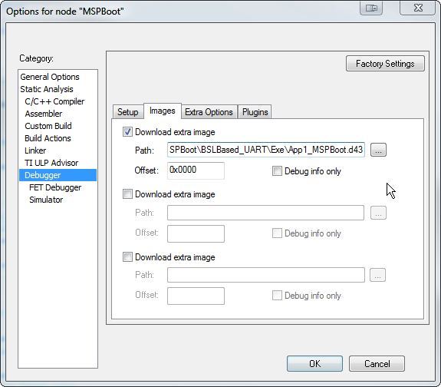
  - Verify if the application and bootloader were downloaded correctly (note that the debugger stops in the first bootloader instruction, and address 0xC000 has the CRC followed by application)
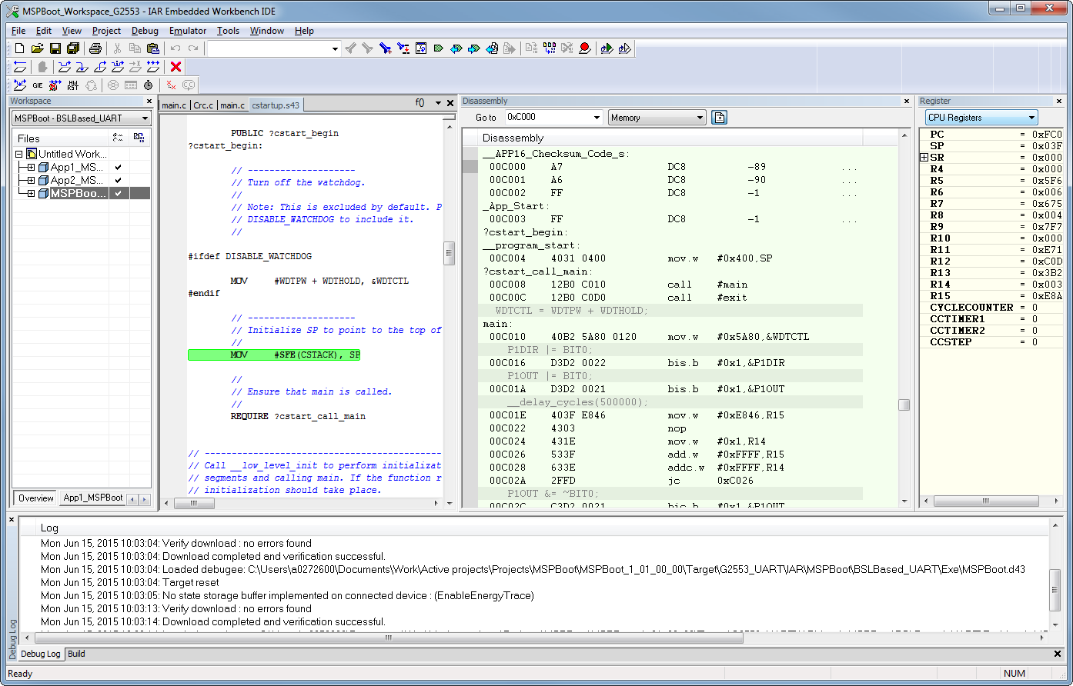
  - Run to function calling crc16MakeBitwise. Make sure R12 has the start address and R13 has the number of bytes:
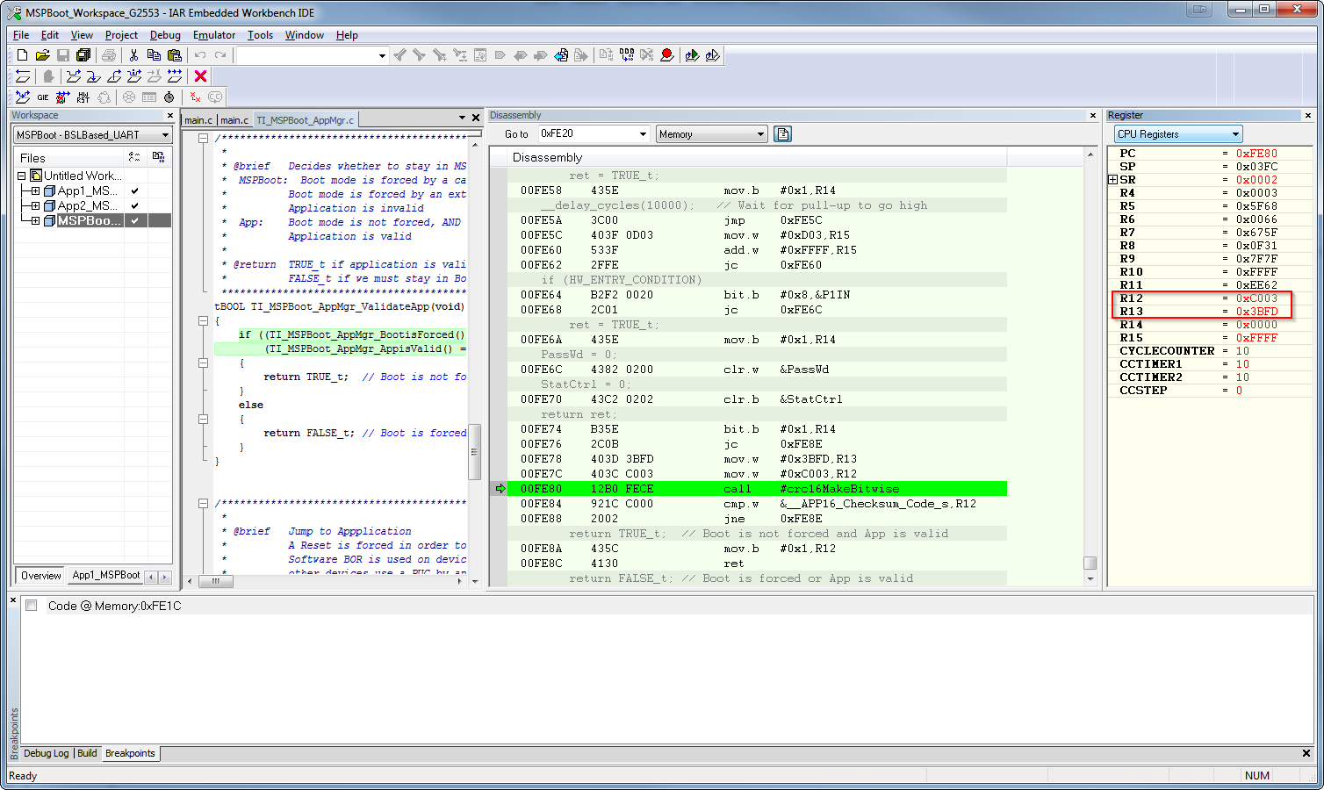
  - Execute function, the result will be stored in R12:
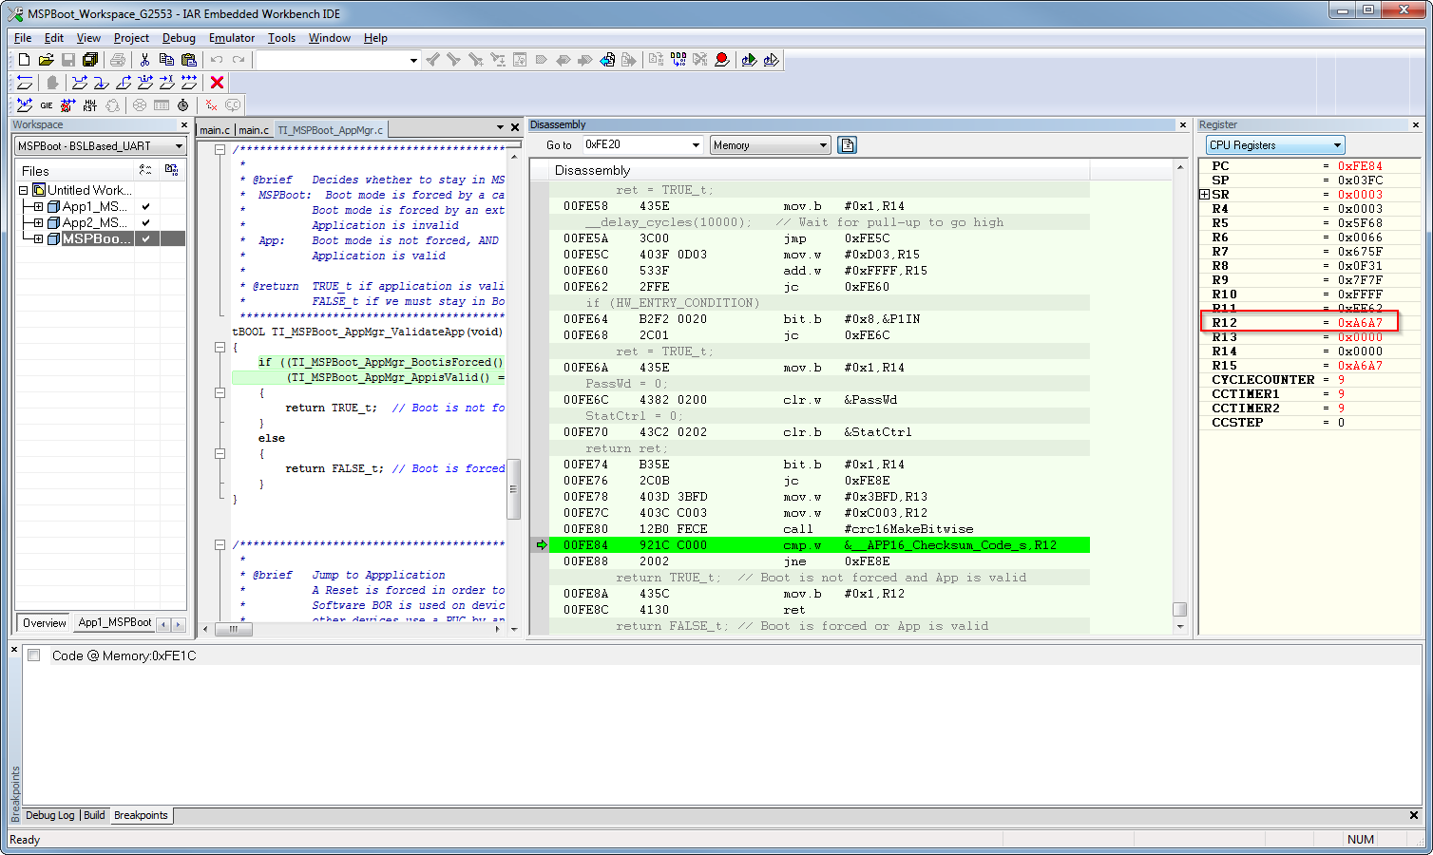
  - The comparison should be true and function will return true (0x01)
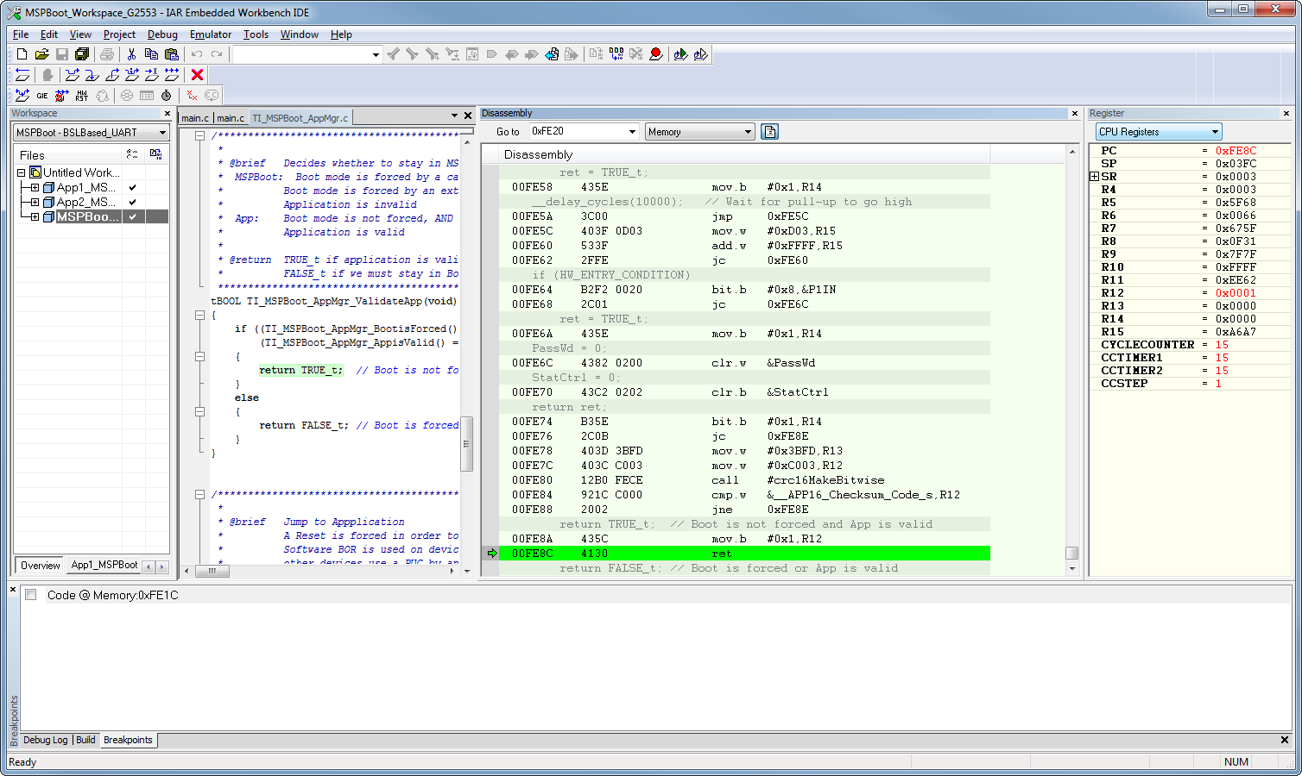
  - Application will execute

