# Using CCS 6.1.0.00104 to download BSL to MSP432

1. Using BSL432_MSP432P401R project from MSP432BSL_1_00_00_00
2. Settings:

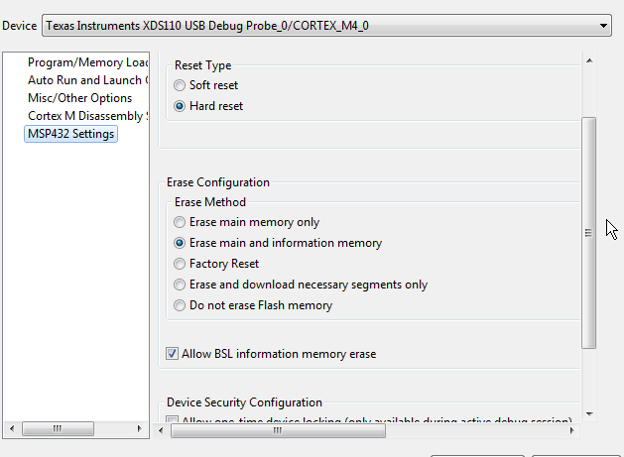

1. Result:

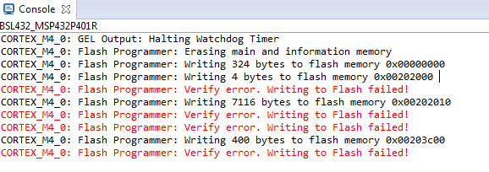

1. Debugger shows that memory is not written:

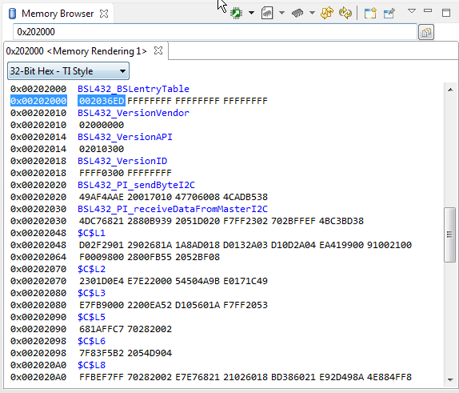

Expected values from .txt:

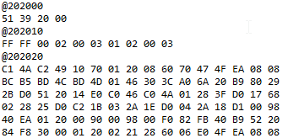

# Using UniFlash 3.3.0.0058:

1. Settings:

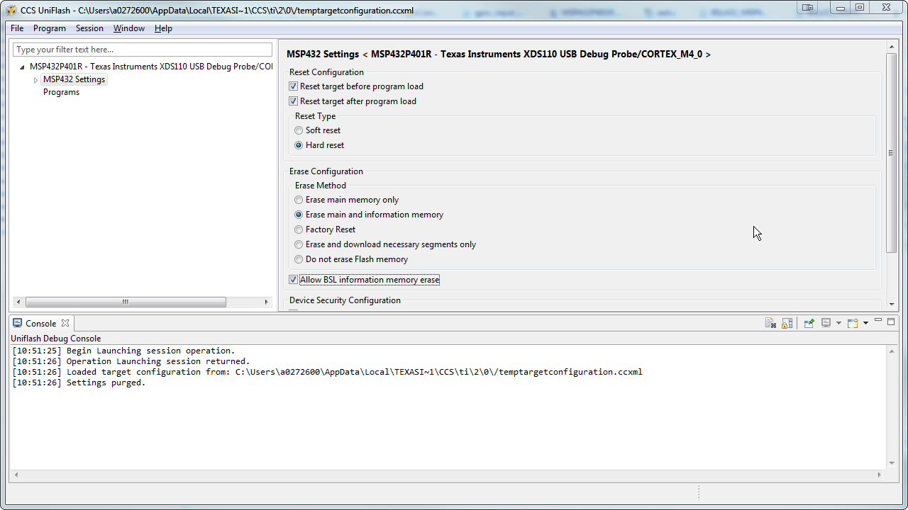

1. Result of download (note: the programmer will throw errors if the .txt file doesn’t start with @)

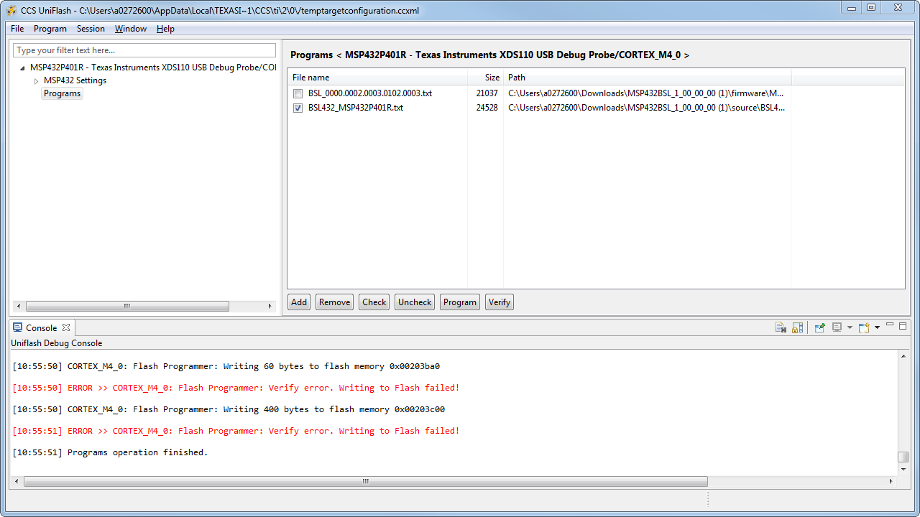

# Using IAR 7.40.3.8938

1. Follow steps from <http://www.ti.com/lit/ug/slau574a/slau574a.pdf> to enable BSL_erase
2. Select Project->Download->Download File
3. Select .out file
4. There’s one error:

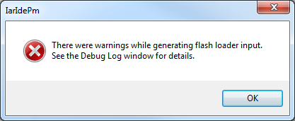

1. However, the download works OK

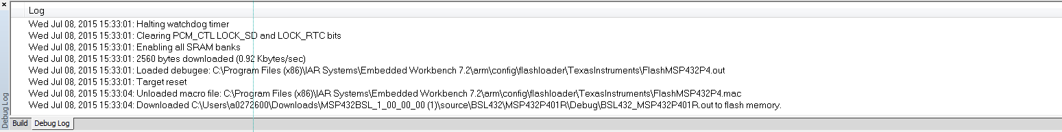

1. When debugging, the memory shows correct results

