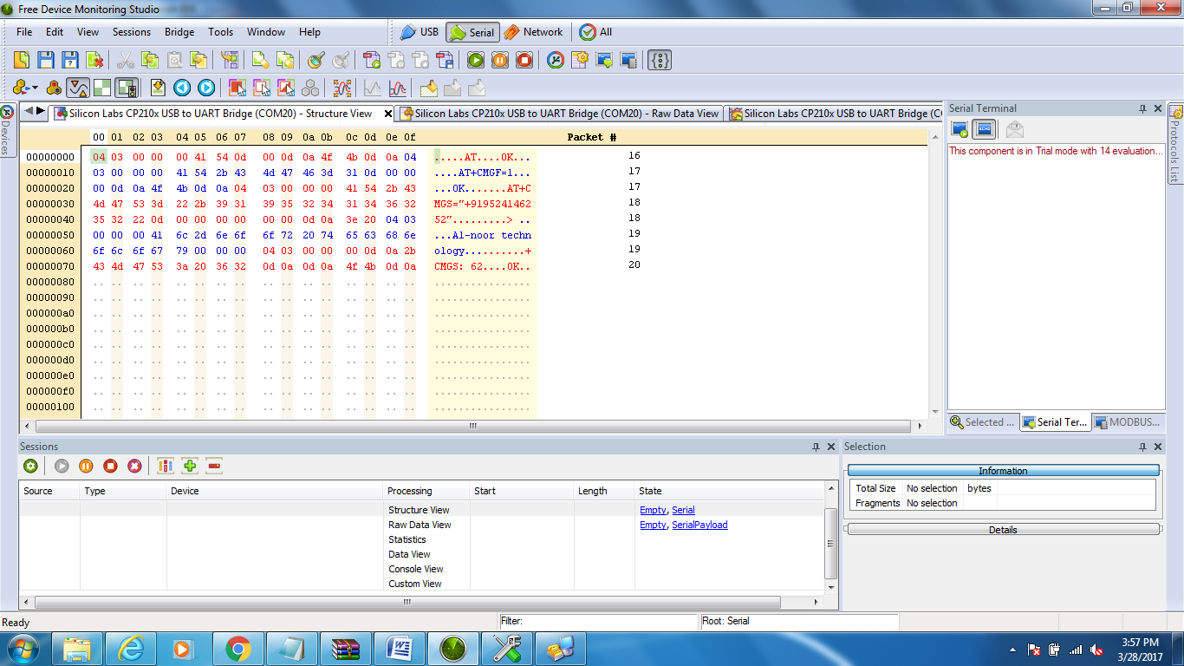

**SIM900A WITH MSP430**

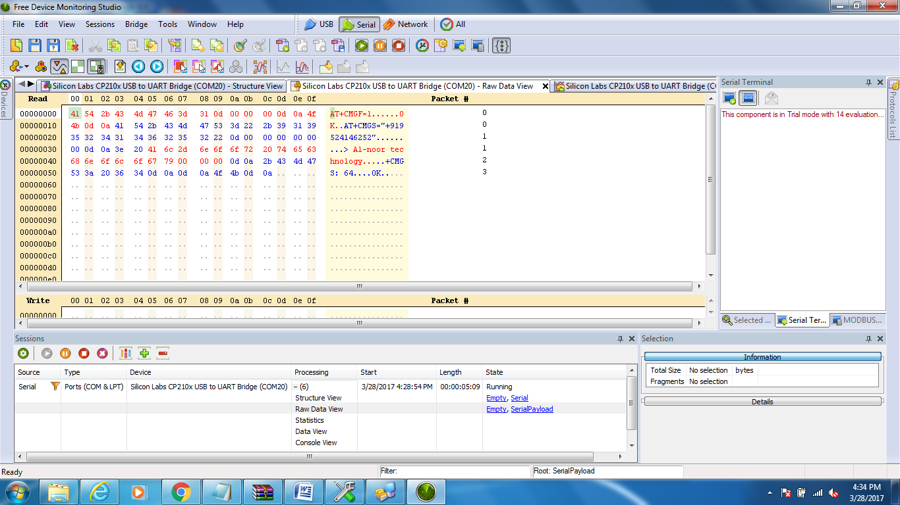

**SIM800L WITH MSP430**