Recovering Bricked CC26x2Rx launchPad steps
- Power off Launch pad, unplugged USB cable
- Grounding the JTAG TDO (pin 97, also located at the top-left pad of the 10-pin ARM connector as shown in picture below.
- 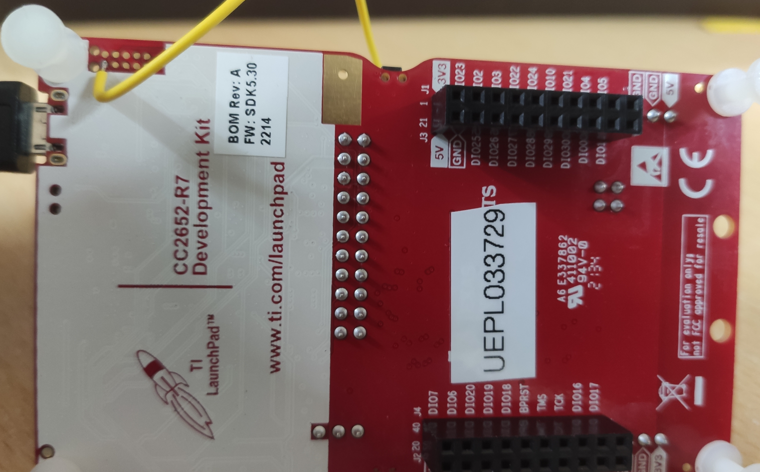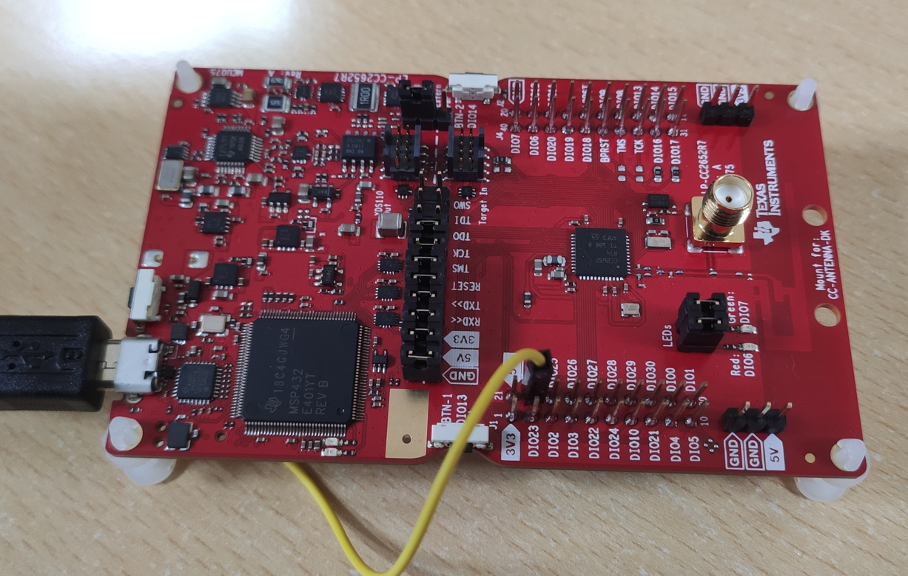
- Open xdsdfu.exe utility which is present in default TI installation path “C:\ti\ccs_base\common\uscif\xds110”
- Remove the ground connection
- Run command prompt from the same location, by writing cmd to same folder location
- Give command xdsdfu -f firmware_3.0.0.13.bin -r, here firmware_x.x.x.xx will be the version of the file available in same folder, it will upload the new firmware into developmentboad.
- 