Program: msp430fg662x_cst16_03.c
# data points collected = 20
Voltage applied at pins 1 and 2 = 0.2VDC
First Run:
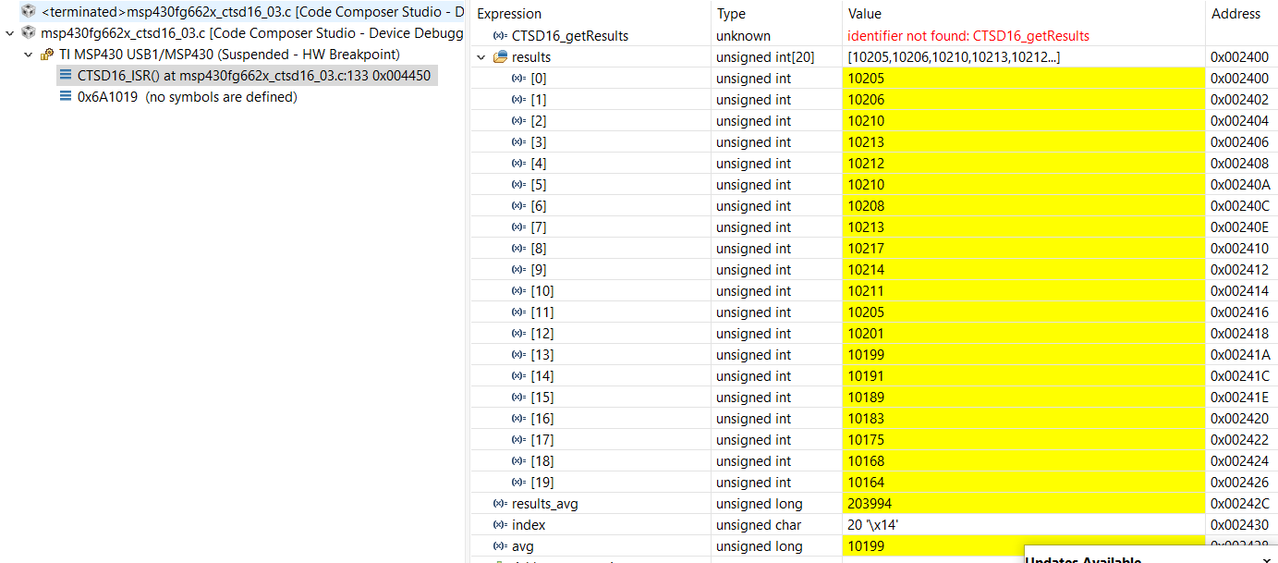
Second Run:
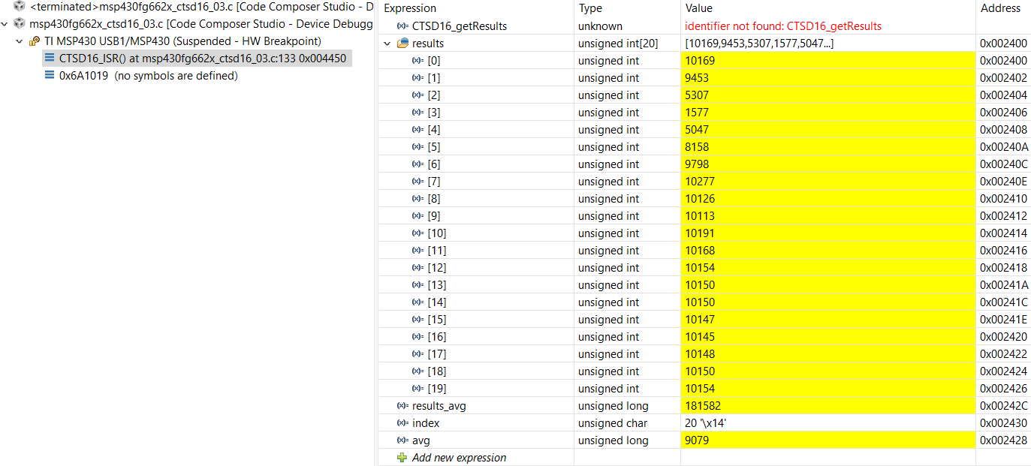
Third Run:
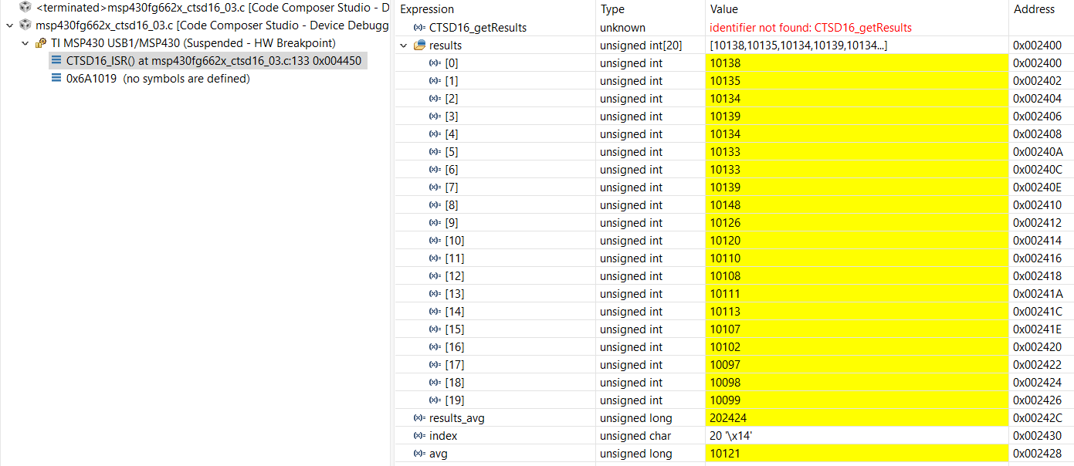
Fourth Run:
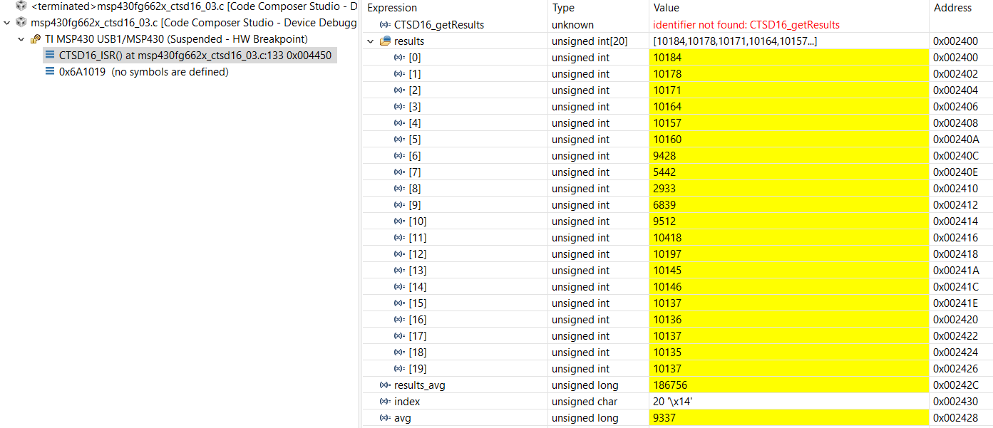

Fifth Run:
