- Open SLAA450\G2xxx_BSL_projects_and_source\IAR\G2xxx_BSL\G2xxx_BSL.ewp.eww
  - Build
  - Project gives an error since YOUR_DEVICE_VALUE is undefined

- Read default calibration values
  - Comment Ln173, Ln 174 of MSP430G2xxxBSL_IAR.asm
  - Rebuild (project builds OK)
  - Click on “Debug without Downloading” (Note: don’t erase the info memory because the values will be lost)
  - Stop the MCU
  - Open Memory View (Menu->View->Memory)
  - Write-down values of 0x10FE and 0x10FF
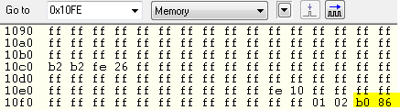

- Build vBSL code again
  - Uncomment Ln173, Ln 174 of MSP430G2xxxBSL_IAR.asm
  - Write the corresponding values
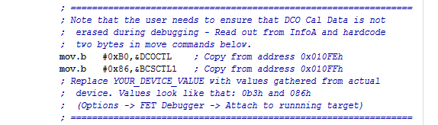

  - Rebuild (project builds OK)

- Program vBSL code
  - Make sure the settings are as follows:
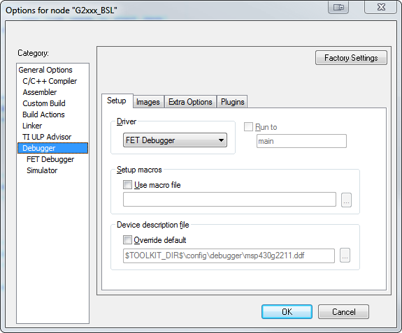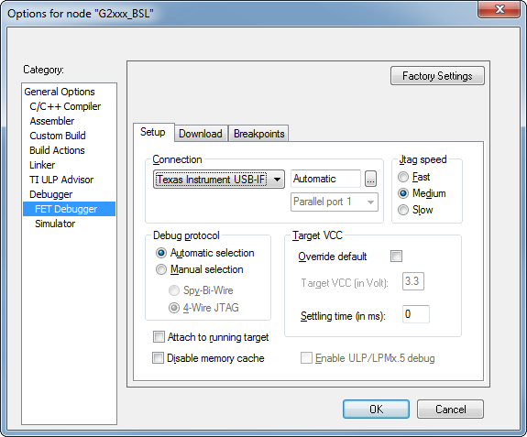
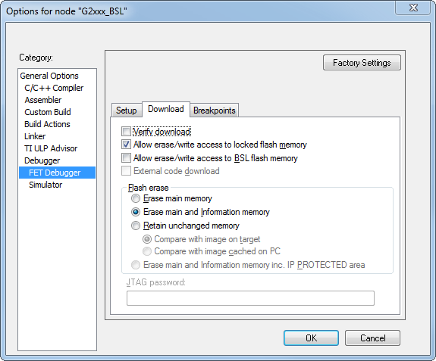
  - Download

- Execute:
  - If P1.3 is High, the default application will run (toggle LED1 in P1.0)
  - If P1.3 is Low, the vBSL will run (LED doesn’t toggle)
  - Note that the internal Pull-up for S2 button is not enabled and the external pull-up (R34) is not populated by default depending on the Rev of the launchpad

- Open the sample application SLAA450\G2xxx_BSL_projects_and_source\IAR\G2xxx_MainApp_C\ G2xxx_MainApp_C.ewp.eww
  - Change settings to generate MSP430 binary file:
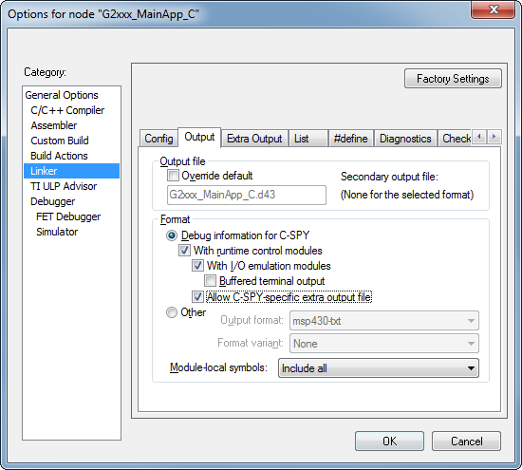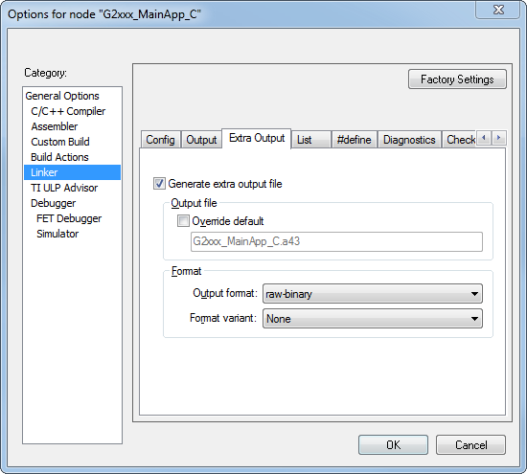
  - Build the application (application builds OK and G2xx_MainApp_C.a43 is in the output folder
  - Don’t download because it will erase the vBSL
- Open an Hex Editor application, such as Free Hex Editor Neo
  - Create a new file with only 0xBA (SYNC byte) and name it “sync.bin”:
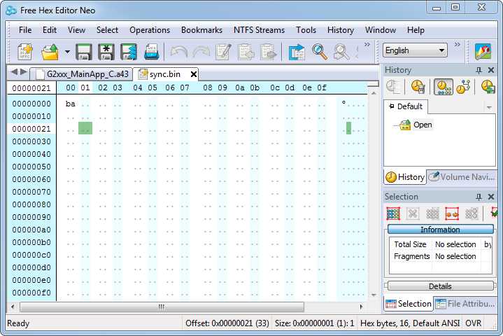

- Set breakpoint to get Cheksum of application
  - Download and Debug vBSL
  - Set a breakpoint in Line 263
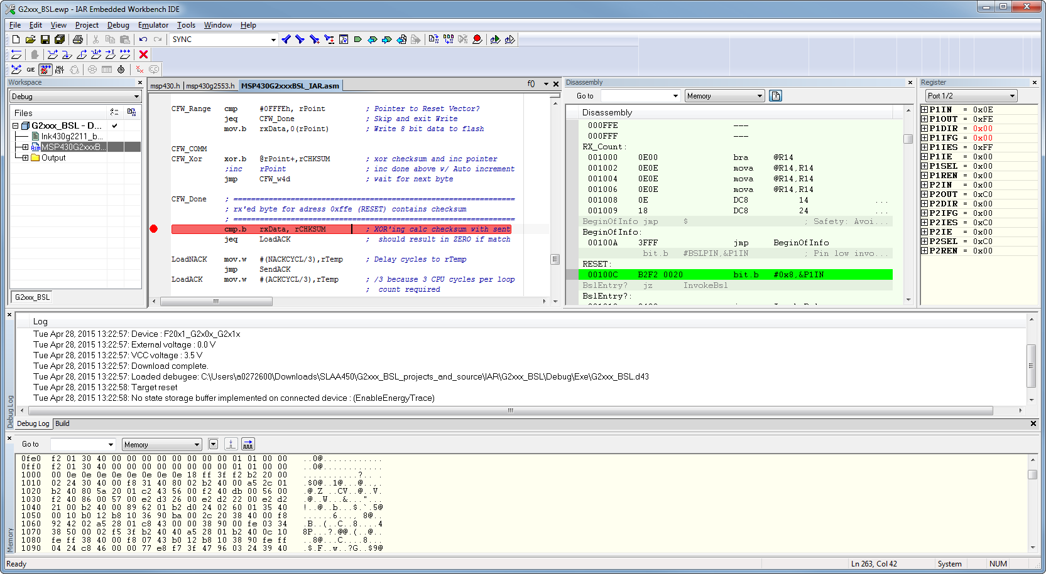
  - Make sure P1.3 is low to force vBSL
  - J3 RXD/TXD must be in SW UART configuration
  - Run it

- Send the code using a terminal program
  - Send Sync.bin.
Note: make sure you send it as binary. It’s a good idea to check that the terminal is sending correctly using an analyzer or oscilloscope
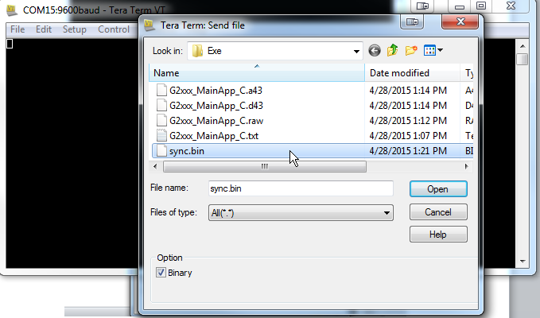

  - Send G2xx_MainApp_C.a43
Note: make sure you send it as binary. It’s a good idea to check that the terminal is sending correctly using an analyzer or oscilloscope

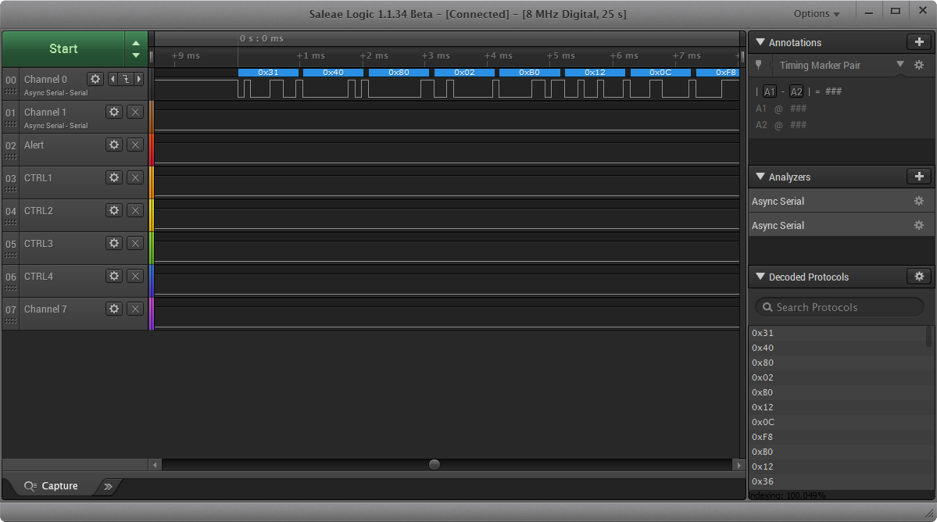
- Get Checksum of application
  - If all bytes were received including the original Reset vector at 0xFFFE, then the debugger will stop at the breakpoint
  - Check the value of R7 (rCHKSUM)
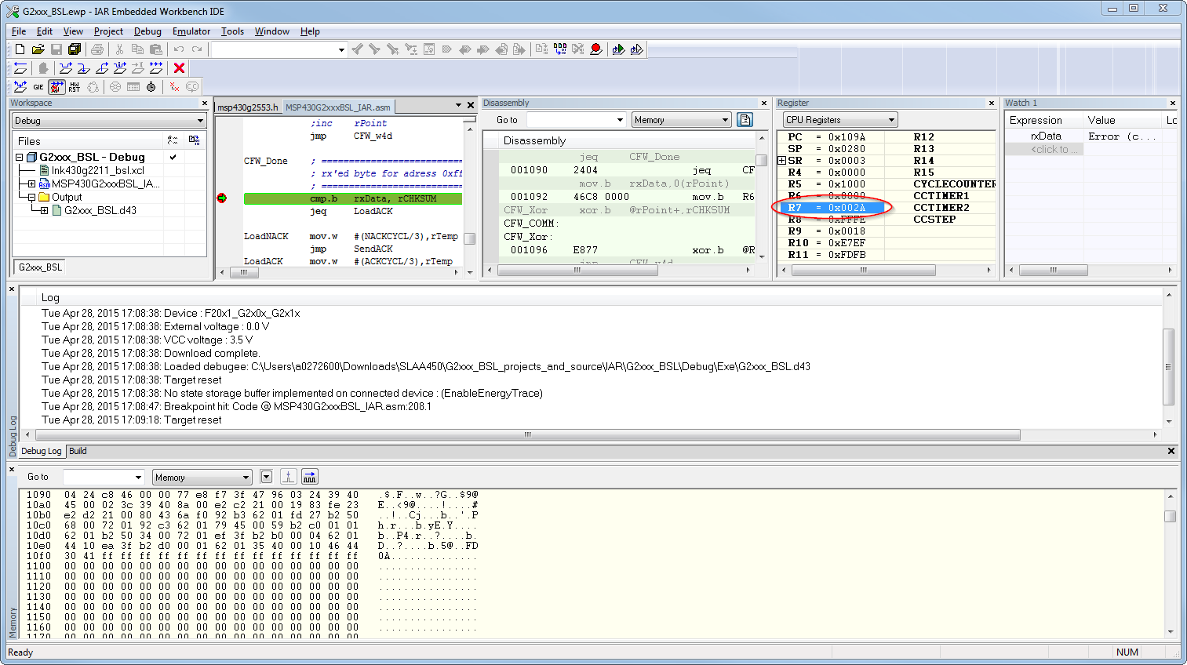

- Update the Checksum
  - Open G2xx_MainApp_C.a43 in an hex editor
  - Replace the Byte in address 0x7FE by the value from R7
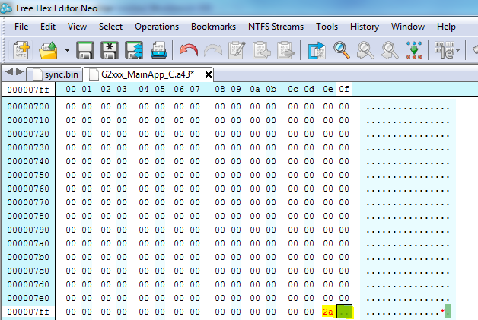
  - Save the file

- Send new image again
  - Repeat step 9, this time without the debugger and breakpoint
  - The device should return 0xF8 (ACK) if the download was successful
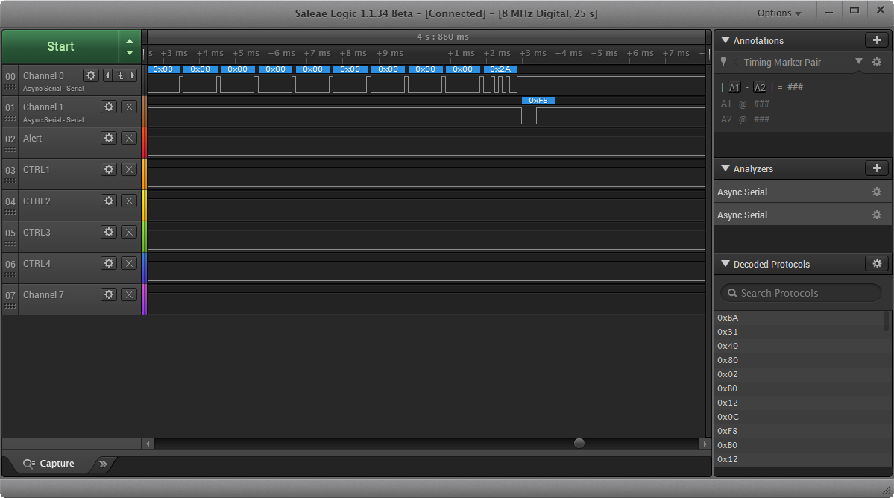

Note:
If the DCO calibration values are lost or incorrect, the communication will probably fail. Try using a tool like the MSP-GANG or run msp430g2xx1_dco_flashcal.c (from code examples) to re-calibrate the device.

