|  |  |  |  |  |  |
| --- | --- | --- | --- | --- | --- |
| Sensor  element | Conversion count | Prox. Threshold | Touch  Threshold | Negative  Touch Threshold | Distance at which detected (Aprox) |
| Button | 150 | 7(Default) | 15(Default) | 20(Default) | Touch detected for 0 sheets, Prox detected for 1 sheets |
| 150 | 5 | 10 | 20 | Touch detected for 0 sheets, Prox detected for 1 sheets |
| 150 | 2 | 6 | 20 | Touch detected for 0 sheets, Prox detected for 2 sheets |
| 300 | 5 | 10 | 20 | Touch detected for 0 sheets, Prox detected for 2 sheets |
| 300 | 15 | 30 | 20 | Touch detected for 0 sheets, Prox detected for 1 sheets |
| 300 | 2 | 6 | 20 | Touch detected for 0 sheets, Prox detected for 2 sheets |
| 500 | 5 | 10 | 20 | Touch detected for 0 sheets, Prox detected for 2 sheets |

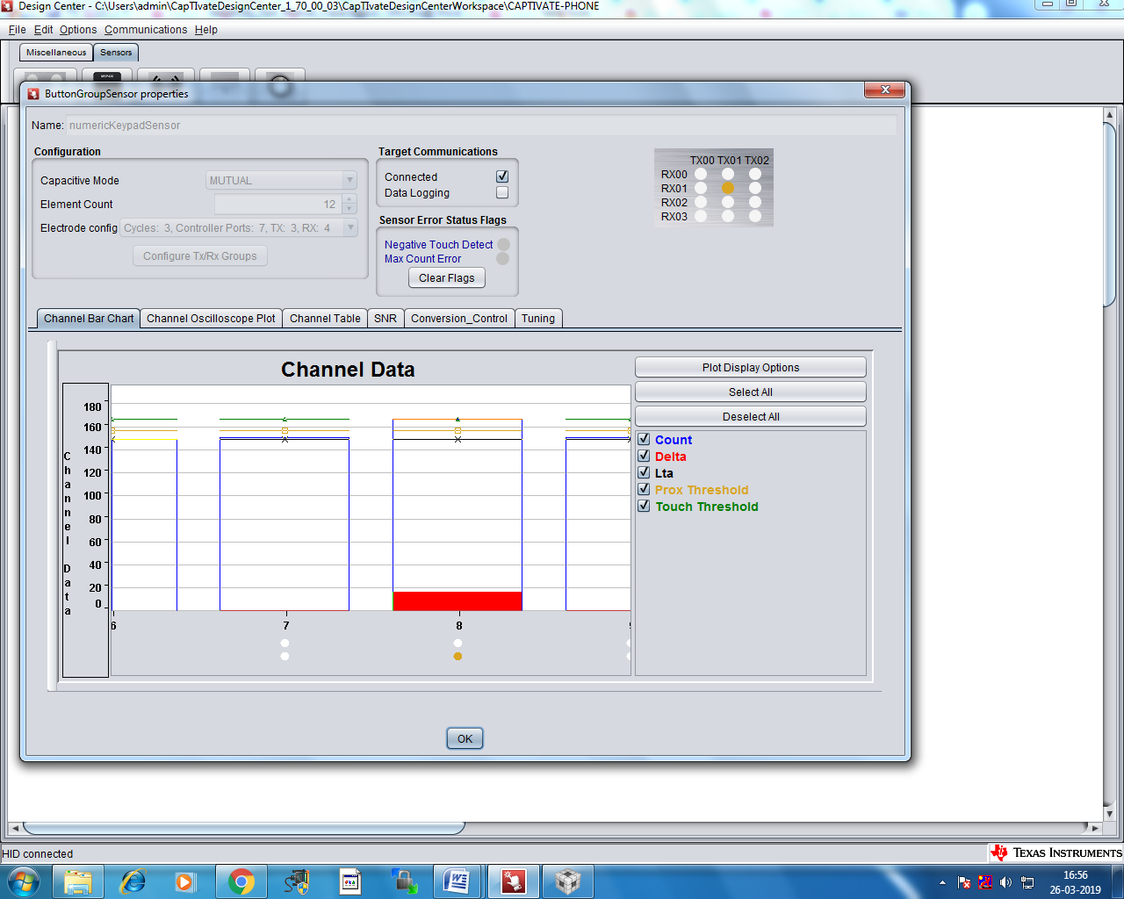

Channel bar chart for proximity threshold set to value 7, touch threshold set to value 15 and conversion count set to 150.

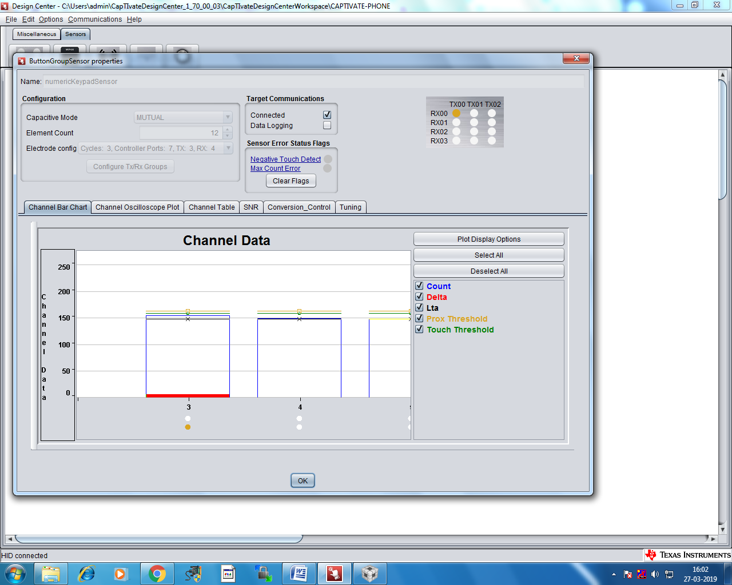

Channel bar chart for proximity threshold set to value 15, touch threshold set to value 30 and conversion count set to 300.

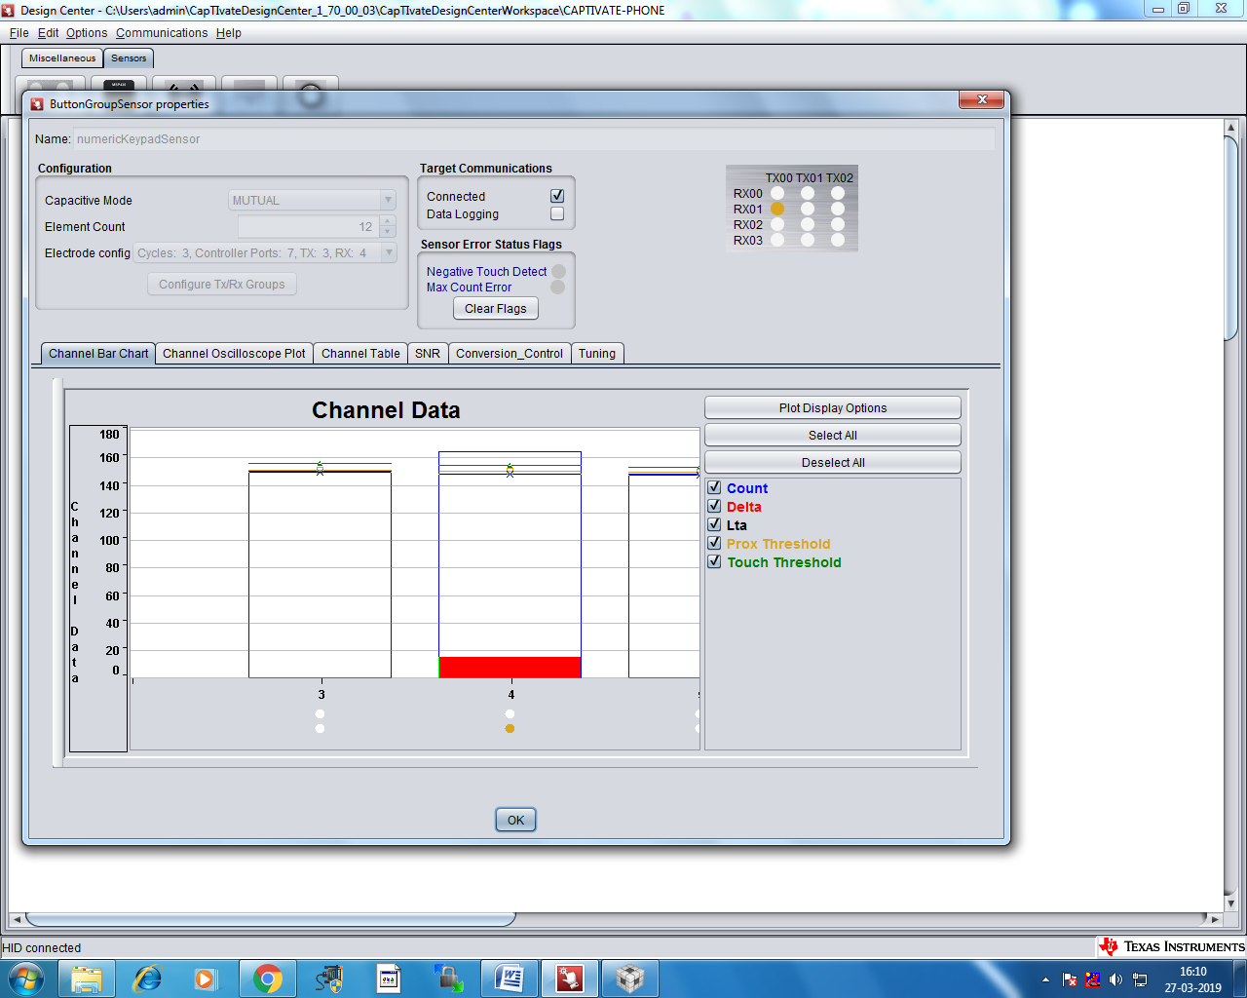

Channel bar chart for proximity threshold set to value 2, touch threshold set to value 6 and conversion count set to 300.

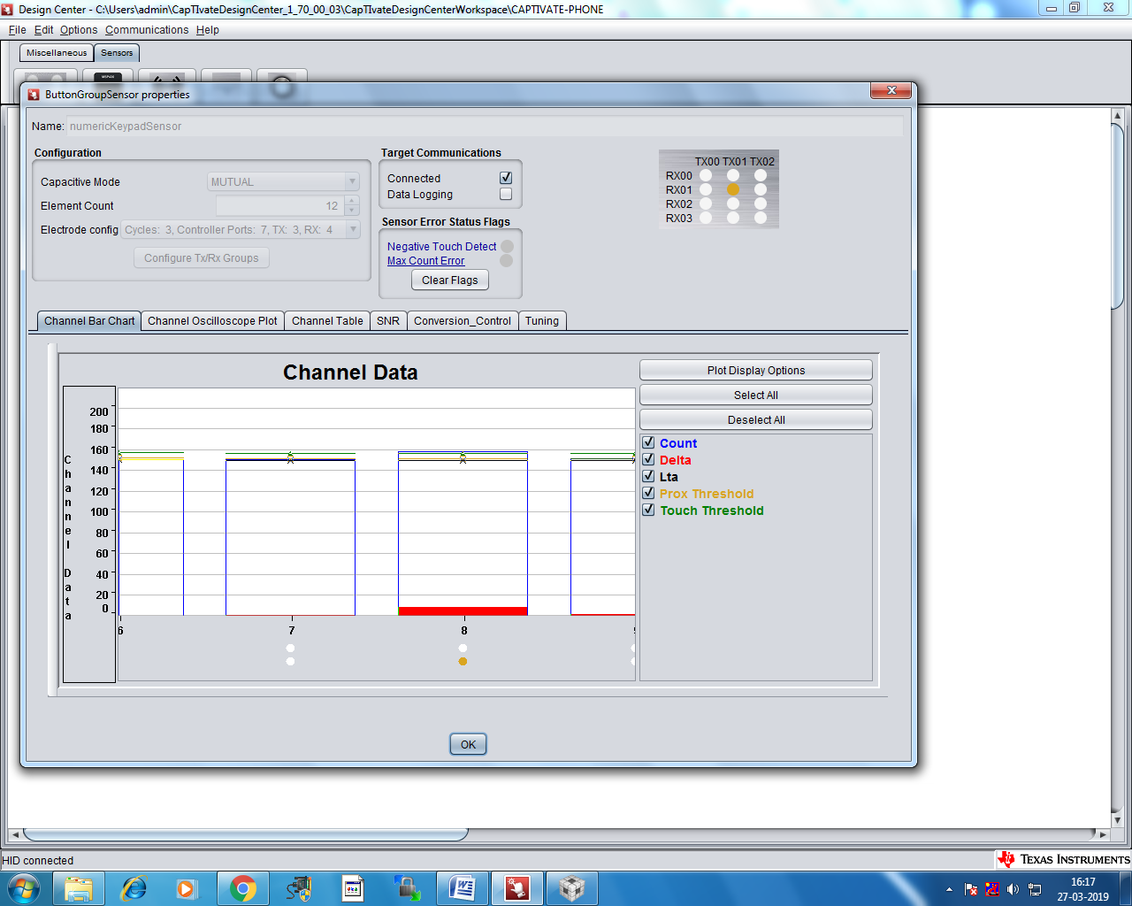

Channel bar chart for proximity threshold set to value 2, touch threshold set to value 6 and conversion count set to 150.