James,
Thanks.
I done some modifications for use Uart_2 (See attached), after I modify the code, I rebuild all the projects in this order after making changes to any files: emeter-toolkit-67641 -> emeter-metrology-67641 -> emeter-app-67641,but still don’t enter the break point, see the attached.
Use IC: MSP430F67641IPN (80pins)

I done below modify for use Uart_1:
- P2 port setting:

Lucy modify (our application)
P2.0 = B0_SPI_MOSI out
P2.1 = B0_SPI_MISO in
P2.2 = UART 2 Rx in
P2.3 = UART 2 Tx out
P2.4 = PE_485_TX_EN out
P2.5 = NC out
P2.6 = LED_PHASE_2 out
P2.7 = LED_PHASE_3 out

*/

#define P2DIR_INIT (BIT1|BIT2| BIT3| BIT4| BIT5| BIT6|BIT7)
#define P2SEL_INIT (BIT0 | BIT1| BIT3 | BIT2)
#define P2OUT_INIT (BIT6 | BIT7)
#define P2REN_INIT (0)

- Uart_2 setting (same as Uart_1):

/*! This defines the speed of eUSCI 2 Lucy add */
#define UART_2_SUPPORT
#define UART_2_BAUD_RATE 9600
#define UART_2_DLT645_SUPPORT

- Uart_2 init (same as Uart_1): in this function: int serial_configure(int port, int mode, uint32_t bit_rate)

#endif
#if defined(UART_2_SUPPORT)
case 2:
//Below Lucy modify refer COM1 setup
#if defined(__MSP430_HAS_USCI_AB2__) || defined(__MSP430_HAS_USCI_A2__) || defined(__MSP430_HAS_EUSCI_A2__)
/* Configure the port with the reset bit held high */
UCA2CTL1 |= UCSWRST; //Lucy
UCA2CTL0 = ctl0;
UCA2CTL1 = ctl1;
#if defined(__MSP430_HAS_EUSCI_A2__)
UCA2BRW = bitrate_divider; //Lucy
UCA2MCTLW = ((uint16_t) mctl << 8);
#else
UCA2BR1 = br1;
UCA2BR0 = br0;
UCA2MCTL = mctl;
UCA2STAT = 0;
#endif
UCA2TXBUF = 0; //Lucy
UCA2CTL1 &= ~UCSWRST;
#if defined(UART_2_DMA_SUPPORT)
DMACTL0 = DMA2TSEL_9 | DMA2TSEL_10;
#endif
#if defined(__MSP430_HAS_USCI_AB2__)
UC2IE |= UCA2RXIE;
#else
UCA2IE |= UCRXIE; //Lucy
#endif
#elif defined(__MSP430_HAS_UART2__)
UCTL2 = ctl0;
UTCTL2 = ctl1;
UBR12 = br1;
UBR02 = br0;
UMCTL2 = mctl;
UCTL2 &= ~SWRST;
/* Enable USART1 TXD/RXD */
ME2 |= (UTXE2 | URXE2);
IE2 |= URXIE2;
/* If you do not initially kick the Tx port, the TXEPT bit is not set. */
TXBUF2 = 0;
#endif
return 0;

- Uart_2 interrupt router(same as Uart_1):

窗体底端
#elif defined(__MSP430_HAS_EUSCI_A2__)
ISR(USCI_A2, USCI_A2_isr)
{
uint16_t tx; //Lucy can enter router

switch (__even_in_range(UCA2IV, USCI_UART_UCTXCPTIFG))
{
case USCI_NONE:
break;
case USCI_UART_UCRXIFG:
uart_rx_core(2, UCA2RXBUF);
break;
case USCI_UART_UCTXIFG:
tx = uart_tx_core(2);
UCA2TXBUF = tx & 0xFF;
if (tx & 0x8000)
UCA2IE &= ~UCTXIE;
break;
case USCI_UART_UCSTTIFG:
break;
case USCI_UART_UCTXCPTIFG:
break;
}
}
Uart_2: can not stop:

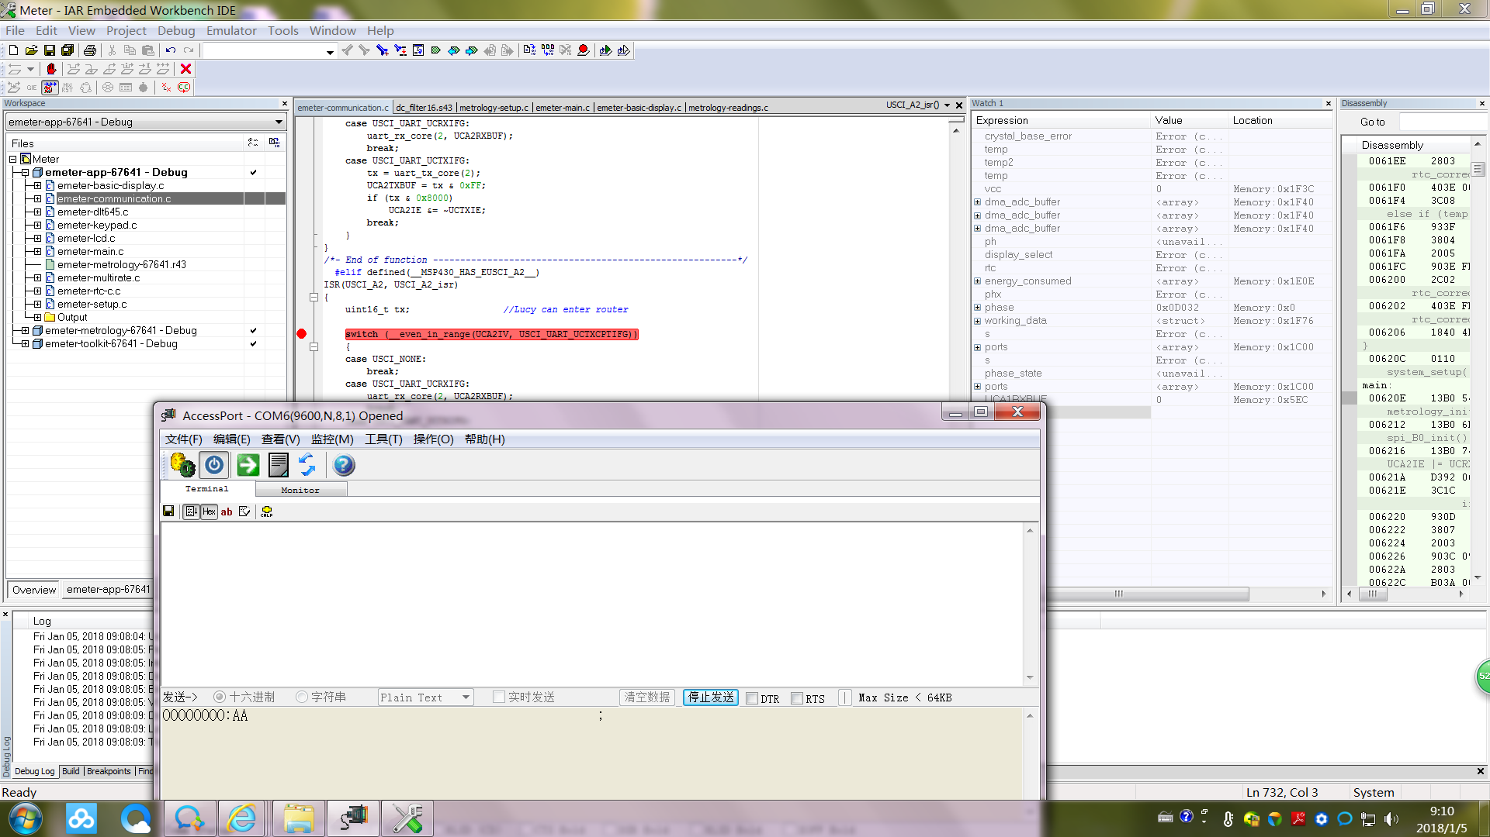

UART_1: Normal can stop and enter this break point.
