Measure ECG – this Bio impedance patch prototype tested OK we want to replace it with TI parts, MCUs and chip set
Project: To use TI’s Bio Patch with a Tetra Polar sensor to measure ECG, EEG, HR and Pulse using a patch or watch
Tested this with non-TI: We are measuring ECG using the Tetra Polar method which includes usage of 4 electrodes. Two electrodes are used to feed the measurement current through measures tissue, the other 2 measure the voltage generated by the current. With 4 electrodes it is easier to control the measured zone and to eliminate the effects of the current carrying electrode.
Use of Waveform Generator: Low Power, 8.5 mW, 2.3 V to 5.5 V, Programmable Waveform Generator. The AD9837 is a low power.
Programmable waveform generator capable of producing sine, triangular, and square wave outputs. Waveform generation is required in various types of sensing, actuation, and time domain reflectometry (TDR) applications. The output frequency and phase are software programmable, allowing easy tuning. The frequency registers are 28 bits wide: with a 16 MHz clock rate, resolution of 0.06 Hz can be achieved; with a 5 MHz clock rate, the AD9837 can be tuned to 0.02 Hz resolution. The AD9837 is written to via a 3-wire serial interface. This serial interface operates at clock rates up to 40 MHz and is compatible with DSP and microcontroller standards. The device operates with a power supply from 2.3 V to 5.5 V. The AD9837 has a power-down (sleep) function. Sections of the device that are not being used can be powered down to minimize the current consumption of the part. For example, the DAC can be powered down when a clock output is being generated. The AD9837 is available in a 10-lead LFCSP_WD package.
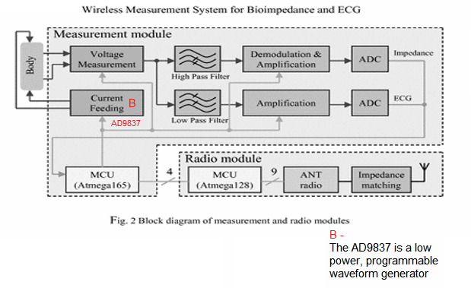
Question1
1. Generate the sinusoidal current – Fig-2 above Using B- AD9837. [How does TI provide the input current for the tetra polar if we use a TI Bio patch? We want to convert to a TI Bio patch platform]
2. Measure voltage signals from tissue
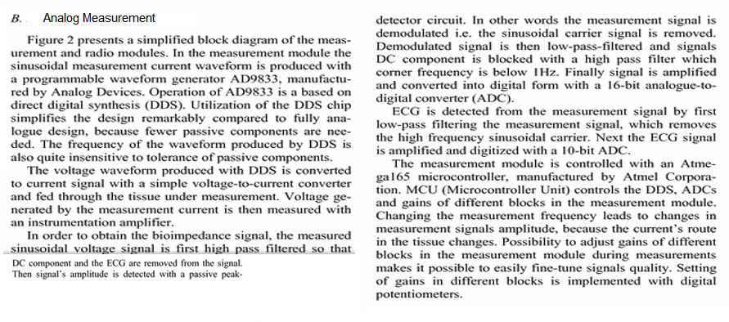
Replacing above with Texas Instruments Bio-patch
Question: Does TI have a similar measuring signal for detecting the ECG, EEG, Heart rate?
TI bio Patch
The bio-patch design incorporates a combination of sensor solutions which enable on-skin temperature measurements and galvanic skin response (GSR) monitoring, [We want to add ECG, EEG, and HR]. The bio-patch design consists of a single-chip solution based on the RF430FRL152H NFC sensor transponder from Texas Instruments. The device handles the sensor signal conditioning, processes the sensor data, enables data-logging of the sensor data via on-board ferroelectric random access memory (FRAM) and provides the RF communication link through NFC to a gateway, such as an NFC-enabled smartphone or tablet. The bio-patch can operate with or without a battery power source. Without a battery, the bio-patch is functional when in proximity of the gateway, scavenging the RF energy of the radiating element through inductive coupling. As part of the system solution, an Android app was developed to collect the information and provide a link to the Internet of Things (IoT).

Bio-patch solutions
TI claims that Bio-patches can be used to monitor a number of physiological parameters ranging from simple on-skin temperature measurements to more sophisticated electrocardiogram (ECG) type measurements. The same sensor solutions have been used to ascertain biological changes associated with an individual’s state of mind. The modulation of the physiological state is achieved by the sympathetic and parasympathetic subdivisions of the autonomic nervous system. Increased sympathetic nervous system activity leads to increased heart rate, blood pressure, sweating and a redirection of blood from the intestinal section of the body toward skeletal muscles, lungs, heart and brain. Physical sensors derive a measurable parameter due to a physical displacement or a change in the physical characteristics of the sensor. Here is what TI claims the Bio patch can do: With support for piezoelectric sensors, photoelectric sensor and thermal sensors. Chemical sensors.
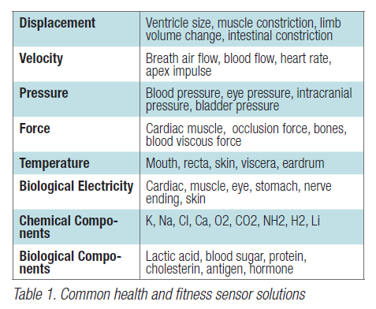
System Analysis
An example block diagram of the bio-patch solution is shown in Figure 1. The system consists of the physical sensor, the associated sensor signal conditioning, the signal processing unit, the data logging component, the RF transmission unit and the overall power management component. How is signal processing handled for our tetra polar sensor?
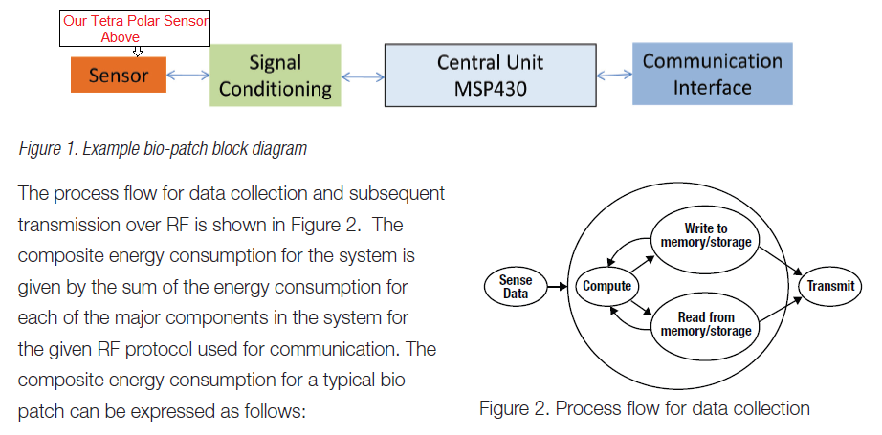
Questions
We want to use our Tetra polar sensor. Based on the claim that your bio patch can handle the ECG signal, how do we do the signal conditioning to pass it to the MSP430? Do you have a Tetra polar sensor to replace ours? Do you have conditioning for a tetra Polar sensor?
Do we have to use Impedance Measurement with the AFE4300. This explains the use of the Tetra Polar sensor. This article gives a brief overview of bio-impedance measurements and discusses the methodology to measure impedance with AFE4300, an analog front end for weight and body composition measurement. [We want to add ECG and EEG to body composition no need for weight] The article also includes the step-by-step procedure to calibrate and measure the impedance using the AFE4300 demonstration kit and the PC application software. The measurement results of two typical bio-impedance networks are analyzed. We want to add an ECG network and others in the future.
Do we have to use AFE4300 and the transponder?
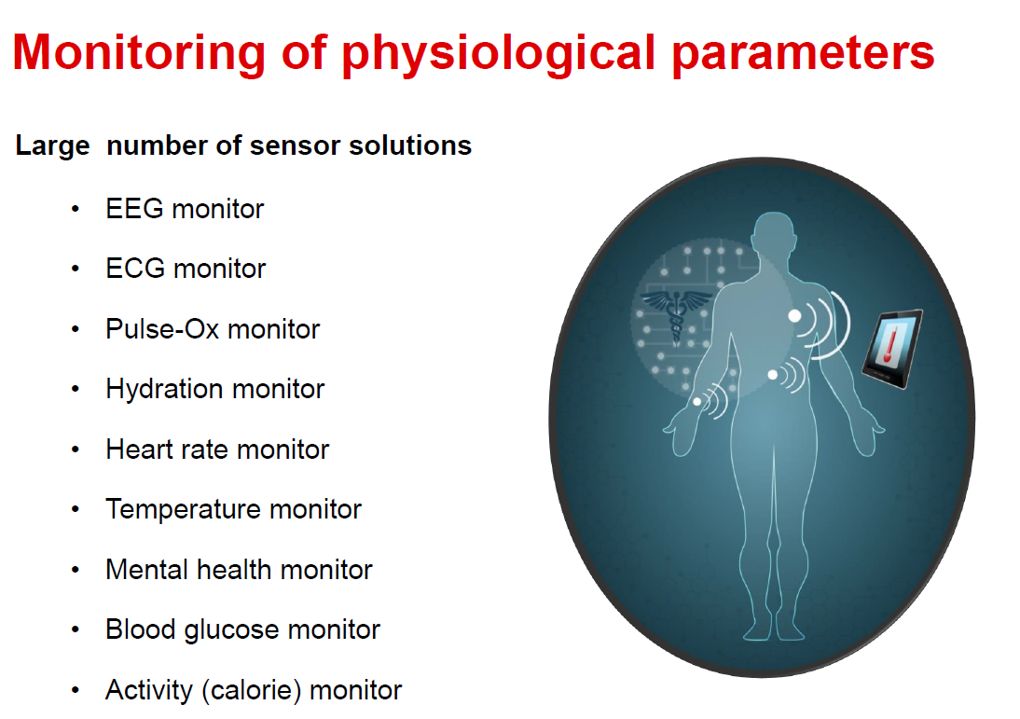

Using sensors on the skin to collect and measure key data
The circuit for the GSR sensor is shown in Figure 1.
Do you have the circuit for the ECG, EEG and all sensors above that we can have or do we have to develop our own?
A non-inverting amplifier design is used to monitor the skin impedance during the sense cycle. The output signal is sensed by the 14-bit sigma-delta analog-to-digital converter (ADC) integrated into the RF430FRL152H device. The impedance of dry skin varies from 1,000 – 100,000 ohms [2]. The transfer function characteristic of the circuit is shown in Figure 2 and is tuned to the expected range. The input resistance on the plot in Figure 2 represents the expected skin impedance and VF2 is the output sensor voltage sensed by the 14-bit ADC. The output response can be adjusted by modifying the R5 and R9 resistor values. The on-skin temperature is obtained via a thermistor and a reference resistor. A small current (2.4µA) is applied on the reference resistor and thermistor. The voltage on both the thermistor and reference resistor is sampled by the sigma-delta ADC. Using the known value of the reference resistor and the exact current being applied allows for an accurate determination of the thermistor value and the correlated temperature value.
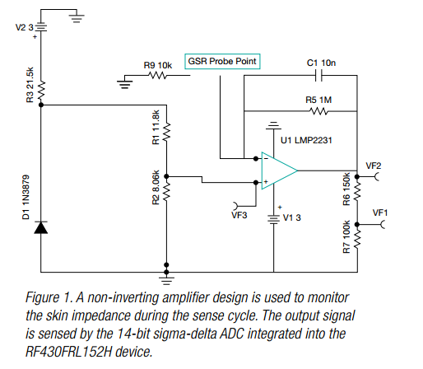
This is what we want to do with a single RF430FRL handling several sensors on a single patch or watch
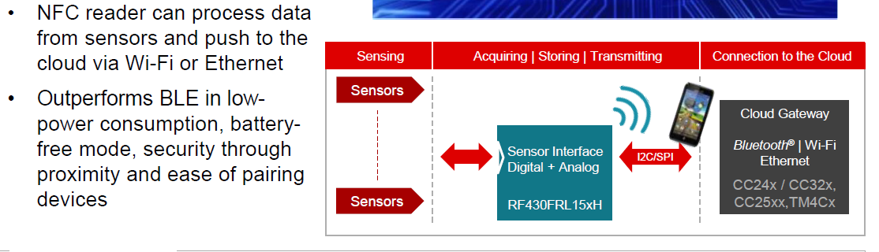
Can you provide the names of your partners that can manufacture the Tetra polar sensor, Patches and watch band for sensor?

