Download latest MSPWare ( e.g. MSPWare_2_40_00_37 )
from : http://software-dl.ti.com/msp430/msp430_public_sw/mcu/msp430/MSPWare/latest/index_FDS.html
using Code Composer Studio Version: 6.1.1.00022
Import Development Tools / MSP-EXP432P401R / BoosterPack Examples /
BOOSTXL-EDUMKII_MicrophoneFFT_MSP432P401R
( from MSPWare_2_40_00_37 )

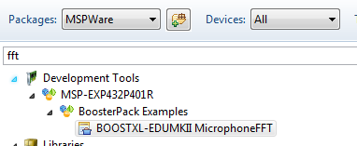

Build the project
