Thanks for your help，I also have some testing questions，Hope we can get your help！
In total, four issues we were encountered:
First of all, here are some of the hardware settings I made in accordance with the Design Guide: TIDM-1000
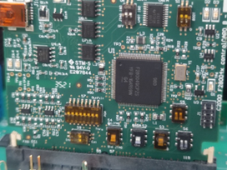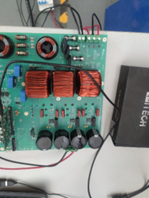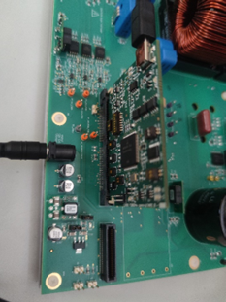

1. when test INCR_BUILD 2 to INCR_BUILD 4，Should I clear the trip when the input voltage is not 0 or clear the trip when the input is 0.

2：INCR_BUILD 2: Closed Current Loop
When input AC voltage is raised to 70VrmsL-N，The circuit board makes a "zi zi zi.." sound，and boardStatus as Figure below is overcurrentTrip（ 30V 40V There is no overcurrent protection ）：
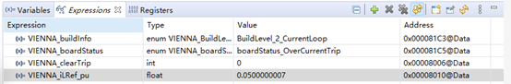
3. INCR_BUILD 2: Closed Current Loop：
When input AC voltage is raised to 40VrmsL-N，There is no overcurrent protection，but when i Raise the current reference iLRef to 0.1，he circuit board also makes a "zi zi zi.." sound，and the current waveform is unstable。
4. INCR_BUILD 3: Closed Voltage and Current Loop and INCR_BUILD 4: Closed Balance, Voltage, and Current Loop：
When input AC voltage is raised to 40VrmsL-N，I Clear the trip by setting the clearTrip variable to 1，but The current waveform does not change，Same as open loop：
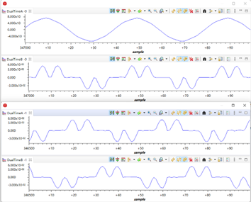
Best wishes！
I‘m looking forward to your help！

