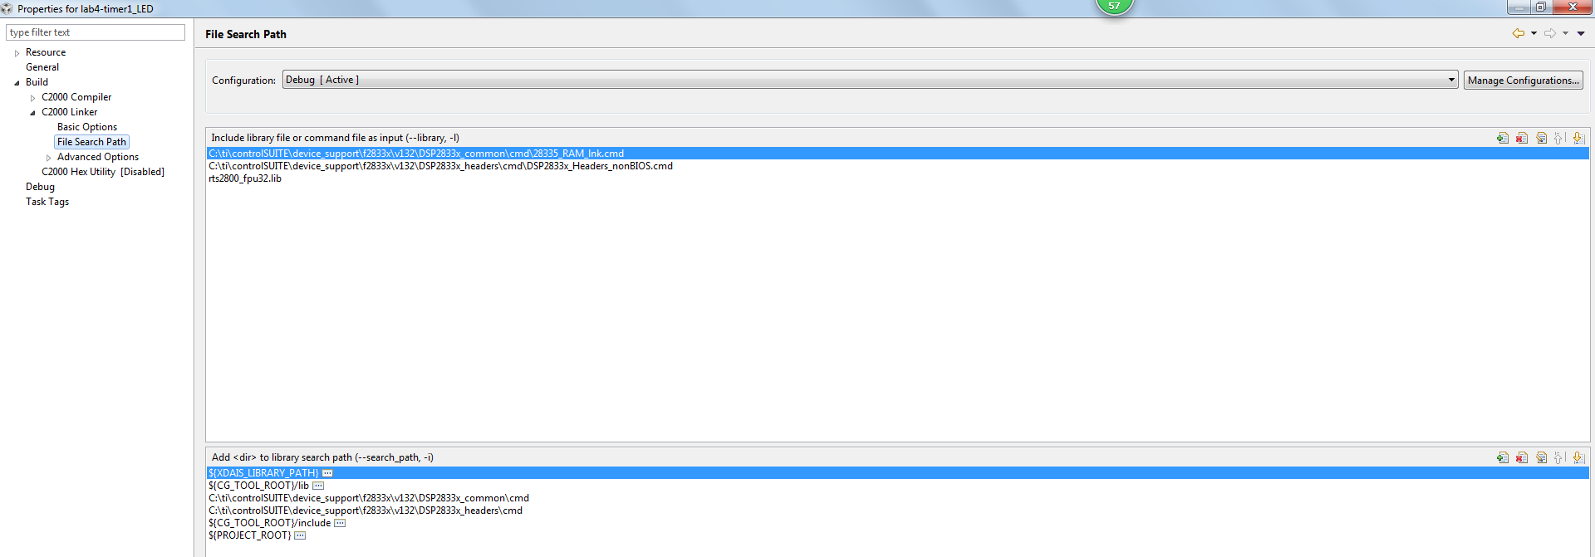
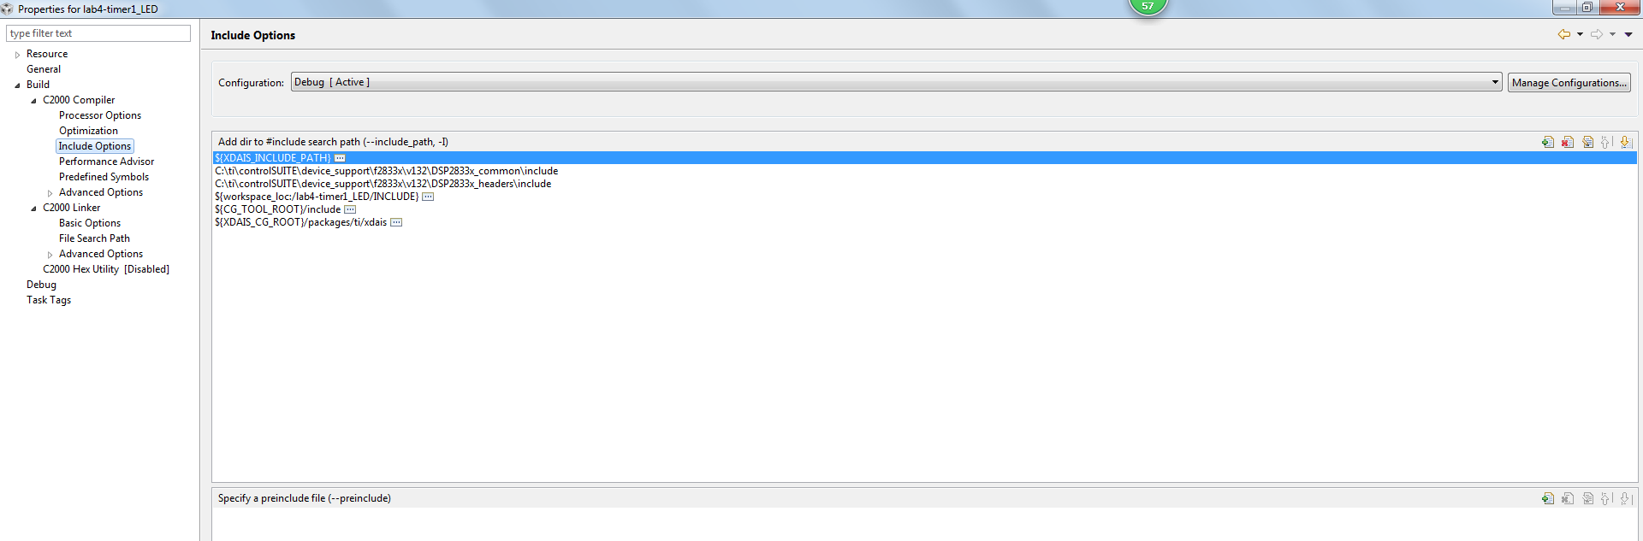

Error
**** Build of configuration Debug for project lab4-timer1_LED ****

"C:\\ti\\ccs800\\ccsv8\\utils\\bin\\gmake" -k all
**** Build of configuration Debug for project lab4-timer1_LED ****

"C:\\ti\\ccs800\\ccsv8\\utils\\bin\\gmake" -k all

gmake: *** No rule to make target 'C:/ti/C2000Ware_1_00_05_00_Software/device_support/f2833x/headers/cmd/DSP2833x_Headers_nonBIOS.cmd', needed by 'TIMER0.out'.
gmake: Target 'all' not remade because of errors.

**** Build Finished ****
**** Build Finished ****

