1. In first step I call USB Boot loader from memory browser of ccs by putting 0XC5A on location 0XD00 as given in page 496 of TMS320F2837XS reference manual and it work correctly (fig 1).

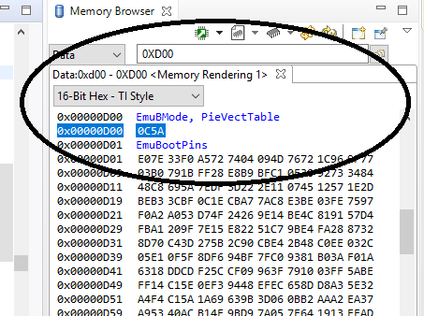

Fig 1

1. When I connect USB probe from microcontroller to PC, I get message that USB is not recognized and when I try to modified the USB driver then it not work and this is related with the devise signature of micro controller(Fig 2).

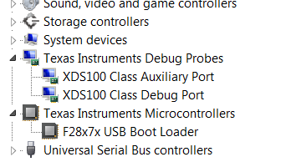

Fig 2

To solve this, I changed my PC setting and disable the driver signature check from windows and it finally worked (fig 3).

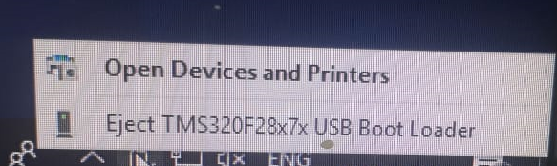

Fig 3

I use hex2000 utility for converting .out file to .dat file. And used USB flash utility to program the microcontroller.

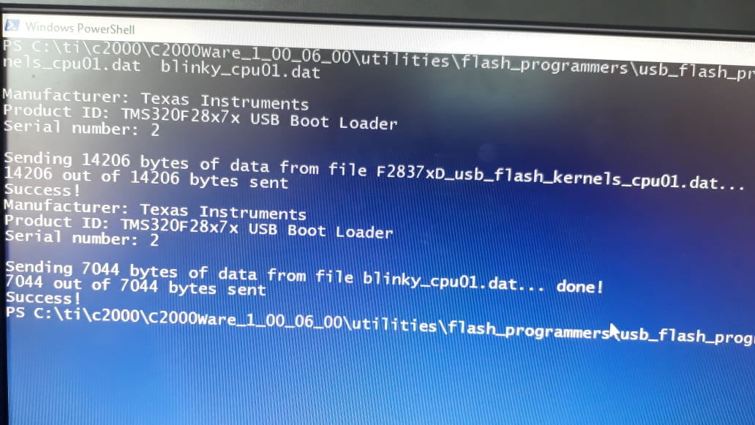

1. Finally I want to call usb boot loader form my code. And as you suggest, I add boot_symbol lib in my project by.

“C:\ti\c2000\C2000Ware_1_00_06_00\libraries\boot_rom\f2837xs\revB\rom_symbol_libs”

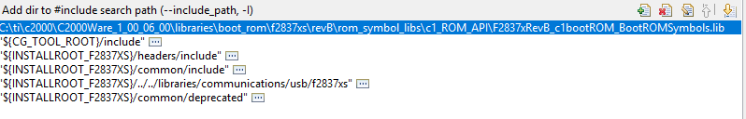

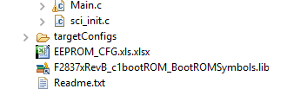

And when I call the function USB_Boot_Init() from main then I get “ error unresolved symbol remain”.

(I add this file one by one on complier (include option) and linker (file search path) setting. And try this from “add file” in project menu).

But the error is not resolved.