Issue description,
CAN peripheral can’t transmit any frame after first time F28335 powered up, and then after random times of CAN peripheral re-initialization, the CAN worked as expected; During this period, the CAN can’t Transmit any data.
The CAN bus connection shown as below figure, the UPS number can reached to 4, the reported issue is happened while the no roundness connection.
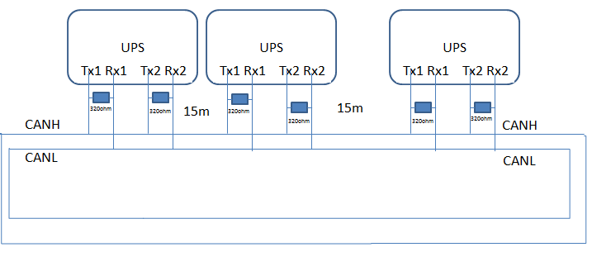
On-site support found that, the CANTEC will up to 255 and then cleared to 0, the CANREC will increased from 0 to 128, during the period that CANREC from 0 to 128, the BO is still 0(no Bus Off reported); and sometimes after CANREC & CANTEC are cleared to 0, the TM can’t set to 1, but the receive is still worked well.
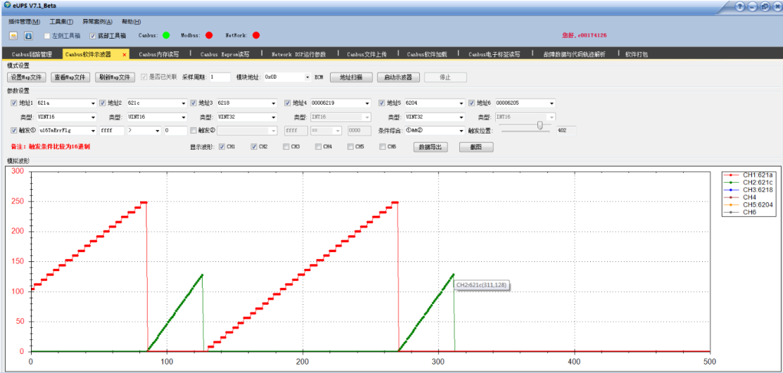

The CAN peripheral register value shown as below while can’t receive any CAN data.
CANBTC: 0xE0031 : 1110 0000 0000 0011 0001
CANES: 0x0002->0x0000: Receive Mode-> No Transmit Mode
CANGIF1: 0x8009: 1000 0000 0000 1001
CANMC: 0x9359: 0010 0100 1000 1111
CANMD: 0x3FF: 0011 1111 1111
CANME: 0x7BFF: 0111 1011 1111 1111
CANMSGID: 0Xdc90 00b1: 1101 1100 1001 0000 0000 0000 1011 0001
CANREC: 0x0000
CANTA: 0x0000
CANTEC: 0x0000
CANTIOC: 0X0009: 1001
CANTRS: 0x7800: 0111 1000 0000 0000

Support Need:
- While the TRS is set, and there is no other issue for the CAN peripheral configuration, the F28335 CAN peripheral can’t transmit any frame, and the TM bit is always 0, which will caused this issue, could you kindly give comments why TM can’t be 1? And how to solve this issue?

