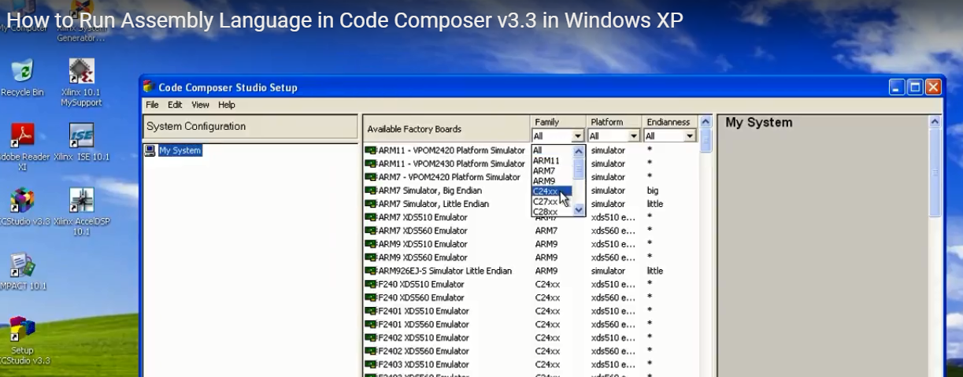
Code File details
.mmregs
.global _c_int00
.text
_c_int00:
STM #10H,AR2;Initialize counter AR2 = 10h
STM #410H,AR1;Initialize pointer AR1 = 410h
LD #0H, A; Initialize sum A=0
SSBX SXM ; Select sign extension mode
START:
ADD*AR1+,A; Add the next data value
BANZ START, *AR2-; Repeat if not done
NOP; No Operation
.end

MEMORY
{
PAGE 0: IPROG: origin = 0x1000, len = 0x3000
PAGE 1: IDATA: origin = 0x400, len = 0x100
}

SECTIONS
{
.text: {} > IPROG PAGE 0
.data: {} > IDATA PAGE 1
