Before the pow-funktion: the XAR2 shows the correct address:
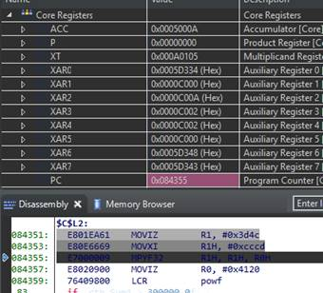

The XAR2 shows the wrong value after the lib function LCR powf and isn’t reloaded:
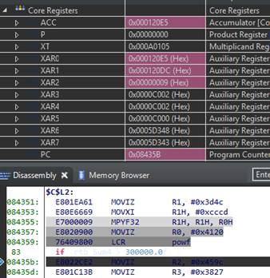

Later the XAR2 is used to write into the Struct (MOV32 *+XAR2[0], R0H). But this is 0x9 now and not 0xC00A any more.
