Issue description:

Unable to secure the password in OTP zone with .asm and .cmd file modification, the devices been locked or unable to worked after power-on-off-on sequences.

Detailed description:

Based on TRM description, secured the OTP password zone with below operation:

1): Remove the type = DSECT from .cmd file; (Just use Bank0 Zone 1: b0_z1); shown as figure 1;

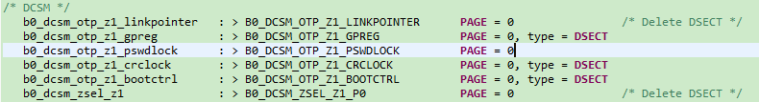

Figure 1: modification of .cmd file

2) changed the pswdlock to 0xFFFFFFFE in z1_otp.asm file; as figure 2 shown;



Figure 2: modification of z1_otp.asm file

The TRM mentioned how to secure the Z1_TOPSECLOCK shown as figure 3;

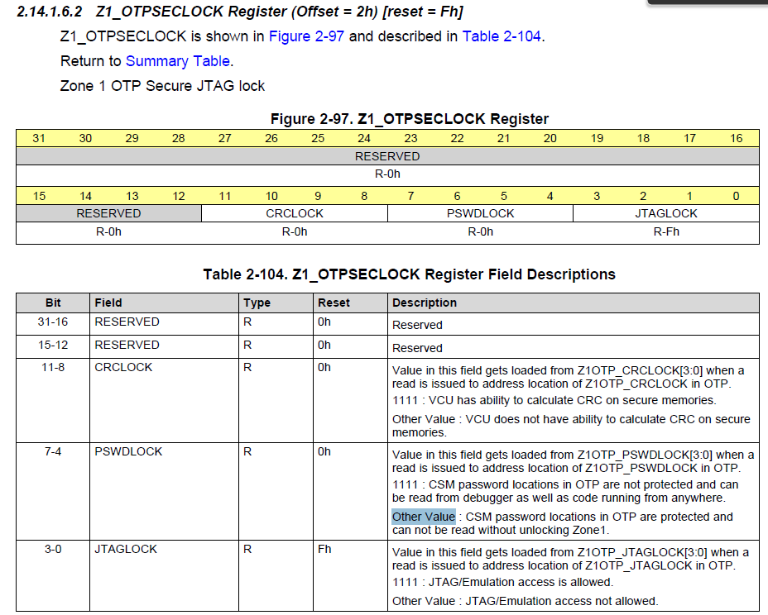

Figure 3: Operation Guides of TRM for OTP_Password secure operation

With Step 1) & Step 2), failure reported while loading the .out file which enable password secure operation, shown as figure 4; 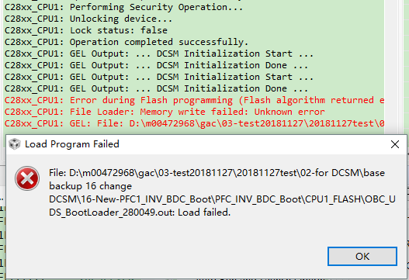

Figure 4: Failure reported while loading .out file

3) Used a fresh F280049, and read the original data for OTP PSWLOCK address, which reported to FB7FFFFF, repeat step 1) & Step 2), and changed to FB7FFFFE in b0_z1.asm file, the failure still existed;

4) Tried to use Uniflash to load the .out file which with step 1) & Step 2), which could be load succeed but still failed at VERIFY stage.

5) With Step 1) & Step 3), succeed with uniflash for loading .out file, but while power off-on operation, the nRST(Reset) PIN reset periodic, which is similar to previous situation(unsecure zone read data from secure zone);

Support Needs:

How to enable PSWDLOCK in OTP with DCSM feature which disabled unexpected OTP read operation from JTAG?