Preparation:
- CCS version is Code Composer Studio 12.7.1
- Use the example boot_ex1_cpu1_cpu2_cm_secure_flash from C2000Ware_5_02_00_00\driverlib\f2838x\examples\c28x\boot\CCS

- Build with Flash to generate boot_ex1_cpu1_cpu2_cm_secure_flash_cpu1.hex
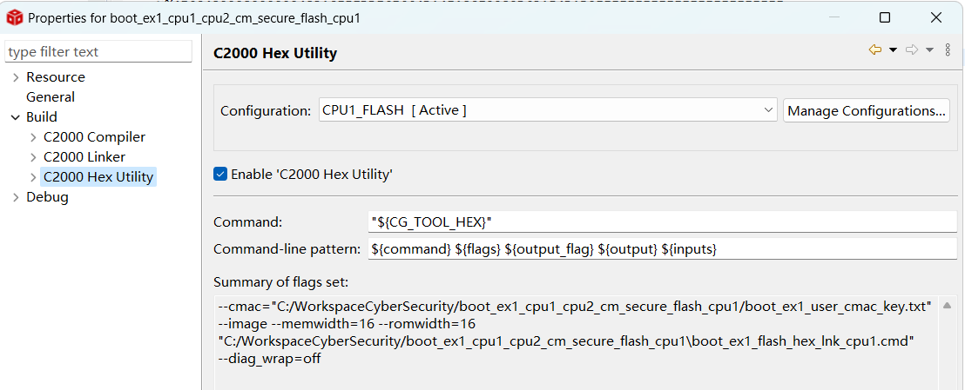
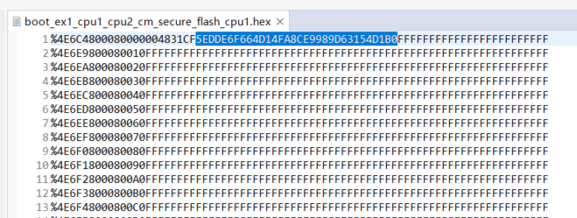
Change name:boot_ex1_cpu1_cpu2_cm_secure_flash_cpu1.hex to boot_ex1_cpu1_cpu2_cm_secure_flash_cpu1(Default).hex
Fact: The format hex did not have the 128bits address alignment problem.
- Add –boot –sci8 –ascii as below picture shows to generate boot_ex1_cpu1_cpu2_cm_secure_flash_cpu1.hex
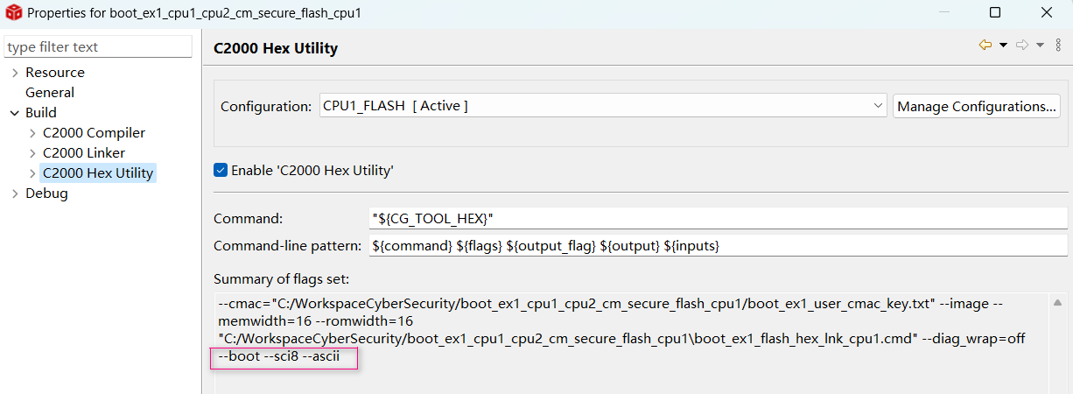
Change name:boot_ex1_cpu1_cpu2_cm_secure_flash_cpu1.hex to boot_ex1_cpu1_cpu2_cm_secure_flash_cpu1(Boot_SCI8_ASCII).hex

The Boot_SCI8_ASCII format hex is difficult to read, so I use the python script to analysis the format.
The blue background marked Block size
The read background marked address, which already converted to normal address
The green background marked data
Fact: The Boot_SCI8_ASCII format hex has the 128bits address alignment problem.
The 0x00080002 is the standalone block, which does not meet 128bits address alignment.
I tried to combine this standalone block with 0x00080000 block by manually change the hex file content, then the firmware update successfully and secure boot successfully.
Expection：Manually change the hex is not the good way, TI shall provide the right method to generate the aligned address blocks for Boot_SCI8_ASCII format hex.
