ECAN case1:
The below screenshot of excel sheet contains the details about transmitted messages and received mailbox configuration.
Mailbox2 configuration to receive multiple ID:
MBX2.MSGID.IDE = 1
MBX2.MSGID.AME = 1
MBX2_LAM = 0xFFFFFFF8
MBX2_MSGID (28:0) = 0x00000003
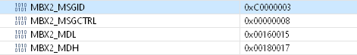
Other eCAN register settings:
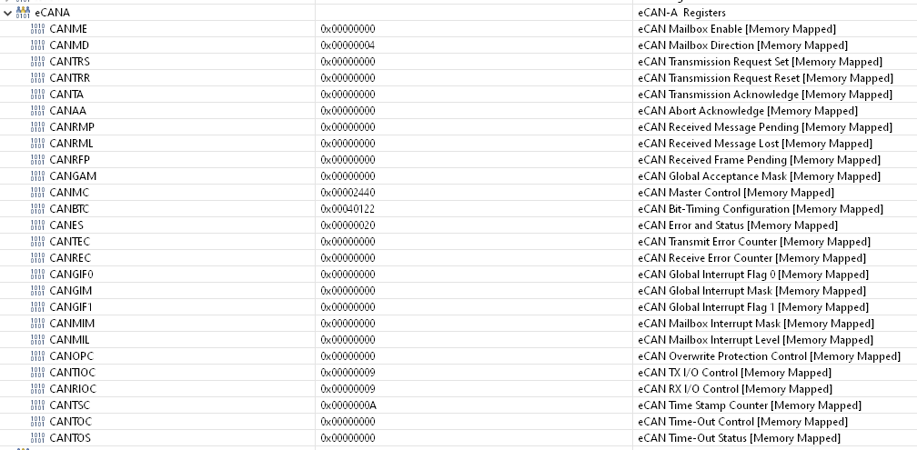
Observation:
Able to receive data from both transmitted messages in MBX2_MDL and MBX2_MDH as expected. But MBX2_MSGID is not reflecting the message ID of received message. IT is always reflecting the ID used during configuration.
Question1: How to get the IDs of received messages in MBX2_MSGID? IS there any setting missing?
ECAN case2:
The below screenshot of excel sheet contains the details about transmitted messages and received mailbox configuration.
Mailbox2 configuration to receive multiple ID:
MBX2.MSGID.IDE = 1
MBX2.MSGID.AME = 1
MBX2_LAM = 0xFFFFFFF8
MBX2_MSGID (28:0) = 0x00000003
Other eCAN register settings:
Observation:
As per the LAM and message ID settings only one message is expected to receive. But able to receive data from both transmitted messages in MBX2_MDL and MBX2_MDH which is NOT expected.
Question2: Is Anything wrong with mask and ID settings for receive mailbox?

