Ethercat issue

Issue summary:
- When use emulator connected, download the code and run, or reset the code by CCS button, everything work well.(good case)
- When disconnected the emulator and run the device standalone, all code run well except Ethercat can not connected to Master, ESC led do not blink. (bad case)

Tests done:
- Get all CPU1 RAM value by CCS for both good case and bad case after run at the beginning of main function, do the comparison and check that all RAM value are the same value except .Stack value have a little different.
- When Power on with standalone, if drive XRS pin to low to reset the device, then fail to work for ESC, other code run well.
- When Power on with standalone, fail to work for ESC, then connected to emulator and CCS without resetting the device, click CCS reset button to reset the device, restart and run the code, then everything work well and ESC can connected to Master.
- They read the register 0x110 to check if ESC work well.
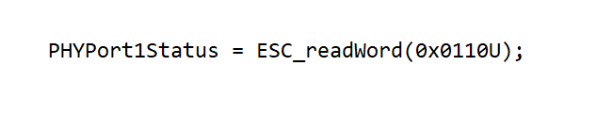
For good case, PHYPort1Status is showed below:
While for bad case, PHYPort1Status is showed below:
- When run the device standalone without emulator, If comment below code, then there have big possibility that the code can run well(maybe 9 out of 10 time will run ok, ESC led is blinking).
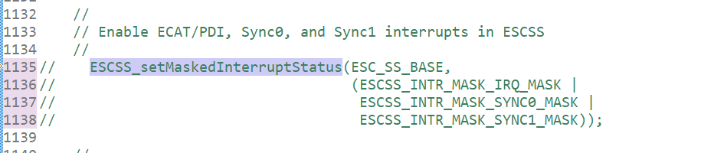
But if uncomment ESCSS_setMaskedInterruptStatus function, and do a little modification which not actually do not enable the interrupt, then still have the issue and ESC led is not blinking).
ESCSS_setMaskedInterruptStatus(ESC_SS_BASE, 0);

Below are the memory map file for both two case w/wo ESCSS_setMaskedInterruptStatus function.

Question:
- What are the difference for power on reset, XRS hardware reset, CCS reset for the code?
- when PHYPort1Status value will be 0x 5507 as below showed?
- any suggestion to debug this issue?

