Issue description:
My customer used 280049 to control digital power. And trigger an interrupt (ISR) by setting EPWM compare value. And found that the latency (delay time) was not constant which will influence customer’s control strategy seriously.
Test Procedure:
1. The ISR code was written by ASM, the latency was tested by setting breakpoint before executing context save as blow figure. And found this latency (delay time) by watching the TBCTR register, the TBCTR shown that the latency is about >300ns;
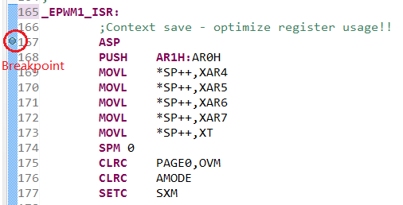
2. To remove the factor of online simulation by XDC100v3, we use GPIO output status by make the chip run alone. So we further confirmed the issue of interrupt latency.

Support Need:
- Which factors would impact the latency for the ISR between interrupt triggered and ISR executive? Is the latency fixed or flexible?
- How to achieve the minimum latency for the ISR configure or which part should be pay attention for the software configuration?

